
InPhase v17 ‘Unity’
17.5.301 Release Notes

January 2019
Commercially Confidential

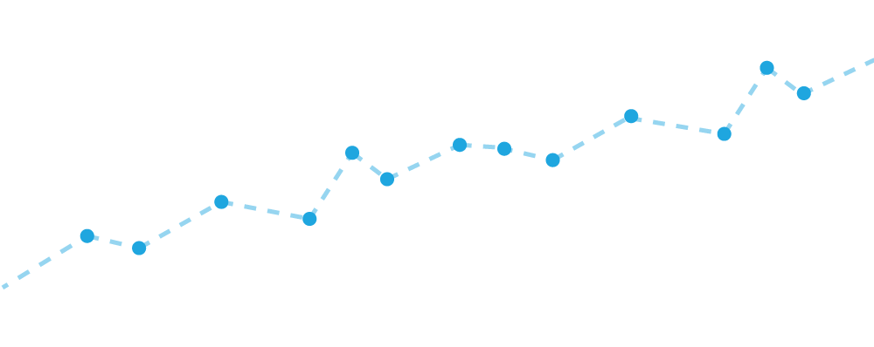

Contents
INPHASE v17.5 Unity Overview 6
INPHASE v17.5 Major Enhancements 6
Booster Capability 6
Projects Boost 6
Other Feature Enhancements 8
Comments Panel Subject Lock 8
Quick Edit Risks (My InPhase) 8
Drag and Drop Lists Columns (My InPhase) 8
Slicers can include Parents 8
Trends Derived Measure Protection 8
Employee Search 8
Sunburst in-Period Values 8
Performance Chart add any Plan Series 8
Benchmark Series in Performance Details Popup 8
Freeform Anchor Right for Responsive Design 8
Reports Object Types configurable 9
Custom Object Types Customisable Icon 9
Permissions 9
Import Permissions 10
Bulk Employee Import 10
Linked Frames 10
Page Flow 10
INPHASE v17.0 Unity Overview (Previous Major Release) 11
INPHASE v17.0 Major New Features 11
Major enhancements have been made, including… 11
Overhauled user interface styling 11
My InPhase 11
Built-in Reports 11
Organogram 11
Extensive Project related features 11
Finance measures 12
Global search, performance analysis and predictive analytics 12
SMS subscription option for notifications 12
User Engagement 12
Top Menu Bar 13
My InPhase 13
Quick Edit Property Panel 18
Key Actions / Tasks 19
Drag and Drop Ordering 19
Drag and Drop as a Sub-Task 19
Quick Sub Task creation 20
In-line Edit 20
Filtering the Display 20
Additional Columns of Properties can be added to the right-hand side of the List using the Property Picker 21
Grouping 22
Create New Action/ Task in My InPhase 23
Linking to Objectives, Measures, Projects, and other Tasks 24
Permissions 27
Reports 28
Organogram 33
Portals 37
Transferring Ownership of an Action / Task 39
Subtasks 40
Create a Subtask 40
Delete a Subtask 40
Unlink a Subtask from a Parent 40
Linking to Multiple Parents 40
Aggregation of Dates 40
Task Dependencies 40
Task Earliest Start Date 41
Task Lead Time 41
Task Minimum Duration (Working Days) 41
Aggregation of Resourcing (where this option is Licenced) 41
Notifications by SMS (where this option is configured and SMS service is activated by the Customer) 41
InPhase Actify - Office 365 Outlook Add-in 42
Visualisations 44
Wide Format Card 44
Causal Graph 44
KANBAN 46
Trends – Charts 48
Trends – Gantt 48
Gantt baseline 49
Gantt History 49
Trends - Widget Title Menu 50
Property Picker – Dimension Panel 50
Search and Add 50
Sunburst 51
Measures 51
New options for Derived Measures: 51
Remaining 51
Remaining FYE 51
Wildcard 51
Series 51
Forecast Series 51
Baseline 51
Baseline Series 51
Resources (App-in for InPhase) 52
Criteria 52
Freeform 53
Trends 53
Live Connect/Scheduled Import 55
ODATA 55
SQL 56
General Import 56
ENTERPRISE – additional functionality previously only in Designer 56
Object Notebook 56
Measures 56
Task Notebook 57
What’s new for Projects Summary 57
Tasks 57
Portal Page Layout 60
Briefing Book Page 60
General Application Changes 61
Aggregation 61
Employee Name 61
Model End date 61
Critical Path 61
Technical Hardware and Software Requirements 63
Hardware Requirements 63
Application Web Server 63
Database Server 64
Combined Application and Database Server 64
Software Requirements 65
INPHASE v17 Cloud Hosting 65
17.5.301 67

INPHASE v17.5 Unity Overview

INPHASE version 17.5 ‘Unity’ includes many advances including the ability to boost your InPhase implementation with Boosts created by expert InPhase Consultants utilising the latest features of InPhase.
The first Boost is the Projects Boost which will aid in delivering more successful Projects and PMO.

INPHASE v17.5 Major Enhancements

Booster Capability
Boost your InPhase implementation with new Booster capability. Boosts will be available from within https://support.inphase.com to download. Each Boost is a file that can be used in the new Booster wizard accessible from the Designer Utilities menu to add new capabilities to your InPhase site including portals, styles, analysis or other features. The Booster Wizard guides you through completing any configuration required for each Boost.

Projects Boost
The first Boost available is the Projects Boost. This contains a portal called Projects & PMO that assists with managing Programmes and their Projects.
This includes creation, approval, update, revision, re-forecasting, closure, costs and benefits, risk management and issue management for Projects, grouped in Programmes.
This Booster will:
- Create a Portal call “Projects & PMO”
- Update the Risk object type to include custom fields used by PMO
- Create/Update the Programme object type to include custom fields used by PMO
- Create/Update the Project object type to include custom fields used by PMO
- Create/Update the Issue object type to include custom fields used by PMO
- Add Comment Subjects:
  - Project Update
  - Issue Update
  - Project Quality
  - Action Update
- Add images used by the PMO
- Add Custom Fields

To use the Projects Boost you will need to have:
- the Risks add-in
- the Gantt add-in
- Planning Patterns for
  - Monthly
  - Quarterly
(names can be different and can be manually mapped):
- Series for:
  - Target
  - Forecast
  - Baseline
(names can be different and manually mapped)
The Planning Patterns and Series are configured through the Administrator application.
Full details of the Boost are available separately in User Guide and Admin Guide documents.

Other Feature Enhancements

Comments Panel Subject Lock
The Comment Panel can now be locked to single Subject. This will help when designing pages where you want end users to create a comment with a specific Subject that they cannot change by accident.

Quick Edit Risks (My InPhase)
Users can now Quick Edit Risks and update the Impact and Probability within My InPhase.

Drag and Drop Lists Columns (My InPhase)
The lists on My InPhase (Key Actions, Projects etc) now support reordering of columns using drag and drop.

Slicers can include Parents
You can now use Slicer for Parent/Ancestor properties.
Consolidate Hierarchy
Tasks that are children of other Tasks in the report are automatically removed from the root of the report and only shown in the hierarchy drill-down.

Trends Derived Measure Protection
You can now prevent data input into all series for Derived Measures to prevent users accidently overwriting the calculated value. This is an enhancement to InPhase preventing all users lower than Performance Manager from updating the Actual series. Users with a Role of Performance Manager and above are always allowed to update the Derived Measure’s series irrespective of this setting.

Employee Search
Employee fields now use the type/search control to assist when there are many Employees.
Multi-select Employee fields now use the multi-value dialog with additional search box.

Sunburst in-Period Values
Now has an in-period option so that you can display the data from the current period rather than the last completed period.

Performance Chart add any Plan Series
The Performance Chart can now show any series for a Measure in addition to the Actual and Target.

Benchmark Series in Performance Details Popup
The Measure Detail Popup includes any Benchmark series on the measure.

Freeform Anchor Right for Responsive Design
When creating a freeform for a page that fits the size of the Browser, you can anchor a picture/text to the right of the freeform. This will mean it will be visible on different size screens.

Reports Object Types configurable
The Reports area, accessible from the top menu, now shows the same list of Object Types as My InPhase. The Object Types displayed can be configured from the My Page by clicking on the cog icon on the 2nd level menu.

Custom Object Types Customisable Icon
Option to upload an SVG for your own Custom Object types icon. This is accessible from Designer Utilities menu.

Permissions
To prevent accidental data loss permission on change start and end dates have been tightened:
- Tasks
  - User requires AUTHOR rights
  - User needs to be a Briefing Book Viewer or above
- Objects (Objectives, Risks, Project, etc)
  - User requires AUTHOR rights
  - User needs to be a Performance Manager or above

Only users with a role of Reporter and above can access the Actions and Control properties in the Property Picker.
Objects and Task only appear in reports if the user has at least view rights. Previously only series

data and comments were hidden.

Import Permissions
Permissions for an Object/Task can now be imported.

Bulk Employee Import
Now creates Organisational Unit (Department) if not found. You will need to set the hierarchy through the organogram.

Linked Frames
Now include option to Cascade the selected Object/Measure. This clears/resets the slicers on destination widget(s). This is useful when using multiple Trends to cascade selects e.g. each trends deals with the level below the previous trends, allowing end users to select a directorate, then the area then the team.

Page Flow
Page flow handles more complex page designers and will automatically display widgets in a single column on mobile devices/small screens, reducing designer workload to support mobile and small screens.
The biggest change is where widgets are touching top & bottom they are now treated as a single container which enables the second image below to benefit from Page Flow responsiveness.
Charts and other visualisations that have no content inherent height use the height they were displayed in Designer mode.
Previously Supported: Now also supported
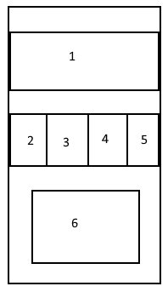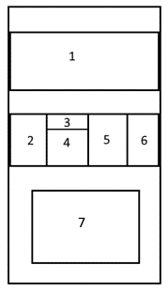

INPHASE v17.0 Unity Overview (Previous Major Release)

INPHASE version 17.0 ‘Unity’ is a major release, with significant advances in connecting all aspects of the business process in a unified solution, to support fact-based decision making to drive Quality and Performance Improvement.
As a result, INPHASE Unity delivers a step change in the Decision Experience, supporting the entire management cycle, or plan-do-check-act cycle, from daily action list to strategy management.
INPHASE version 17.0 contains major enhancements which are listed in this document.

INPHASE v17.0 Major New Features

Major enhancements have been made, including…

Overhauled user interface styling – delivering faster and easier usage on desktop, tablet and mobile,
My InPhase – significant improvements in routing all relevant information directly to every individual, without navigating, searching or ‘self-service’ for goals, metrics, key actions, projects, risks and compliance
Schedule – unified Gantt view of the timeline of all your Key Actions and Tasks
Timesheet – in-built timesheet capture option for all your project, task and other action resource times for Resources (if licensed)
Built-in Reports – a new built-in core reports area, reports for each management level and each business planning area, for unified reporting or specifically related to information type; be it goals and objectives, measures, projects, key actions risks, or custom object types, for more than 20 standard reporting requirements. This is a library that can be updated and expanded with new report masters in the future.
Organogram – dynamic organisation chart, for managing, viewing, navigating when using in-built reports, and for access to users’ Profiles. Supports Administrator users to edit the Org chart and users’ org unit association
Extensive Project related features – including resources on Tasks (if Resources are licenced) and any number of levels of sub-tasks. Links between Tasks can now include lead time, calculated working days, and Critical Path Analysis extended to analyse task and sub-task. As well as Theory of Change diagram support in Causal Chart and a Kanban view that is especially useful for projects in addition to other types of goal, measure and action tracking, and management.
Finance measures – as well as analysis improvements and budget management enhancements with in-built functions for ‘remaining budget to go’, ‘save as baseline’, ‘update baseline’, and automatic update of forecast series with historic actual as it is entered.
Global search, performance analysis and predictive analytics – directly from the application menu search for any type of item, using any field, and open the selection to view the current, historic and predicted performance analysis against target, collaborative discussion, past, present and future planned actions, related risks and projects, impacts and drivers, linked analytical data sets. Update manager forecasts, assessments, discussions, actions, risks or related information, with auto-routing to involved and interested parties.
SMS subscription option for notifications – performance alerts, reminders, and action update notifications are now available via SMS as well as by web dashboard and email.

User Engagement
A beautiful overhaul of the Enterprise user interface styling provides the most modern engaging styling for the end user experience, helping to improve engagement.
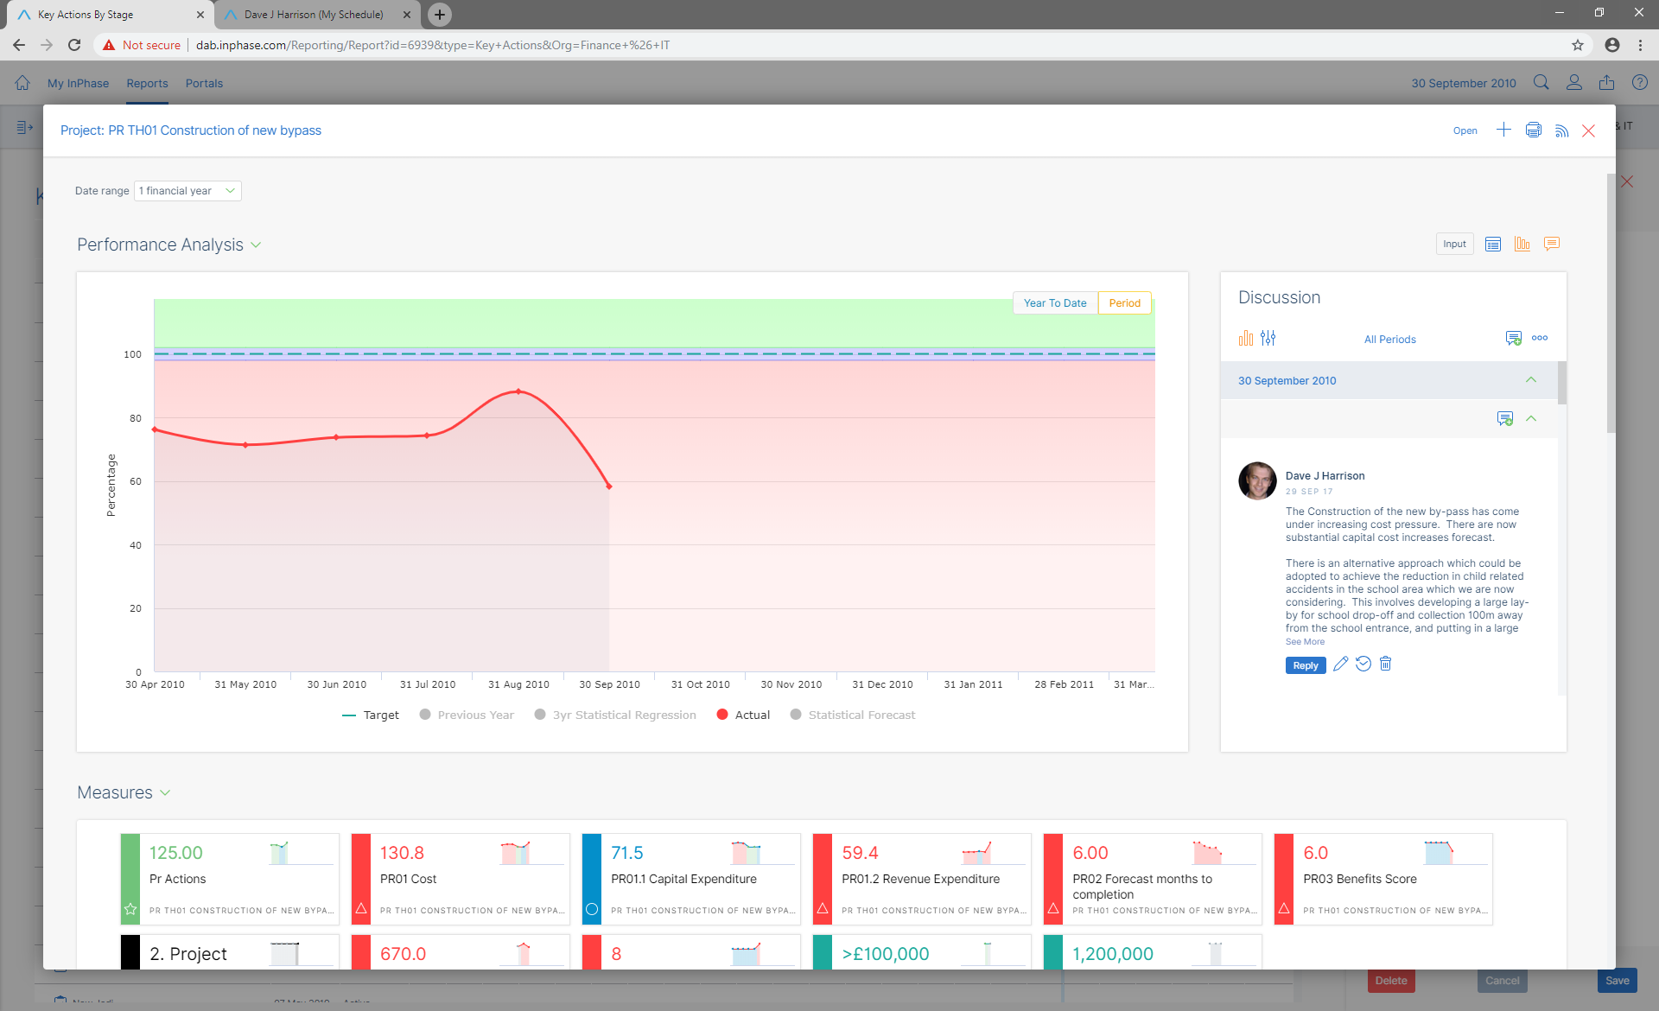The in-built capabilities of the InPhase have been extended substantially with increased My InPhase content and in-built reports area.

Top Menu Bar
The menu hamburger has been replaced with menu texts and now provides menu access to
My InPhase – with extended sections bringing all your performance, quality, risk, key actions, and schedule information directly to you
Reports – for in-built reports that work on all objectives and measures without pre-building
Portals – search and access all your custom briefing books and pages
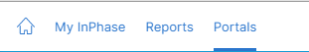
There is no longer a page refresh, as the browser refresh, as well as back and forward, now works fully on all browsers on all pages.

On the righthand end of the menu bar:
Global search and view is a fast way to search using any field and then see the details of anything in the entire application that you have permission to view.
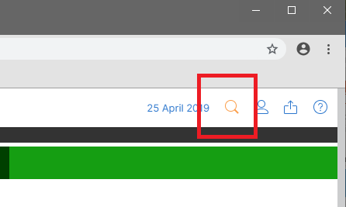

My InPhase
Summary for each Object type the user is interested in (sunbursts).
Toggle to swap between the Summary and the details of all Object Types. This setting is remembered.
Menu to view types of items individually for each type, for quick and easy access.
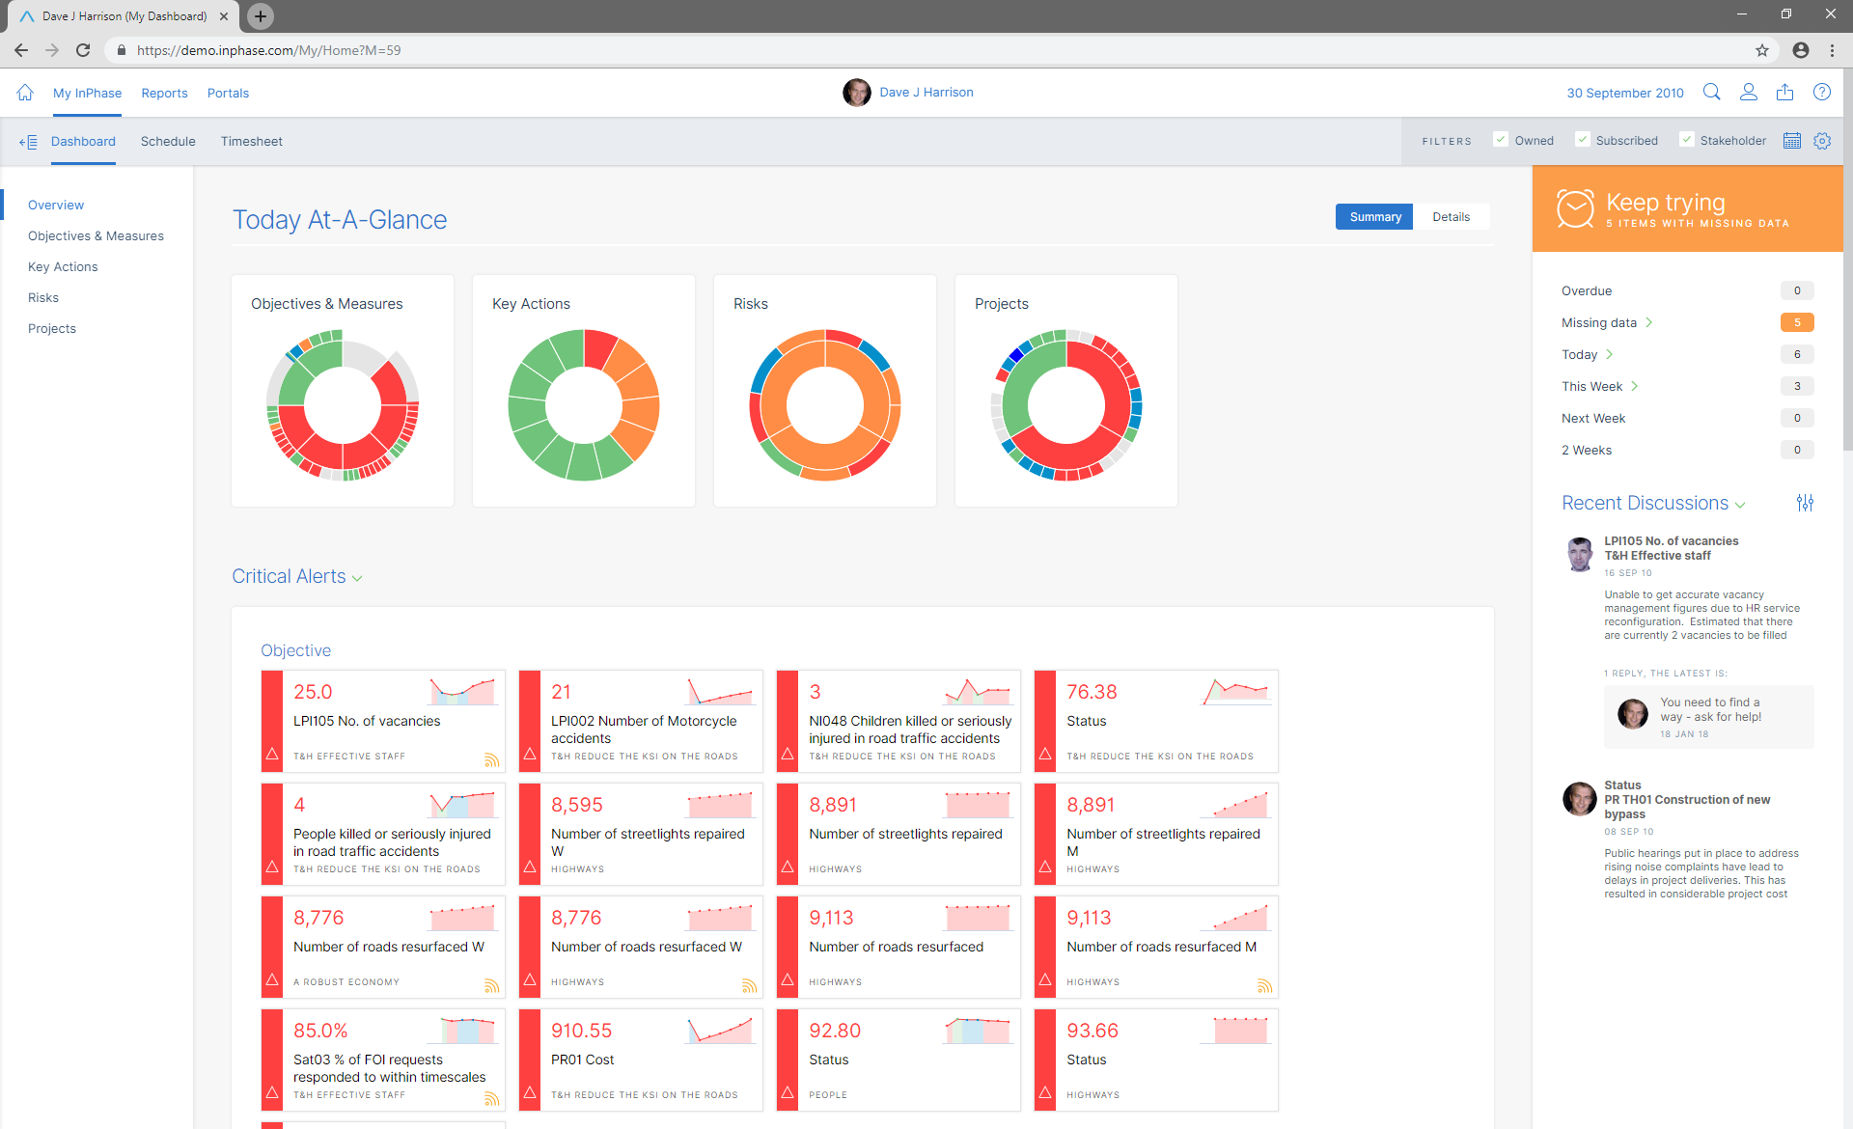

Key Action Summaries section of Overview has Count bars for number of Actions/tasks late, on time, that need updating, and where performance is poor. On time and completed badges. Click on the bars or the badges to access the relevant Actions/Tasks in a pop-up, to get a list of Tasks.
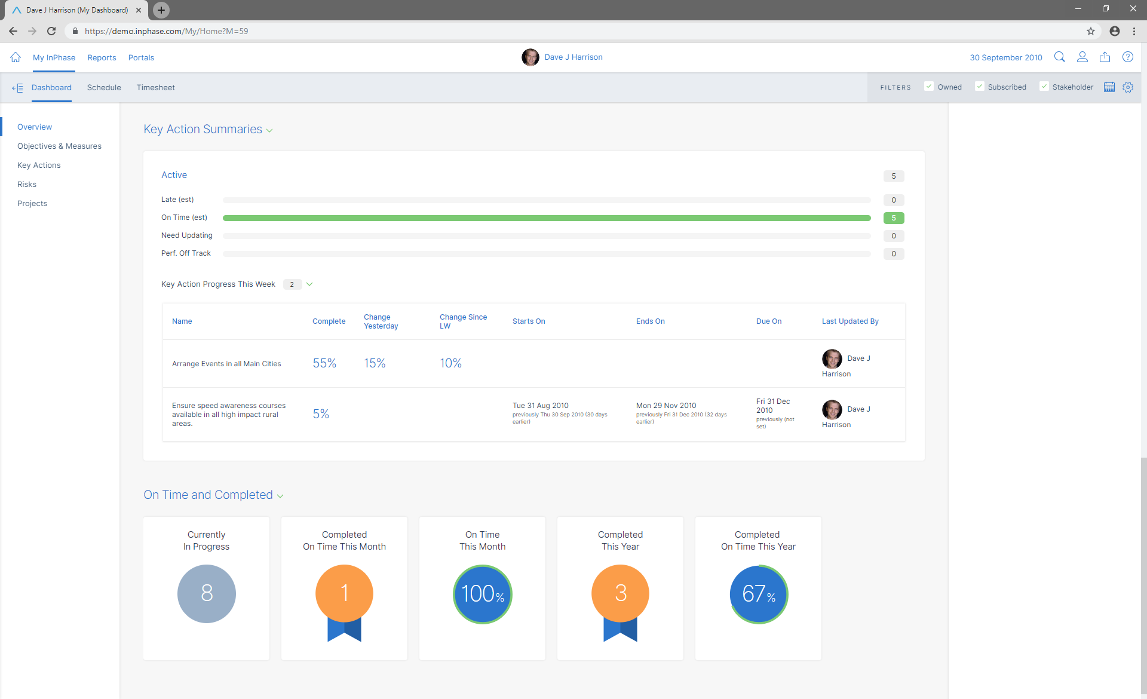
Key Action section has a list of changes (start/due/end/stage/%complete) to a User’s tasks made in the last week. Useful for checking what tasks the user has progressed and for the User to see if any of the Tasks with children have been updated due to the children changing – e.g. a child owned by another user could overrun causing the User’s parent Task to be estimated as late.

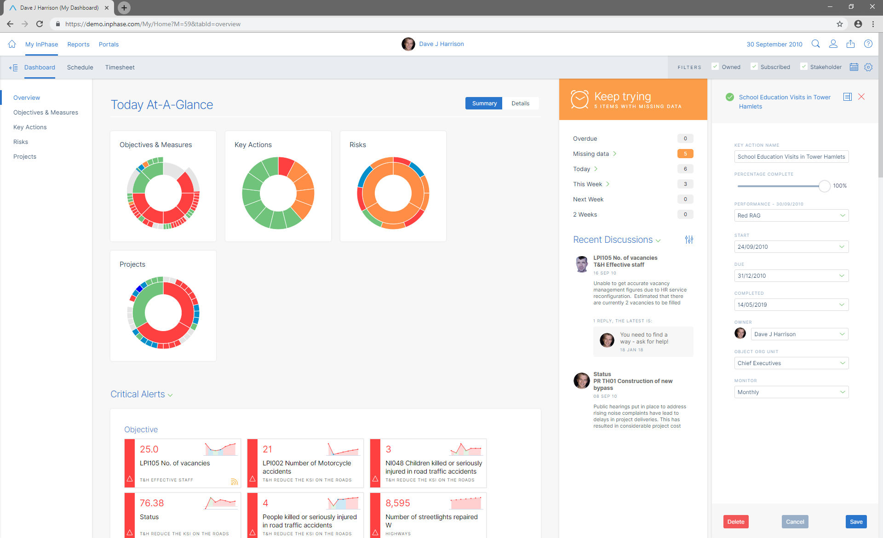

Each User can select which Object Types they want included on their My InPhase with the page level filter:
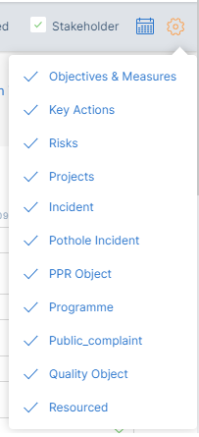

Each User can also filter the page at any time by the items where they are
- Owner
- Subscriber
- Stakeholder (custom field)

Ability to select the active date range to focus on only entities that are active in that range:
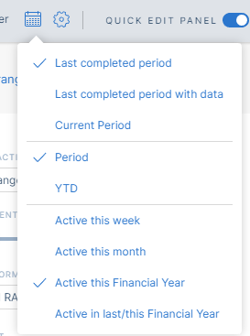

Schedule Tab
Shows all Actions/Tasks on the users My InPhase in a single Gantt chart, with selection filters.
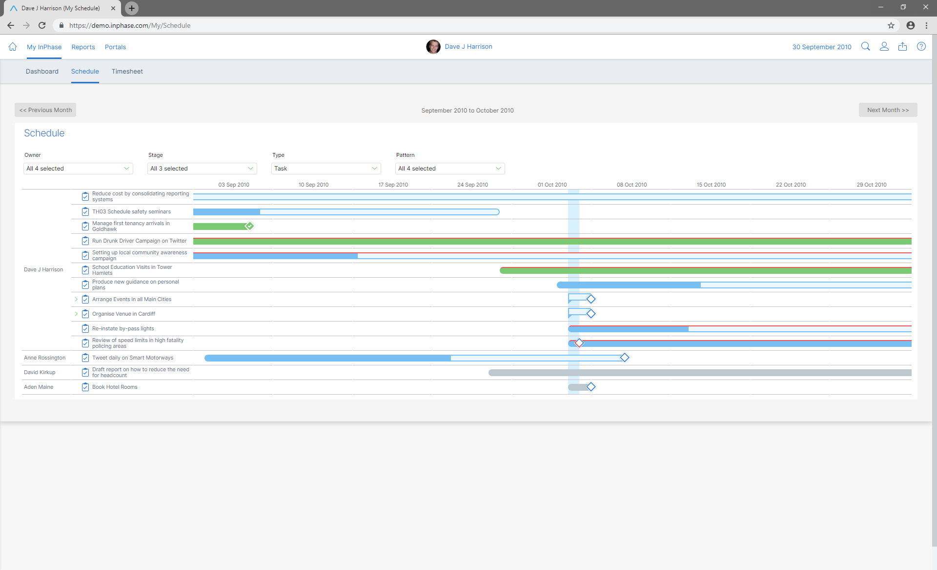

You can view other users’ My InPhase pages based on the Manager hierarchy. If viewing as a different user then when changing pages in My area the user is retained. An Administrator can view any users’ My InPhase irrespective of the management hierarchy.

Right Hand Schedule counts
Items set to “Deferred” stage no longer appear in missing data area.
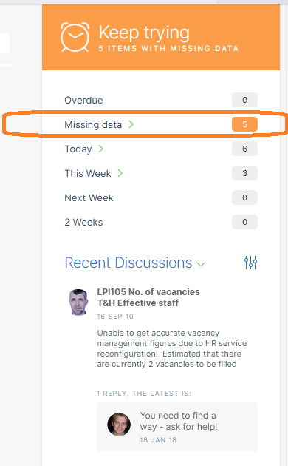

Quick Edit Property Panel
On My InPhase and the Reports pages, you can click on any item (a Key Action, Project, Objective, Risk or Measure) to open a quick edit property panel on the right-hand side of the page that provides quick access for editing key fields.
You can choose to position the side panel in overlay or side-by-side view modes.
If you want to disable the Quick Edit, there is a toggle in the top right of the page:


Key Actions / Tasks
New usability features, listed below, have been added to the Key Actions list display.

Drag and Drop Ordering

The Key Action List now supports drag and drop ordering of your tasks into any manual sort order. Clicking on the column header will sort by the column header.
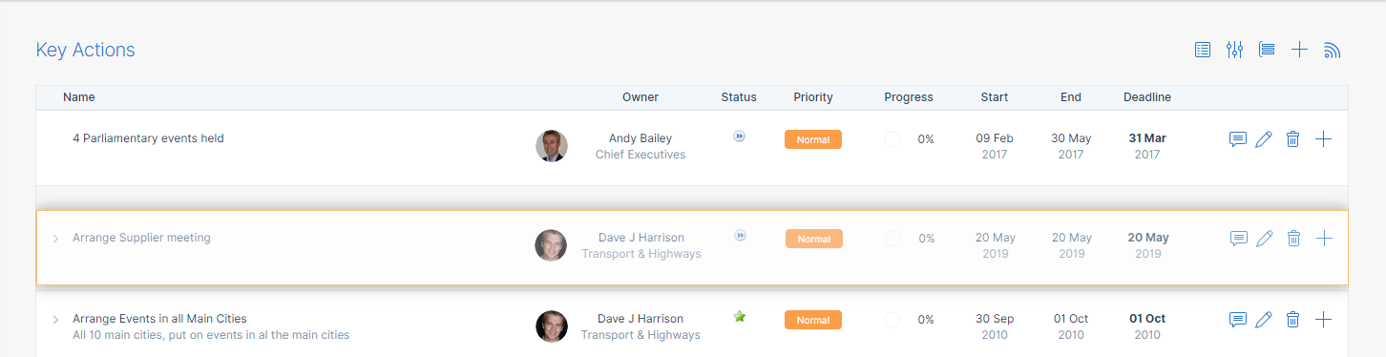
Drag and Drop as a Sub-Task
Dropping an Action on to another Action will make it a sub-Task
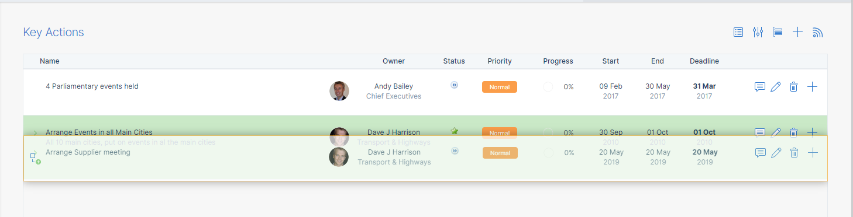

Quick Sub Task creation
The + will create a sub-task ‘in-line’ under the existing Task.
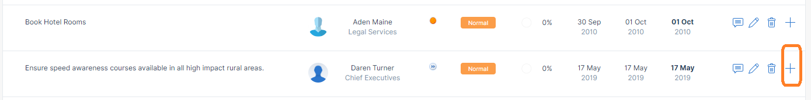
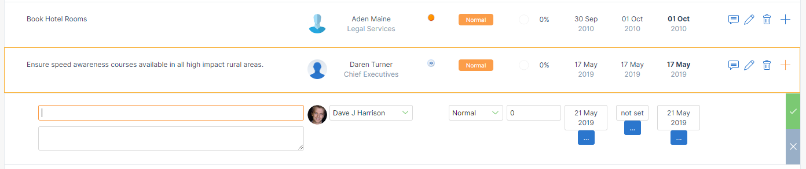

In-line Edit
Selecting the edit pencil icon enables quick in-line editing of the Task

Filtering the Display
Each section can be filtered via making selections by accessing the filter panel
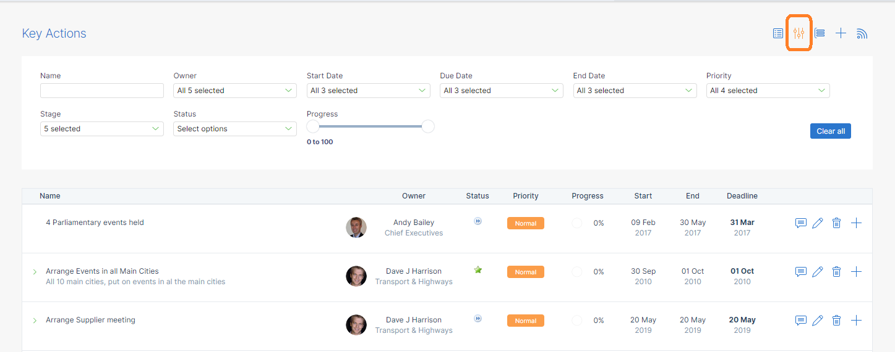

Additional Columns of Properties can be added to the right-hand side of the List using the Property Picker

For example, dragging and dropping Object Org Unit. This column will stay on the List for this user.
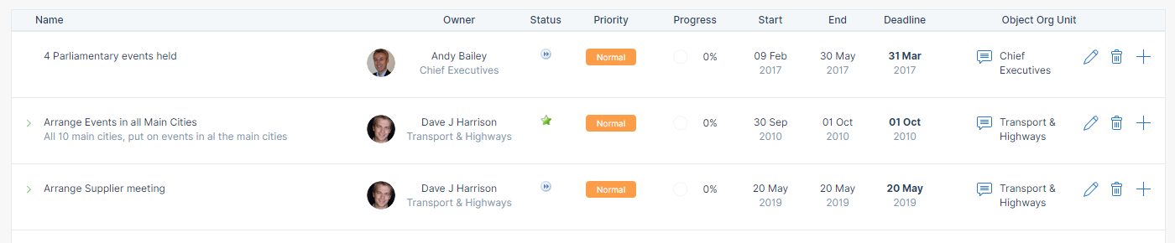
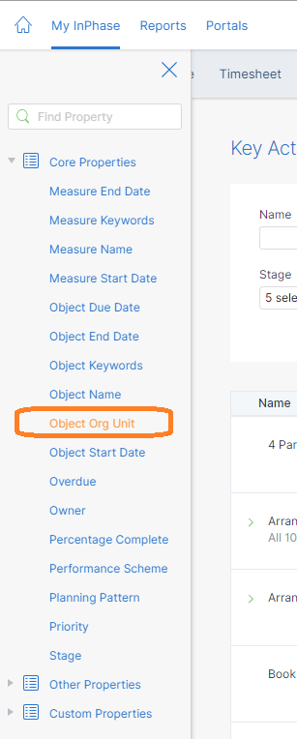
Added columns can be removed using a context (right-mouse button) menu.
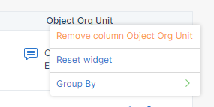

Grouping

Each section can also be Grouped from the grouping menu.
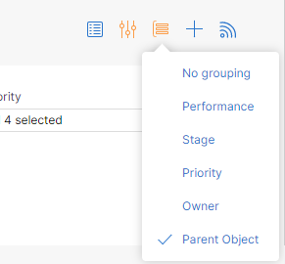
Grouping creates a grouped title of the selected Grouper. For example, grouping Actions/Tasks by Parent Object.
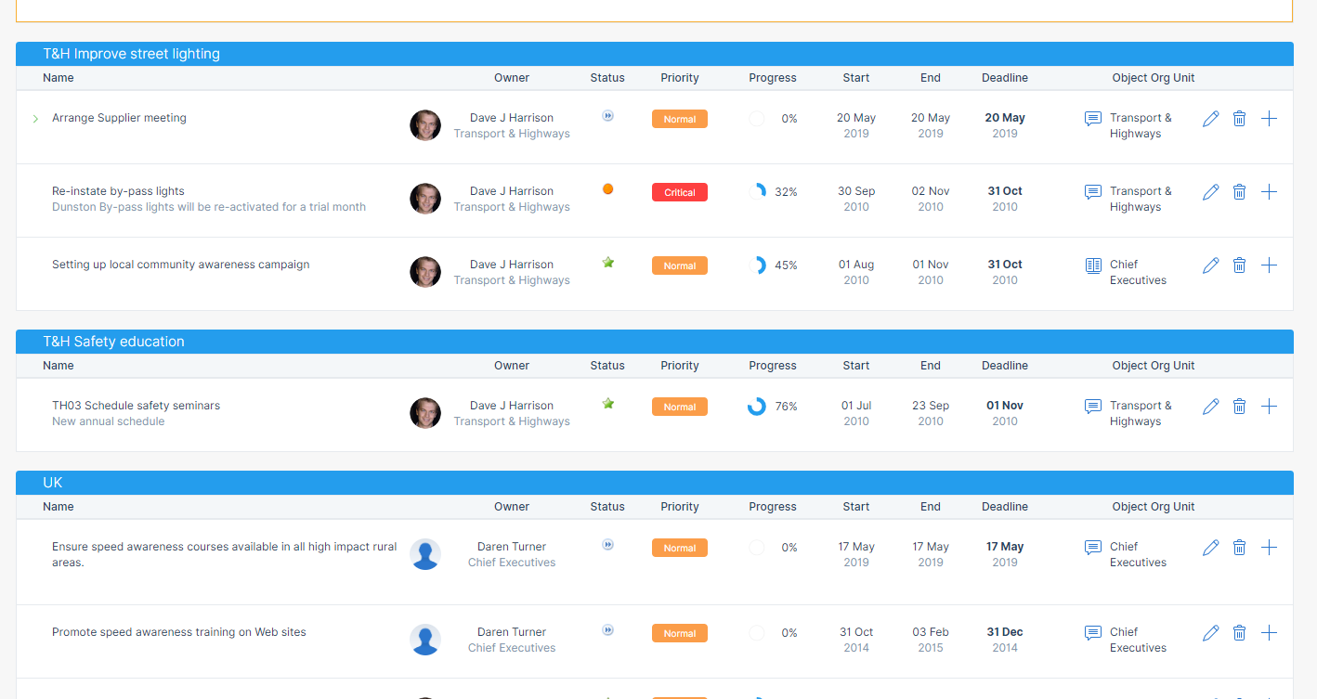

Create New Action/ Task in My InPhase
New Actions and Tasks have been made very easy to create throughout the system. In the My InPhase, Key Actions section, using the + sign at the top or bottom of the list creates a new Key Action/Task.


From top of list
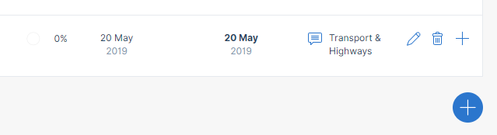
From bottom of list
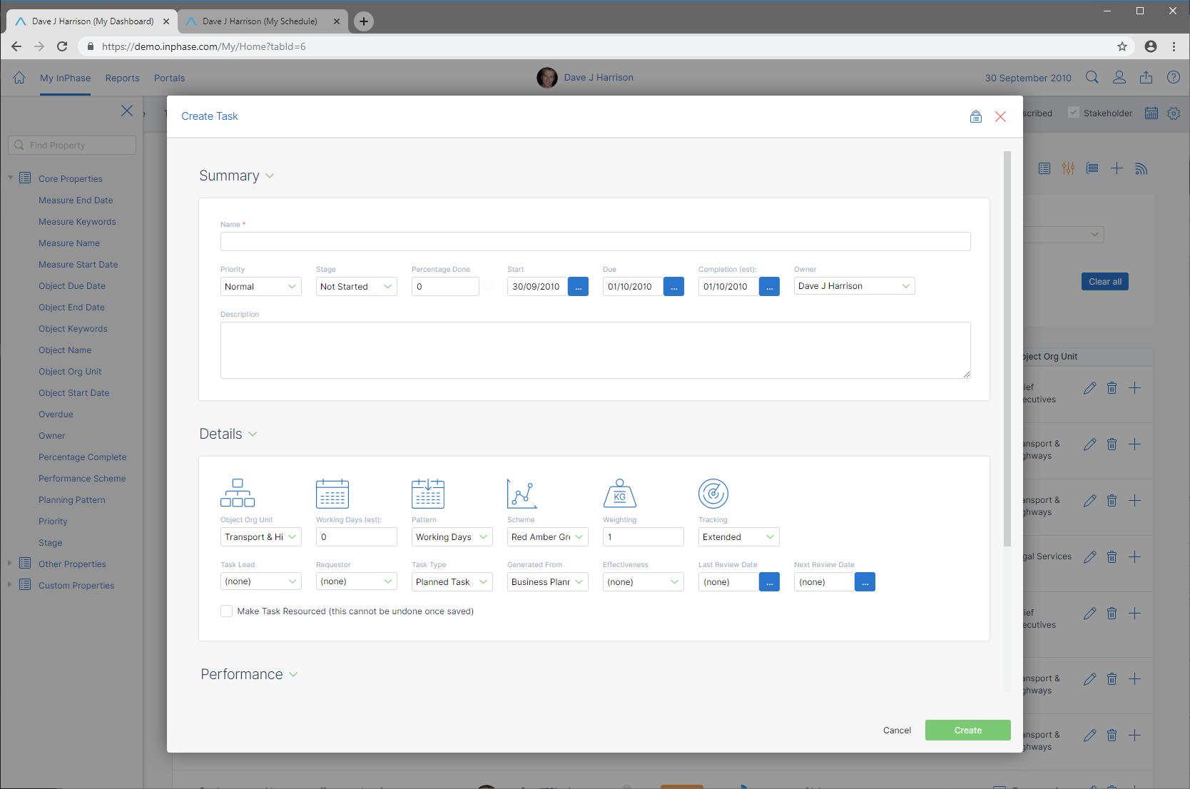

Linking to Objectives, Measures, Projects, and other Tasks

If you want to link a new Action/Task to an Objective or Measure, Project, Risk, or another Task you can do it further down the dialogue:
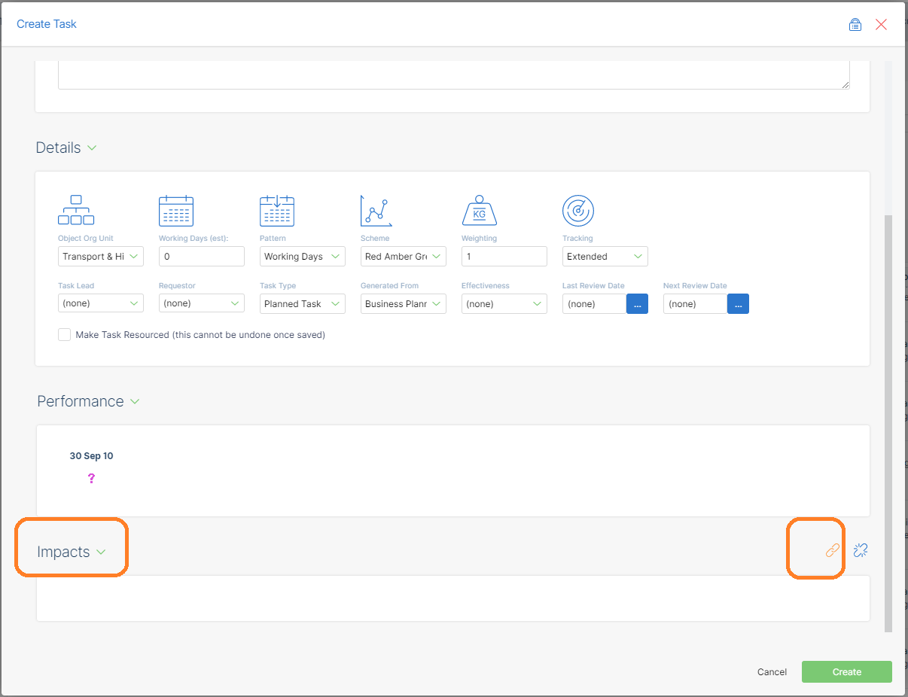
The extended full search capability enables you to find the item you want to link to quickly and easily, using any property field to identify the item.
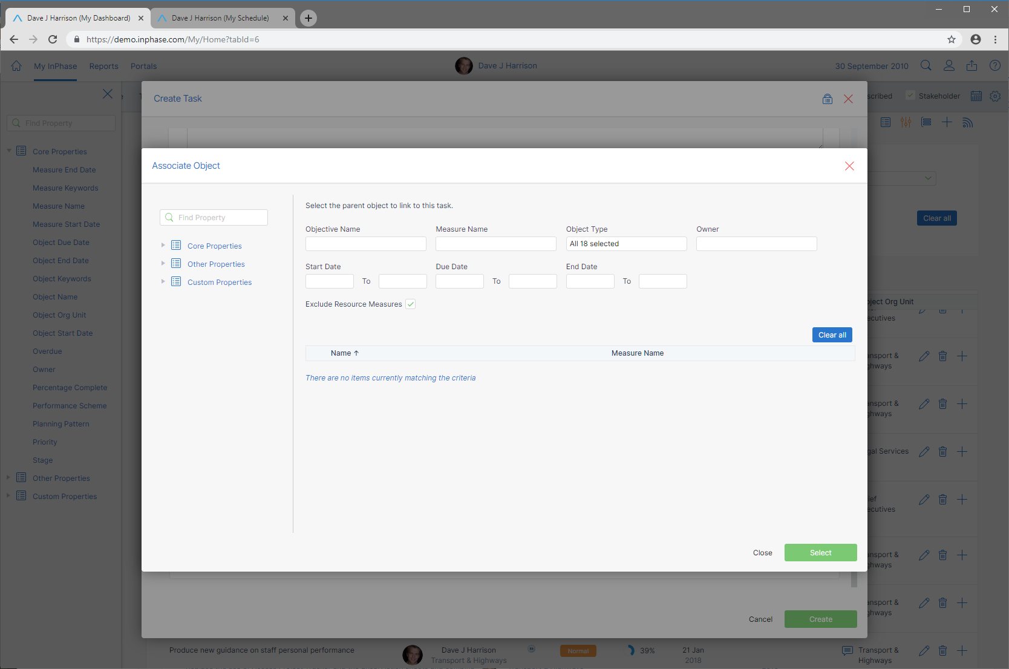
If you want to use properties that are not on the dialogue by default, you can drag the property from the left panel onto either the table or the search criteria area at the top, where you can use it to search.
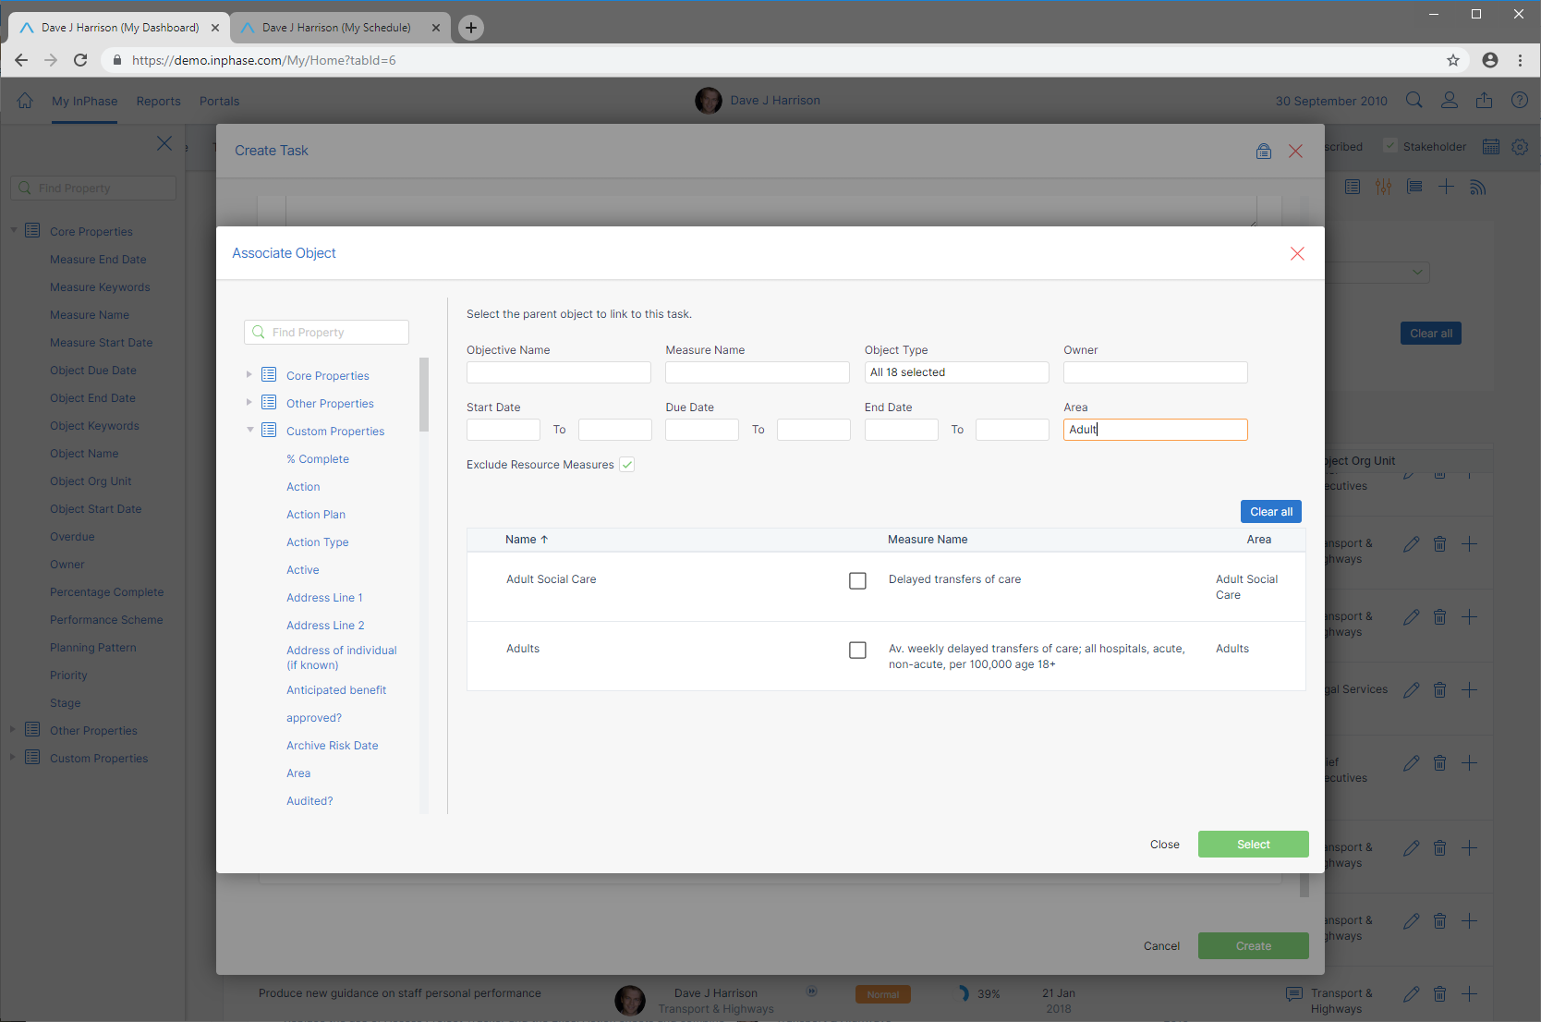

Permissions
By selecting the lock icon you can assign permissions – for example, to enable other users to update your new Task.

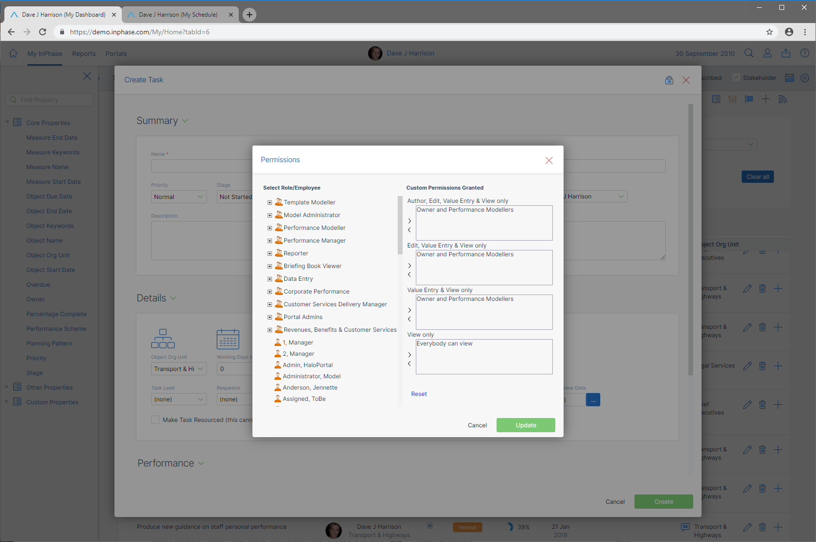

Reports

InPhase built-in Reports are a very low administrator workload route to enable users to access instant reports for all the information in InPhase using standard layout reports.
Whilst these can never replace the Custom Portal pages of dashboards and reports that can be designed in InPhase, the built-in Reports provide a core capability to see each item type in your InPhase by each Organisation Unit and its sub-units for a range of standard reports.
The library of reports will be extended in future releases.
Built-in reports are accessed from the Reports menu.


The submenu provides access to the report choice navigator, the Organogram, and selection of the object types in your model
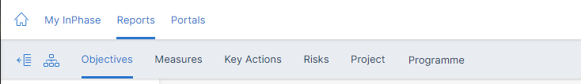
On the right hand of the sub menu is the Org Unit selection
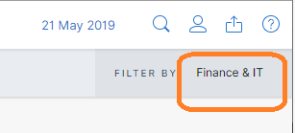

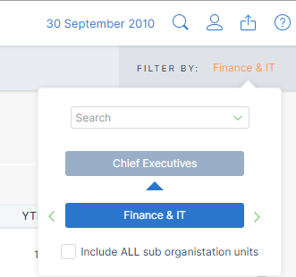

Select a Report, the object item type, and the Org Unit, to retrieve the reports available.

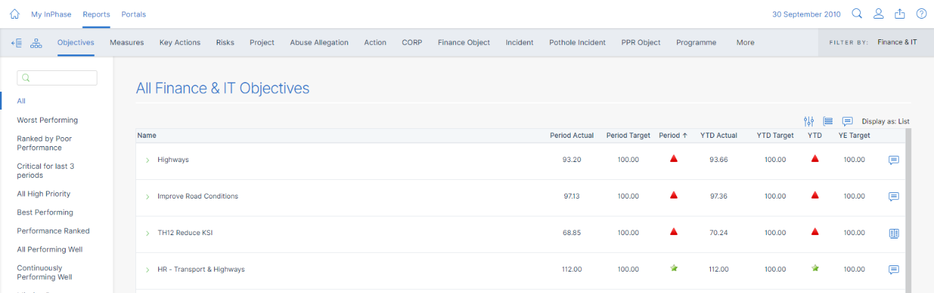
Example: All Finance & IT Objectives - by selecting the
- All report
- for Objectives,
- with the Org Unit of Finance & IT.

Many Reports have their own additional options including filters, group by, sort by, and choice of display styles including List, Gantt, Kanban Charts, and within Kanban charts, Kanban by Priority, Owner, or Stage.
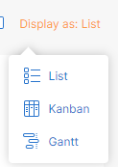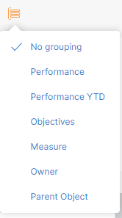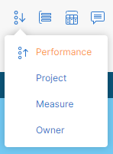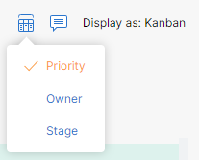
Key Actions by Stage, Kanban 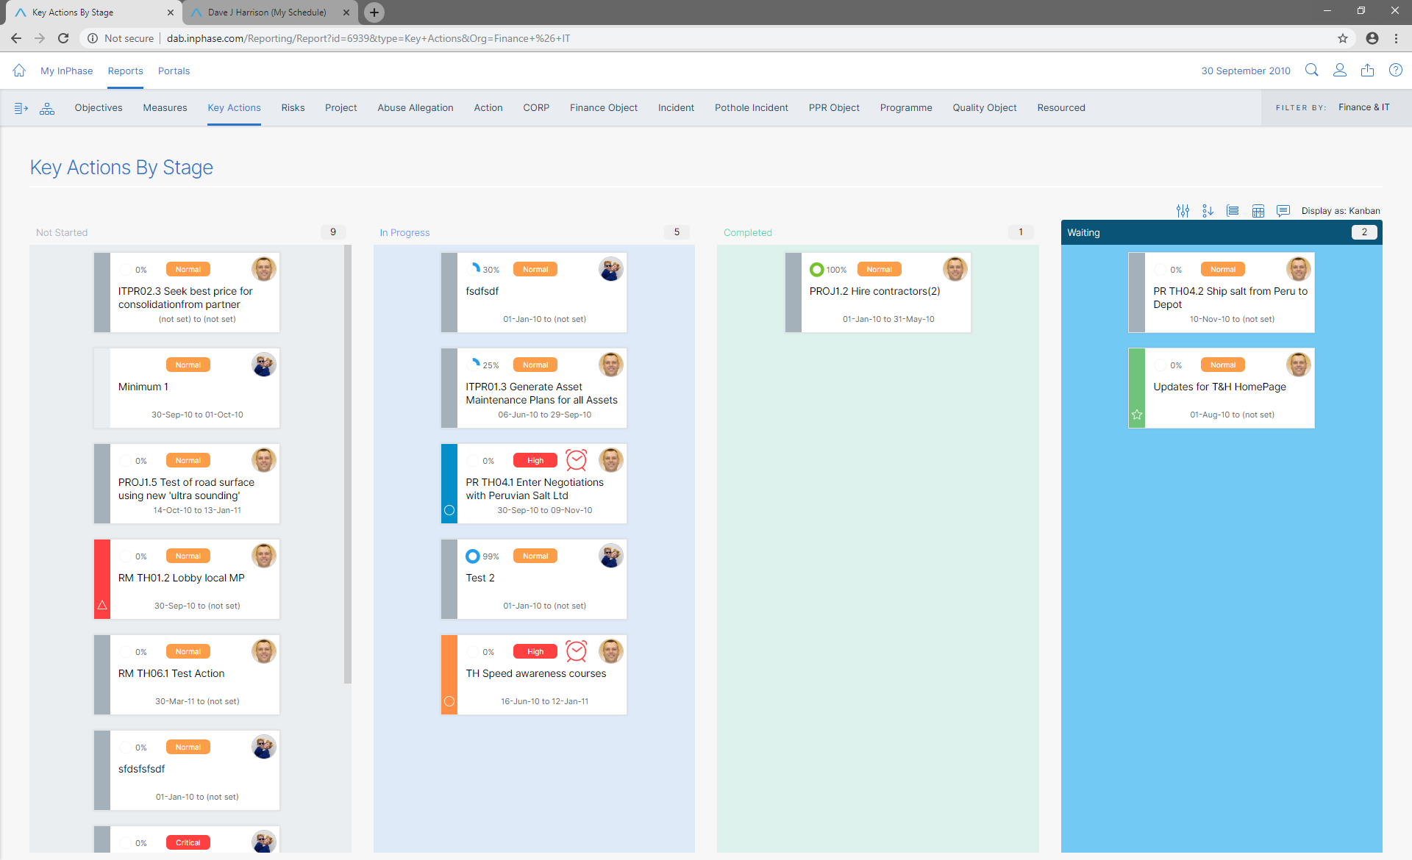
Projects by Stage, grouped by Performance
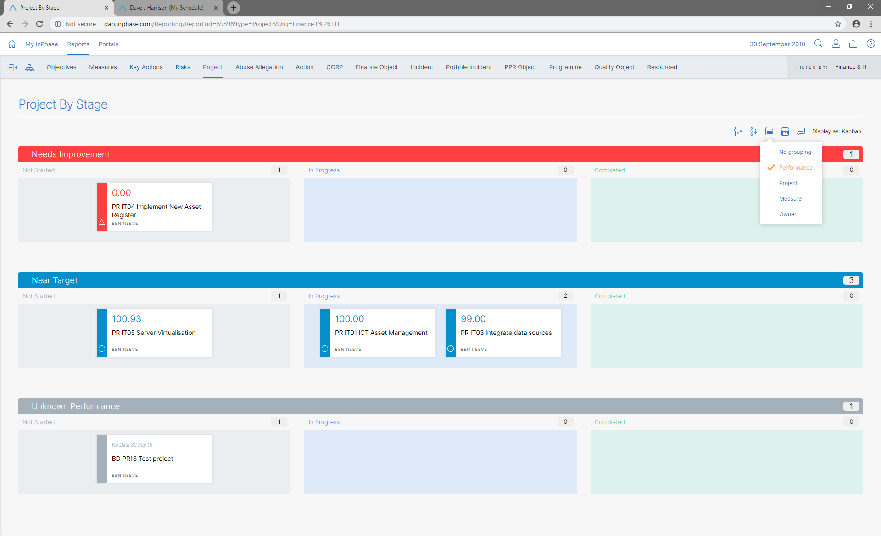
Explore them all!

Here, as in every part of InPhase, including in your Custom Portal widgets, double clicking on any item’s data will immediately provide the user with the Performance Details pop-up. Giving full access to Performance analysis over time, regression and predictive forecast using Winter’s Seasonal Regression, discussion panel, measure cards, Actions Gantt, Action Critical Path, Impacted on performance cards, Key Drivers performance cards for driver objective, measure, projects, risks and other object types, and access for create new tasks, as appropriate, all based on InPhase permissions.
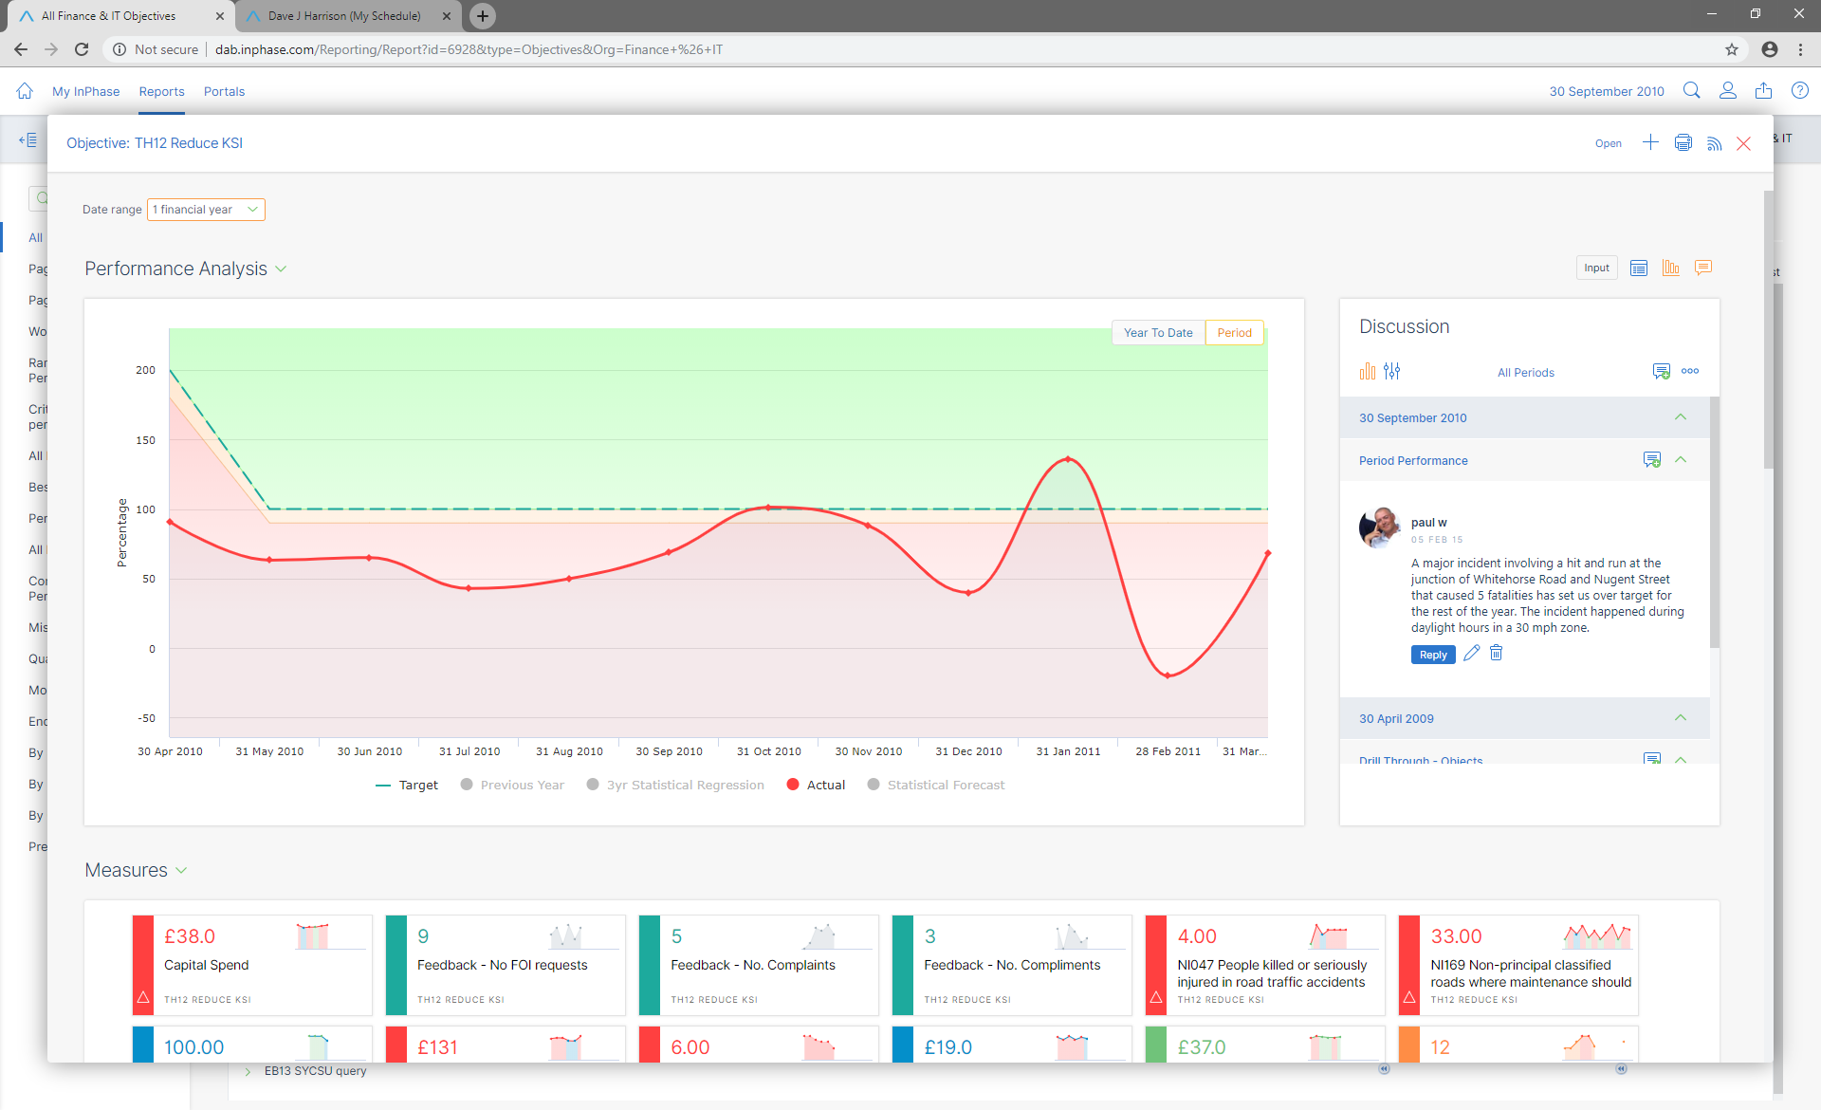
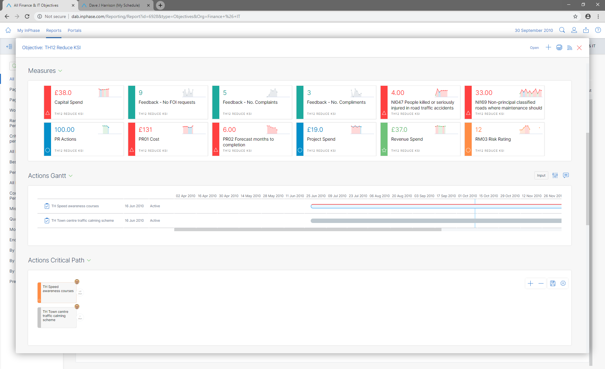

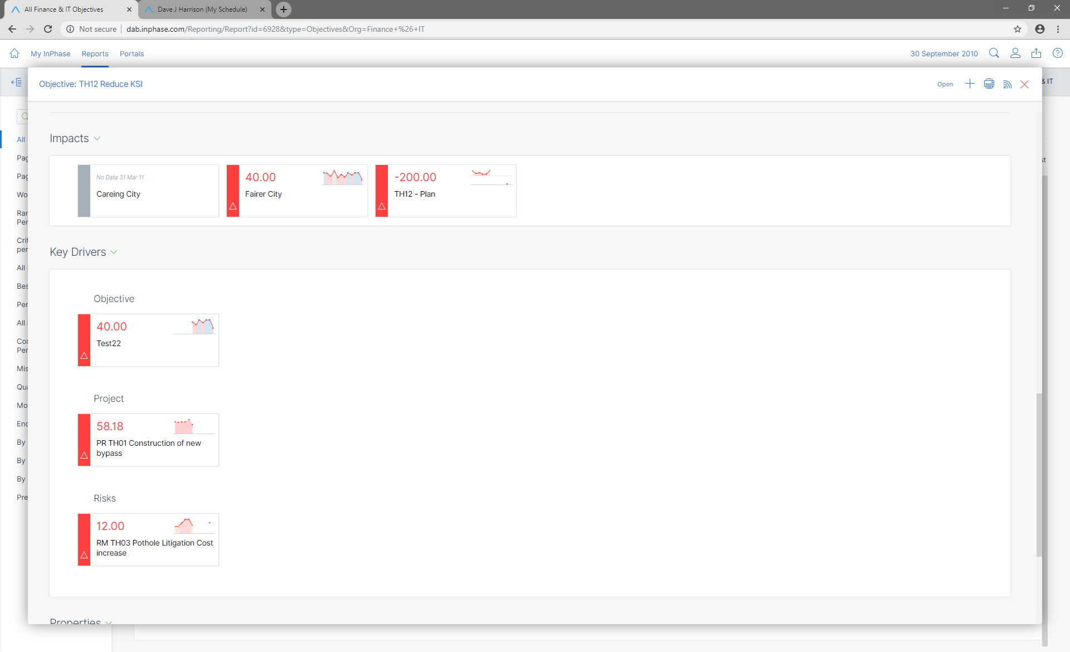

Organogram
Built in Reports are driven by the new Org Unit hierarchy which is a progression from the flat list of Department names in previous versions.
Selecting the Org icon gives you access to an Organogram which any user can see and that the Administrators can use to structure the hierarchy, assign people to the right Org Unit, and access all users’ Profiles rapidly.

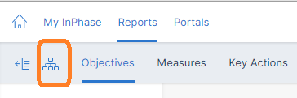

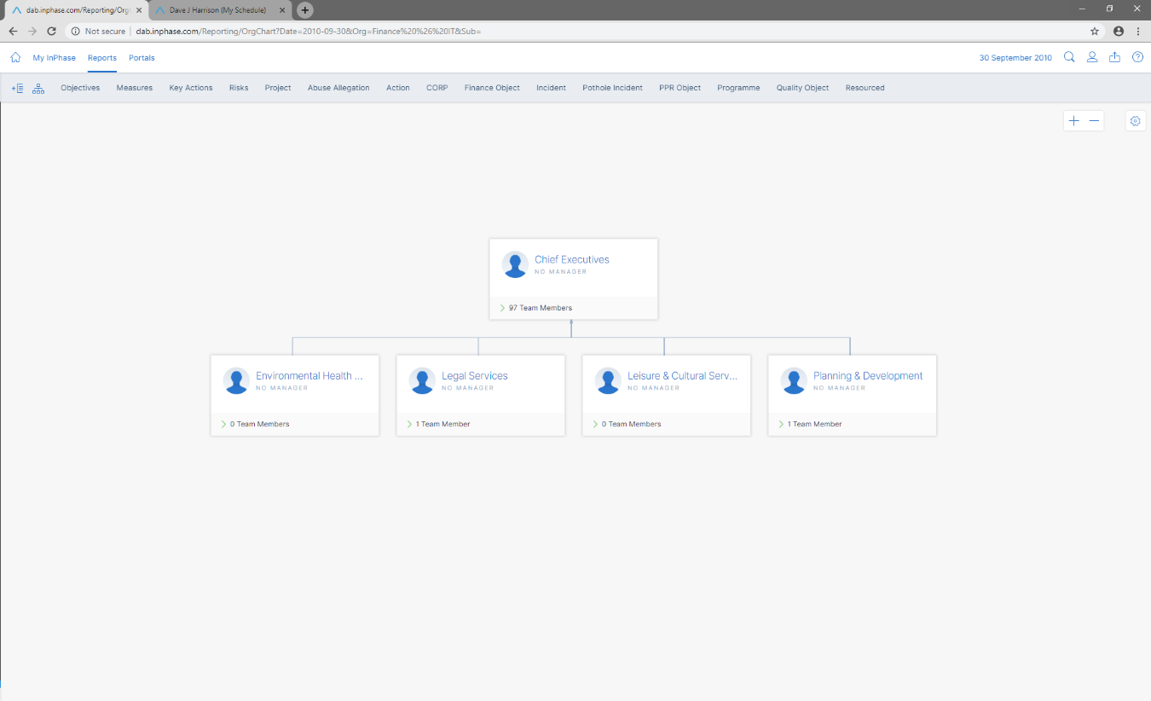
Clicking on the Team Members expand icon lists the staff in each Org Unit
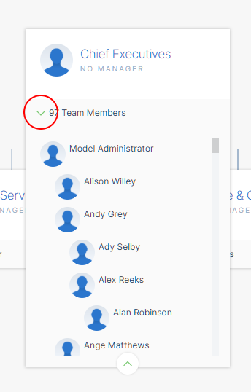
Staff can be dragged form one Org Unit to another to update their Org Unit.
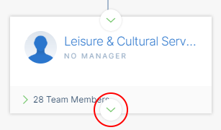
Click on the children expand area to expand the Organogram
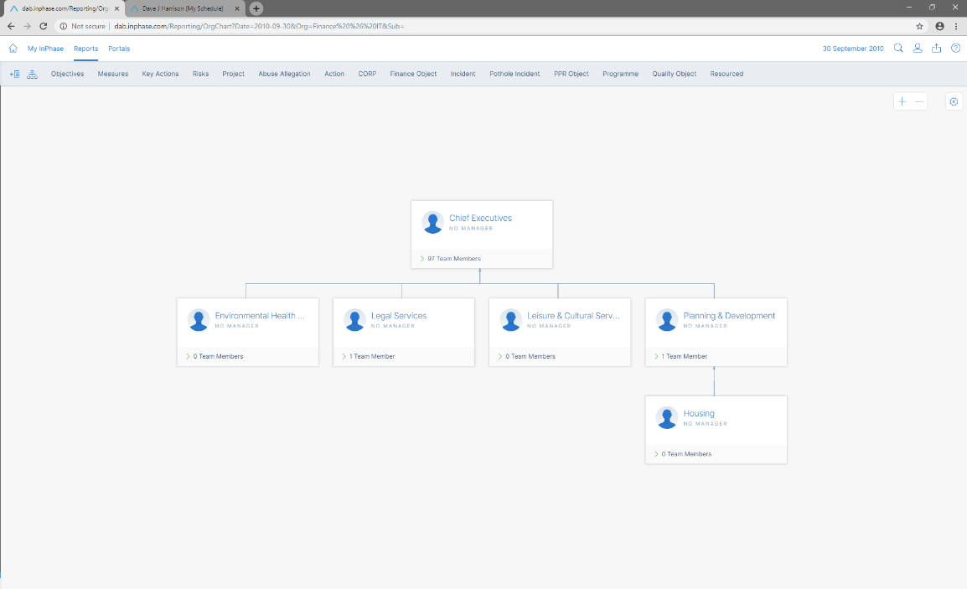
Context Menu (right mouse click) and top right Zoom, Styling and Linking menu, provide access to the features.

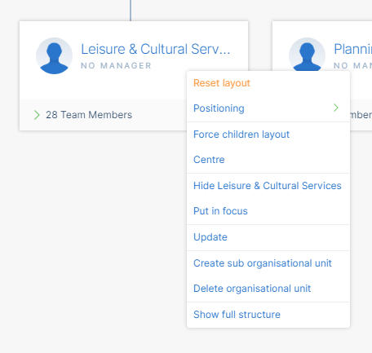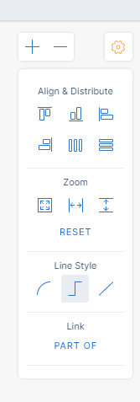

Portals
The Portals Menu provides access to all your Custom Portal books and pages
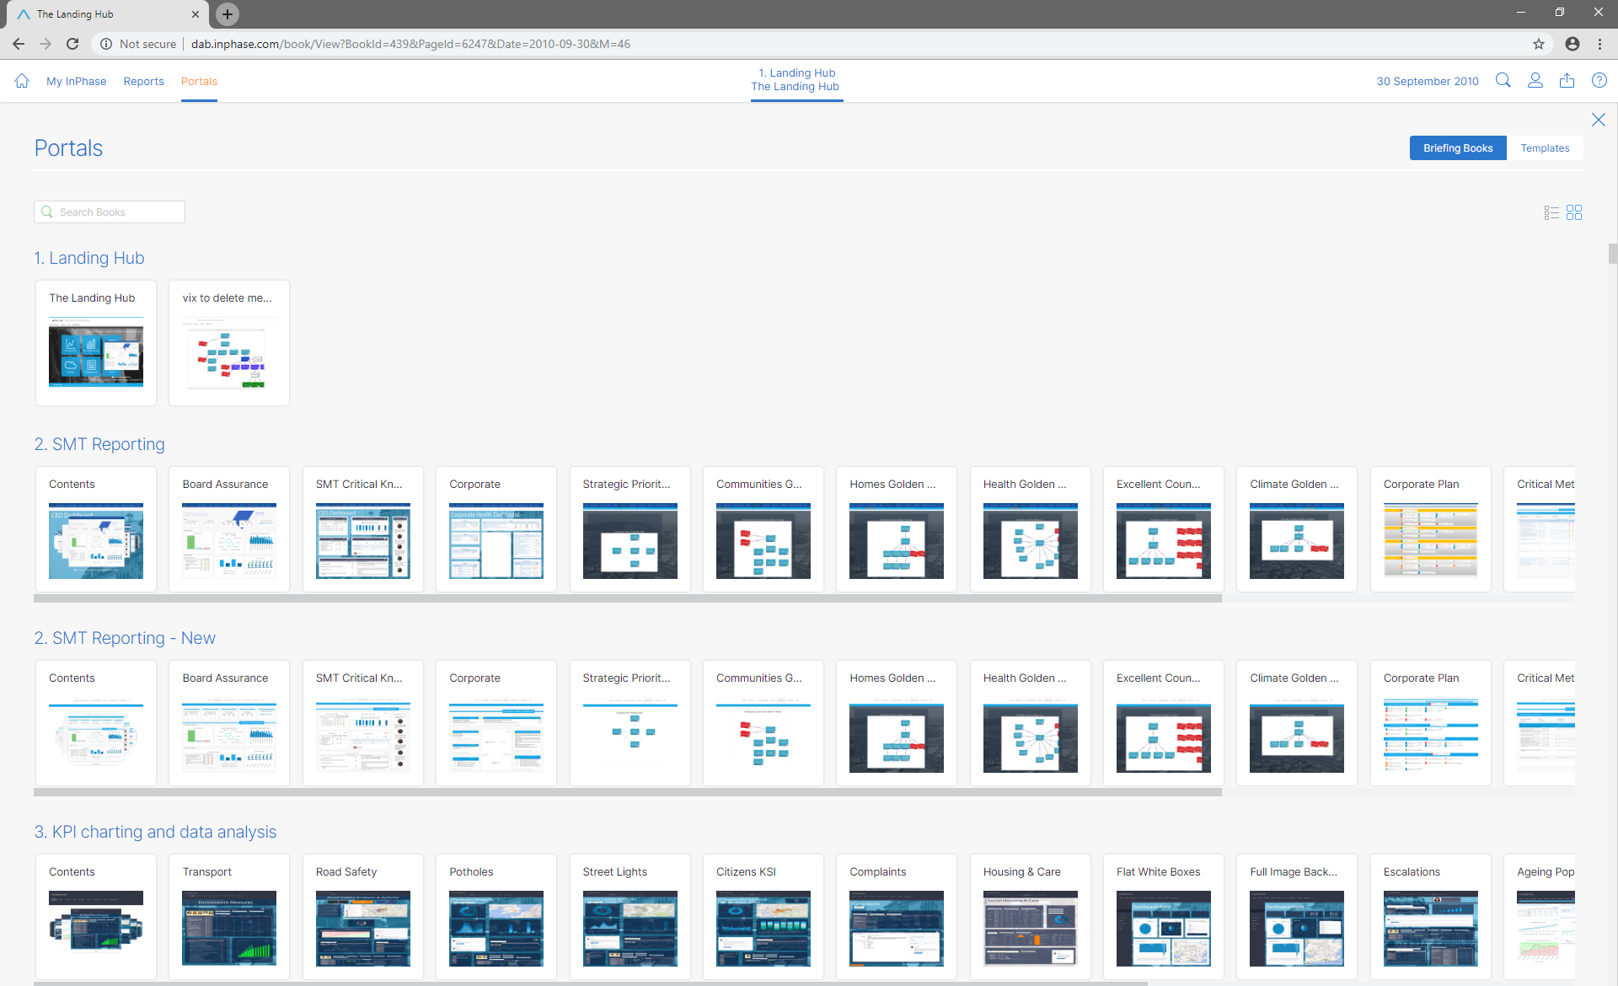

You can select List or Thumbnail view
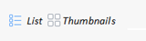

If you want to limit which Books are displayed for which users then you can use the Briefing Book Permissions settings. For example, if you set View Permission on a Book to Reporter, Owner and System View, then BBK viewers will not see it, whereas Reporters and above will see it and see the page images.
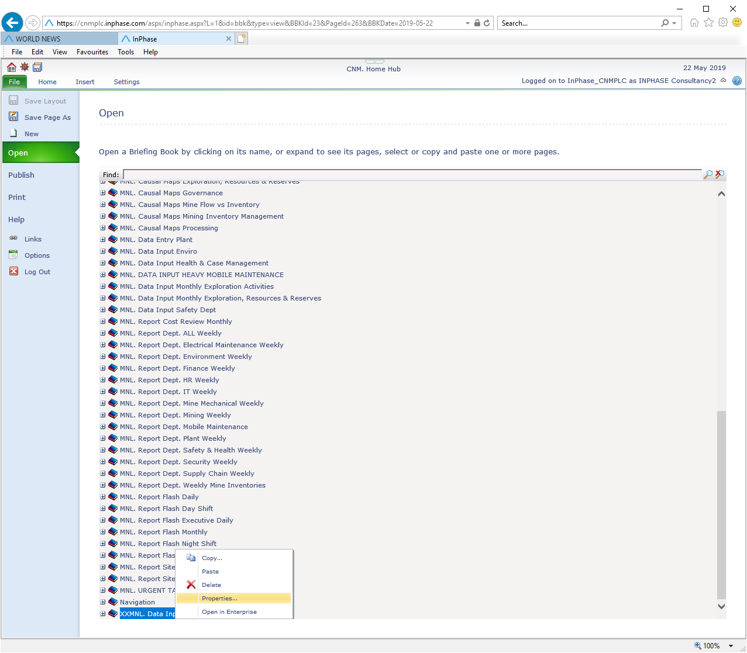

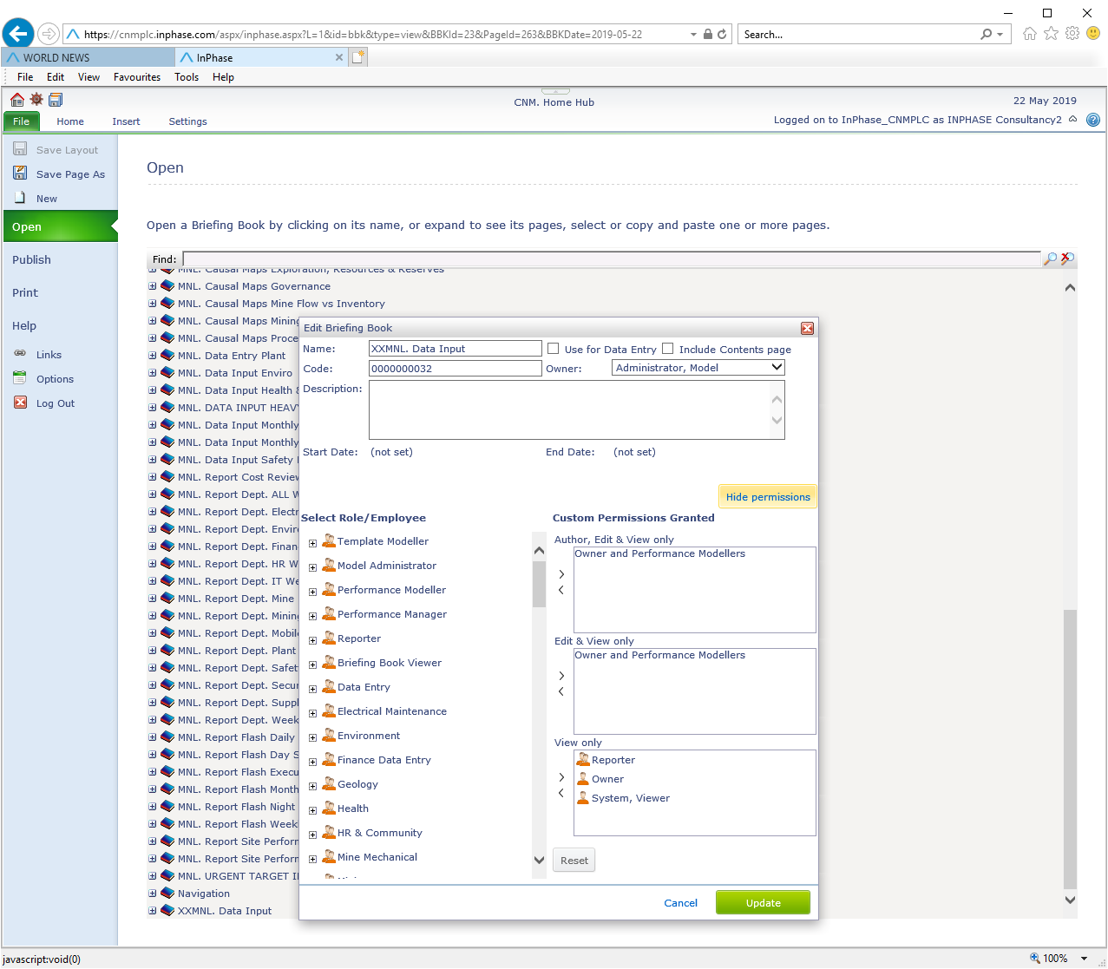

NOTE – if you don’t add System, View – then everyone will see the book as a Padlock.

Transferring Ownership of an Action / Task
If a user has a role of Performance Modeller or above then they can transfer ownership of a Task to other users, regardless of whether the Performance Modeller was the creator of the Task.
Things are slightly different for Book Viewers, however. A Book Viewer can create a Task and then assign the Task to other users. However, a Book Viewer who has had a Task transferred to them will not be able to reassign that Task to someone else; only the Book Viewer who created the Task can change the owner of the Task. You cannot pass a Task you have been assigned to someone else without involving the Task creator.

Subtasks

Create a Subtask
Any number of levels of subtask can be created. Tasks and subtasks can be created in many places throughout the application. To create a subtask in the Task Notebook click on the plus icon near the bottom. This will create a new task and associate it as a subtask of the current task. There is also a ‘Create Resourced Task for Object’ action available in the Dimensions picker which can be inserted into any Trend Table. Tasks can be created from any Details pop-up. Tasks can also be created directly from My Page.

Delete a Subtask
Subtasks can be deleted just like any other task.
Tasks can be deleted in the Task Notebook and in the Properties Panel
When a task is deleted it will automatically delete all of its subtasks that are not associated with any other parent tasks or objects. If any of its subtasks are associated with another task or object then they will not be deleted; they will just be unlinked from the task you are deleting. If you do not want to delete the subtasks of the task you are deleting, then you can choose to automatically unlink the subtasks instead of deleting them.

Unlink a Subtask from a Parent
Near the bottom of the task notebook, in the ‘Part of’ section, you will see all the other objects that the task is associated with. Parent tasks have a task icon next to them in the list. Simply click on the unlink icon to bring up the picker and choose which tasks or objects to unlink the task from.

Linking to Multiple Parents
If you have an existing task or subtask that you want to link as the child of another task then you can do this in the task notebook. Just go to the ‘Part of’ section near the bottom of task notebook and click the link icon to bring up the picker. Then choose the task that you want to make the existing task a child of.

Aggregation of Dates
When a task has subtasks then its start date, due date, and completion date, will all be aggregated up from its subtasks. The start date of the parent task will therefore be the earliest of the start dates of its children. And the due date and completion dates will be the latest of the due and completion dates its children. You cannot specify start, due, or completion dates in a parent task. When you add children to a task, the task’s existing start, due, and completion dates will be overwritten by the aggregation from its child tasks.

Task Dependencies
Only tasks that are bottom-level ones can depend upon completion of other tasks. A bottom-level subtask can depend upon any other task, including top-level ones. However, tasks that are not at the bottom-level cannot depend upon other tasks. Nor can they have their start, due, or completion dates modified. This is because these dates are aggregating up from their children.

Task Earliest Start Date
Tasks that depend upon the completion of another Tasks can now have an earliest start date. This means that the Task will not start until the specified earliest start date even if the task it depends upon completes sooner.

Task Lead Time
Tasks that depend upon the completion of another Task can now have a lead time set. This means that there is a specified delay between completion of the first task and when the second task will start.

Task Minimum Duration (Working Days)
When a Task has its first child added, the current duration of the Task is stored as its Minimum Duration (Working Days). This prevents the Task from collapsing to the end date of its children where the child’s duration is shorter than the parent. This assists with building Tasks from the top down, where you know there is at least x days of work, but you are in the process of building out all the child Tasks. At any point the Minimum Duration can be changed by the user, to either remove the minimum and let its be controlled by the children or to set a different minimum. This setting will not change the fact that the start date of the Task is aggregated from its children.

Aggregation of Resourcing (where this option is Licenced)
Tasks can aggregate their resources, as can Projects, Objectives, or any object that is activated with Resources.
Where the Resources option is Licenced, each Task, objective, project or other object type can have expenditure and people time and costs associated to it.
The resources will aggregate from the lowest level recorded to the highest level of parent item incorporating any additional resources at all levels.
People resource can be configured to report by time or by time and cost.
Asset resources, such as meeting rooms etc, can also be assigned.
Reporting resource plan, and actual for the combined and at each level is supported.

Notifications by SMS (where this option is configured and SMS service is activated by the Customer)
As well as Email notifications, users can now be notified by SMS messages. Individually set notifications per measure and generic Task notification (Task creation and new commentary, change in estimated completion date) by SMS.
This feature can be activated by contacting InPhase.
SMS messages are sent to the mobile number that users configure in their user profile under the ‘Details’ tab. Under the ‘Notifications’ they can select which generic Task notifications they are interested in receiving. Note, these options are only available when the feature has been activated. The SMS service is provided by a third party and is a payable per message service.

InPhase Actify - Office 365 Outlook Add-in
Create Key Actions in InPhase from within Outlook, with auto population of Key Action fields from email content. Simply download the InPhase Actify Outlook Add-in from the Microsoft Office Store. Office 365 is required to use the InPhase Actify Add-in.

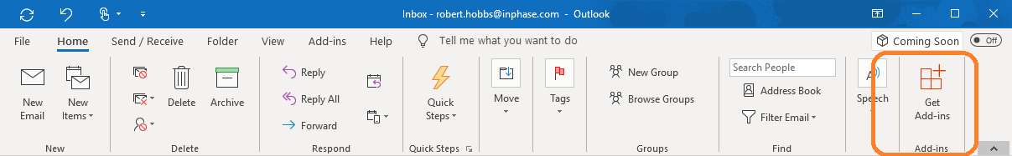
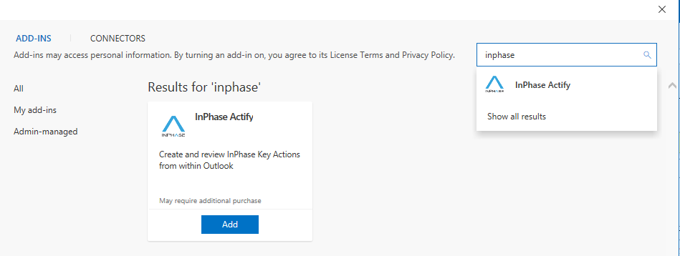
Key Actions created from within Outlook are associated with the email thread in which they were created. At any time you can go back and see the Key Actions you created, including their current status and progress, within InPhase and within Outlook.
To use Actify you must have Office 365 and your InPhase installation must provide InPhase over HTTPS. All hosted InPhase installations provide HTTPS access.
See the in-App help in Actify for more details on how to use Actify.
Please note that if you wish to use Actify with shared Outlook mailboxes then you must currently use the online version of Outlook 365. Support in the desktop version of Outlook for allowing add-ins to work with shared mailboxes is a feature that Microsoft are currently working on.
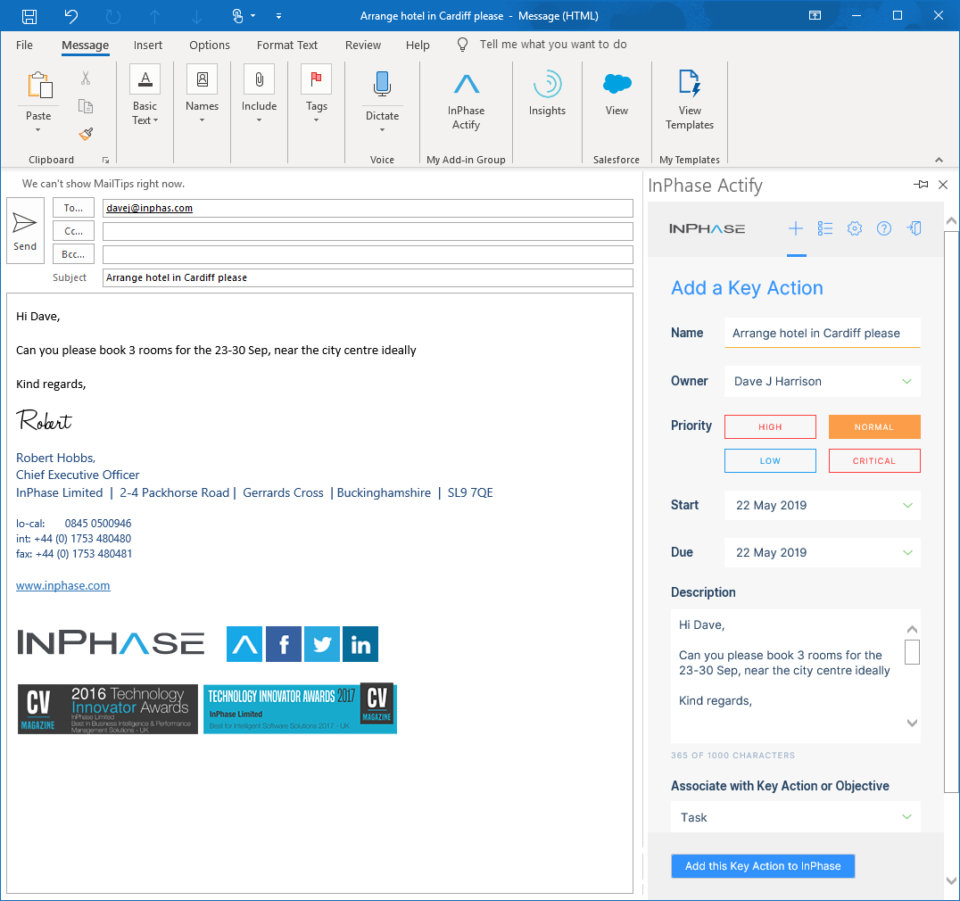

Visualisations
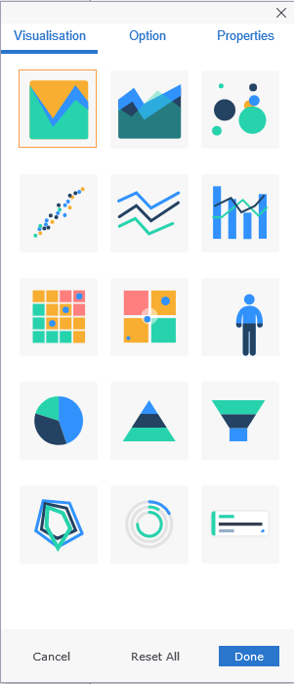
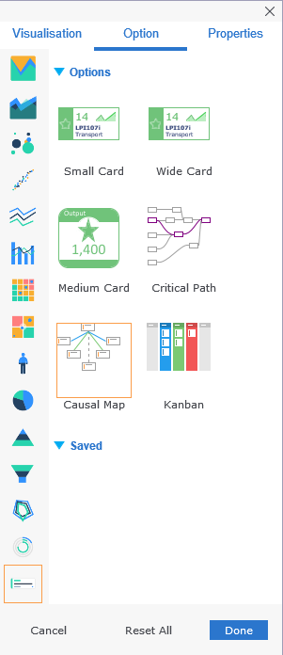
New Card options: Wide Card, Causal Map chart, Kanban

Wide Format Card
There is a new wider format card accessible from the chart designer. This is similar to the cards that display in the Public Portal (previously known as Citizen Portal).

Causal Graph
A new visualisation in Trends. It displays all selected content of a Trend Table is a linked causal map chart.
- Display Objects, Measures, Tasks
- Create links (Part-whole/Other/Task Parent-Child)
- Delete links
- Animated layout on load
- Auto layout using basic tree
- Zoom, move, align, multi-select (hold ctrl)

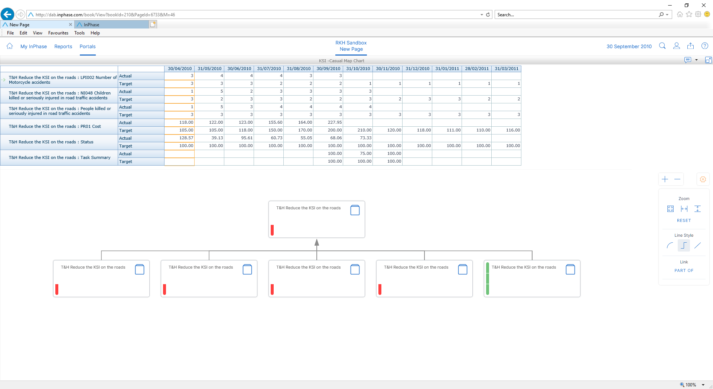
Tools available in Enterprise for zoom, alignment, line style, link.

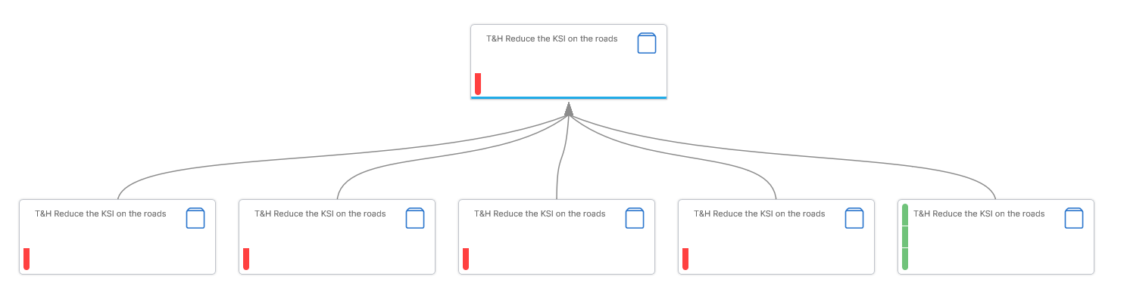
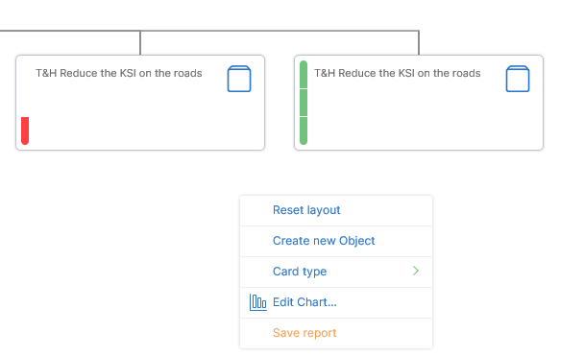
Context menu in Enterprise Save, Create and Link of Objects.
Card Type options, keywords, large, medium and small card styles.
Saves as a Trends Report.

Existing Causal Maps (provided by ActiveX in Designer) can be converted to an interactive Causal Graph using the right click menu in Enterprise. This will reload the Objects in the new Causal Graph. The new Causal Graph is not a perfect replication of the Causal Map which means there will be a few inconsistencies such as no background images and the object shape is based on the default keyword, ignoring any shape settings applied in the Causal Map.
Model Administrators will be able to save the Causal Graph over the original so that it opens as an interactive Causal Graph for all users on page load. If the original Causal Map in designer is saved, the enterprise version is reverted to show the Causal Map image.

KANBAN
The Kanban display style is very useful in Action and Task reporting, but also quite useful for any other type of item.

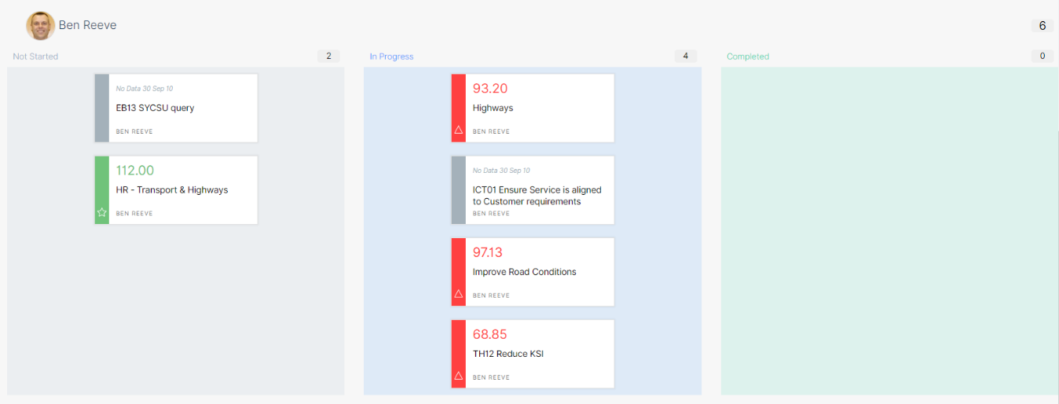
Kanban layout options enable many different grids to be displayed.
Cards can be dragged from one grid into another grid, and any Property that is determine by the grid such as Stage or Owner, will be modified, provided the user has permission to change that property of the object.

Trends – Charts
- Pie – Ability to control distance of labels

Trends – Gantt
Updated visual style and handling of Task parent/children.
Bar colour:
- Grey – Not started
- Blue – In progress with centre fill to show % complete
- Green – completed
- Purple – any other state
- Top red line – running late or estimated to run late based on Due/End date
- Thin red to current date – late, since it is past the end date, but not set to completed
Due diamond icon:
- Blue with white filling – The Due date
- Blue and red with white filling – The Due date, but late or estimated late
- Green filled with tick – completed
- Green and red with red tick – completed late
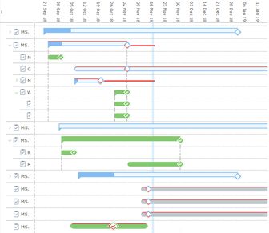
When Tasks with children are expanded lines are drawn to show which child tasks belong to the expanded Parent Task.
Performance improvement if ONLY displaying Gantt.

Gantt baseline
Ability to set a Baseline for Start/Due/Planned End dates. Each Object only has ONE baseline and it can be baselined multiple times, overriding the stored baseline. To Baseline an Object and ALL descendant tasks use the Baseline Dates action button in a Trends.

To view the Baseline on a Gantt either:
- turn it on via the Series in the Trends designer, or
- in the Dimension Picker under Report Controls, add the Gantt Baseline option to the Slicer area of the Trends. This allow an end user to turn it off/on.

The Baseline is show under the current active bar as a slightly transparent dark bar which has its own tooltip for further info:
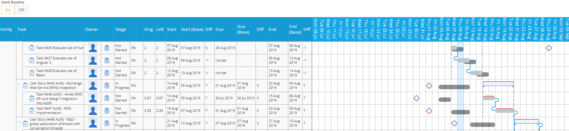

Gantt History
Ability to view what the Gantt would have looked like at a specific date e.g. if I was looking at the plan at the beginning of Last week, how does it compare to the current plan.

To view the historic view on the Gantt:
- in the Dimension Picker under Report Controls, add the Gantt History option to the Slicer area of the Trends. This allow an end user to choose a single date to view the plan.

The history is shown under the current active bar as a slightly transparent orange bar which has its own tooltip for further info:
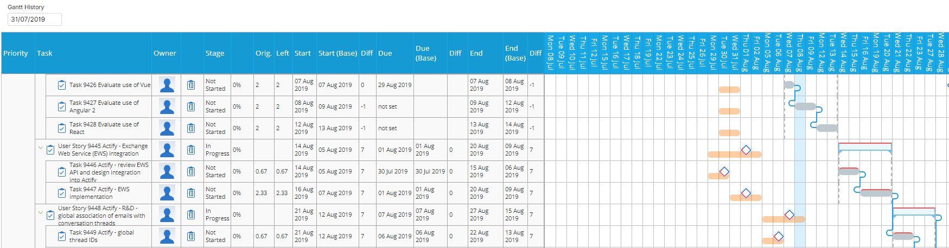

Trends - Widget Title Menu

Property Picker – Dimension Panel
The Property Picker also known as the Dimension Panel is now available as a Widget Title menu or icon item. It now searches any part of the property name, no need to prefix with “*”, and auto expands the root elements on search.

Search and Add
Trends Table can now have items added to it within Enterprise. The report definition can be Saved by suitably permissioned users.
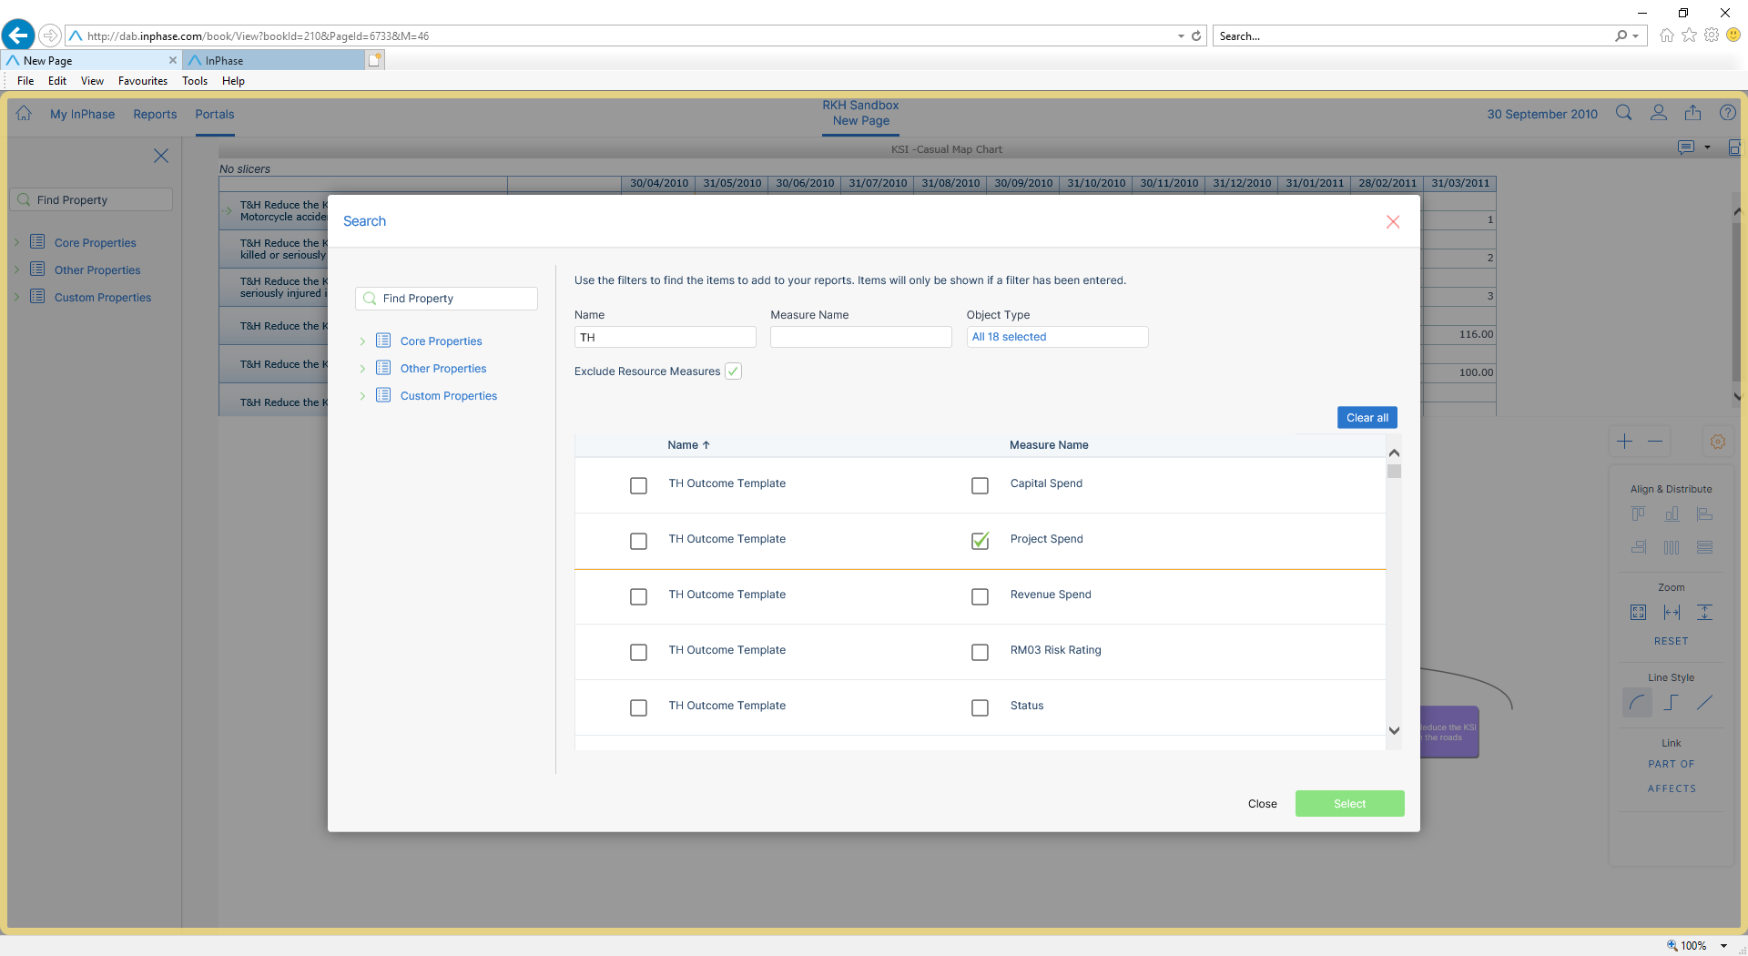

Sunburst
Ability to set the label to any property of an OM.
When displaying a large number of segments at level 1, the border is removed so you can actually see the colour, not just the white border.

Measures
FINANCE
Option to use “0” as default for all periods without values. These zero values will be aggregated as though they were entered by a user. Useful for cost measures, zero based budgeting, and ‘null’ import situations.

New options for Derived Measures:
Remaining – Sums the values from the source Measure(s) from the period to the Model End Date/source measure end date. Useful to show remaining cost/time for a Project. Once the Period End Date has past the period will no longer be updated, thus locking the value. This then provides the historic estimate of remaining. It will read the source Measures’ Forecast values if available, otherwise it takes the Target (PLAN1) value.
Remaining FYE – Sums the values from the source Measure(s) from the period to the Financial Year End. Useful to show remaining cost/time for a Project. Once the Period End Date has past the period will no longer be updated, thus locking the value. This then provides the historic estimate of remaining. It will read the source Measures’ Forecast values if available, otherwise it takes the Target (PLAN1) value.
Wildcard – Derived Measures using sum/average can use a WILDCARD to match other Measures in the same Object and use them as its donor. Automatically picks up new measures.

Series
Forecast Series – now is overridden with the ACTUAL value once the Period End Date has passed. To activate this, rename a Series in Administrator as Forecast (even if already called Forecast).

Baseline
Baseline Series – Series used to hold a copy of the Forecast. Use with the Action button in Trends to copy the Forecast series period values into the baseline series period values. The values are stored at that level and are not aggregated from children. This then acts as a baseline for the Measure to be able to compare current values with the historic estimates. If there are no Forecast values, the Target series is used. To activate this, rename a Series in Administrator as Baseline (even if already called Baseline).

Resources (App-in for InPhase)
Resources allow the tracking of time and cost of three different types of resource:
- People – Track the time spent per person per day. Each person has a Cost Per Hour which is used to calculate the cost per day and cost per month.
- Asset – Track the time using an Asset (Meeting Room, Vehicles, Projector, Digger etc). Each Asset has a Cost Per Hour which is used to calculate the cost per day and cost per month.
- Expense – Track direct costs per Month of any other expenditure – e.g. contractors, travel costs, purchases etc

All object types support resourcing.
Create your Tasks and assign the required resources. All resourced parents of the Tasks (including parent Tasks/Projects) will automatically have those resources added and will sum the Total for each resource. This allows a high-level view of the costs (money and time) with the ability to drill down.

Baseline Series – (See Series)

Criteria
New Criteria:
- All descendant tasks – all child tasks of the object and all their child tasks (recursive). Does not look at any child Objects’ children.
- All descendant leaf tasks – processes all Tasks below the object recursively and returns all Tasks with no children (i.e. the leaves).

The global filters now respect the Object Type – e.g. only run filter against Risk objects.
If using nested Parents Of/Children Of, these are retained when using linked frames to set the Object/Measure in focus.

Freeform

Enhancements
- New options on Hyperlinks:
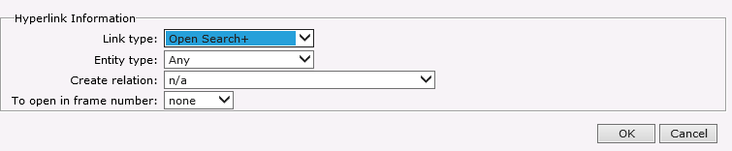
  - Open Search+
Opens the Search+ dialog with the ability to select the object type filter, create a relation to the selected object to the Object In Focus (set with linked frames/Master View) and a frame to add the object to.

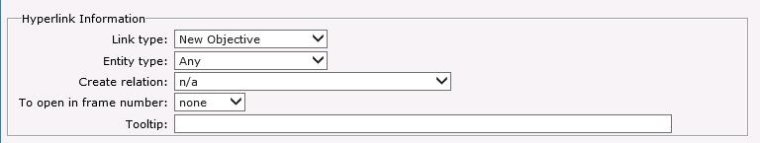
  - Create Objective
Now has an option to create a new object with a relationship to the Object In Focus (set with linked frames/Master View).

TABLE REPORTS

Trends
Enhancements
- New text Slicers type: wildcard filter
- Drop down slicer has text box to allow filtering of options
- Application level Option to display time units as HOURS and MINUTES where the time is stored as hours (1.5 = 1 hour 30 minutes)
- Application level Option to display time units as HOURS, MINUTES and SECONDS where the time is stored as seconds (3662 = 1 hour 1 minute 2 seconds)
- Group “header” can be at top or bottom of the group
- Ability to Format specific Row Header/Contents
- New Dimensions
  - Overdue – “”/”Overdue”/”Estimated Overdue”
  - Parent of Type – Displays parents of the specific type. If this is used as a series, then input mode allows the user to select parents filtered to this type. This will not affect parents of other types.
  - Ancestor of Type – Displays first found ancestor of the specific type – e.g. from the task you can show the owning Project
- New Action Dimensions
  - Baseline – (See Series) – Copies the Forecast series values to the Baseline Series
  - Copy Series Values – Copies values from the source series to the target series (source/target is configurable). Values are only copied at the level they were entered (Inputted or Imported) and this process will work down through all children. Normal aggregation of values is maintained.
- New Slicers
  - Comments Contents – Ability to search within the Comments of Measures/Tasks in the Trends Report. The report DOES NOT have to show the comments.
- Report Slicers
  - Planning Pattern –
    - Ability to zoom in/out using Planning patterns – e.g. looking at monthly you can “zoom in” to fortnightly. Auto detects the next smallest/biggest pattern.
    - Can also just pick the pattern from the drop down.
  - Report Dates
    - Ability to move the date range to earlier/later, keeping the size of the range the same.
- Speed of entering Input Mode improved.
- If using Page Flow, the Column Headers “float” down the page with you, so you can always see the column headers.
- If any Row headers are hidden (width of 0), there is the option to “show hidden headers” on context menu.
- Option to hide row/columns that have no data in.
- Drill Down to Level X (max 5)
  - Option to open the report with all Object/Measures/Tasks drilled down to level x.
If the item in focus is changed via linked frames then it will be expanded to level x.
  - Option to print the report with all Object/Measures/Tasks drilled down to level x.
- Series definitions now include Limit Roll up. This allows Measures that use a more granular periodicity than the report (e.g. daily measures show in a report showing as monthly in the trends) to only be calculated to the view date. This includes its Performance and can be used as an indication of how the measure is performing against target at the view date, rather than against the target at the end of the rolled up incomplete period. This is a setting per Series:
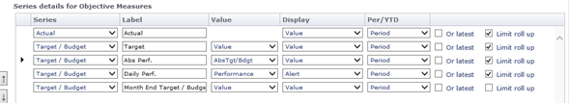​
The above shows the Actual, Target and Performance only being calculated to the View date and also including what the Target is at the end of the month.
This works in conjunction with the Report dates:

Live Connect/Scheduled Import

ODATA
New connector for OData. Includes the ability to cache in a local SQL Database (auto building, InPhase application needs permissions to alter schema) for performance improvements. For example, Acumatica is an accounting system that can be linked to using this ODATA connector.

SQL
When importing, can set an option to force the Live Drill Through to use the Logged-on Users credentials (token). This is useful to import the aggregated values while only allow some users to see specific transaction data.

General Import
Removed the running of Dynamic aggregation due to property change when job is configured to not run dynamic aggregation with value import. This is for when a FULL aggregation is run at the end of the job.
Not logging “value not changed as it was already that value”.

ENTERPRISE – additional functionality previously only in Designer

Object Notebook
Can now set permissions in Enterprise.
Has delete button on popup.

Measures
Can now create new Measures.
Can now add a Measure from the Measure Definition
Can now Clone a Measure. This allows you to select one or more Measures from another Object to clone and add to the current Object. The clone includes:
- Standard Fields like name, description, accumulation
- Custom Fields
- Derived formulas. Any reference to the source Object is replaced with the current Object. If the formula contains references to measures that have not been added to the current Object, the clone will be aborted. You can select the derived measure and all its needed measures from the Clone dialog and add in one go – e.g. selecting the nominator measure, denominator measure and the Percentage derived measure will clone all these measures and the derived measure will be calculated using the current Object’s measures.
Can now edit Measure.
Limitation Note: Cannot create or edit derived formulas in Enterprise mode

Task Notebook
Can now set permissions in Enterprise.

What’s new for Projects Summary

Tasks
Can now have the sub tasks.
- Any number of levels
- Different representation of Tasks with children on the GANTT. If drilled down, dotted lines show the grouping.
- Task with children has its following properties aggregated:
  - Start Date – earliest
  - Due Date – latest
  - End Date – latest
  - Progress – weighted average based on each sub-task’s total days (end minus start)

Tasks Due and End default on new Tasks to the day after the Start.
Tasks now have number of working days (daily planning pattern that doesn’t include weekends or bank holidays) display that can be used to set the End Date.

Changes to Tasks are recorded and reported on the My page:
- Start
- End
- Due
- Stage
- % complete
- Priority

If a Task has >0 % Complete, it cannot be set to “Not Started”.
Ability to set Default Planning Pattern/Performance Scheme. Currently only via Database, please contact InPhase Support.
If the Task’s start/end doesn’t cross a single period for its planning pattern, it now allows input for the period the task ends in.

When a Task is marked as completed and the last Period Value has not been set, it is now set to Green.

New Gantt features showing view date vertical line, % complete progress, late red bar, overdue update error bar.
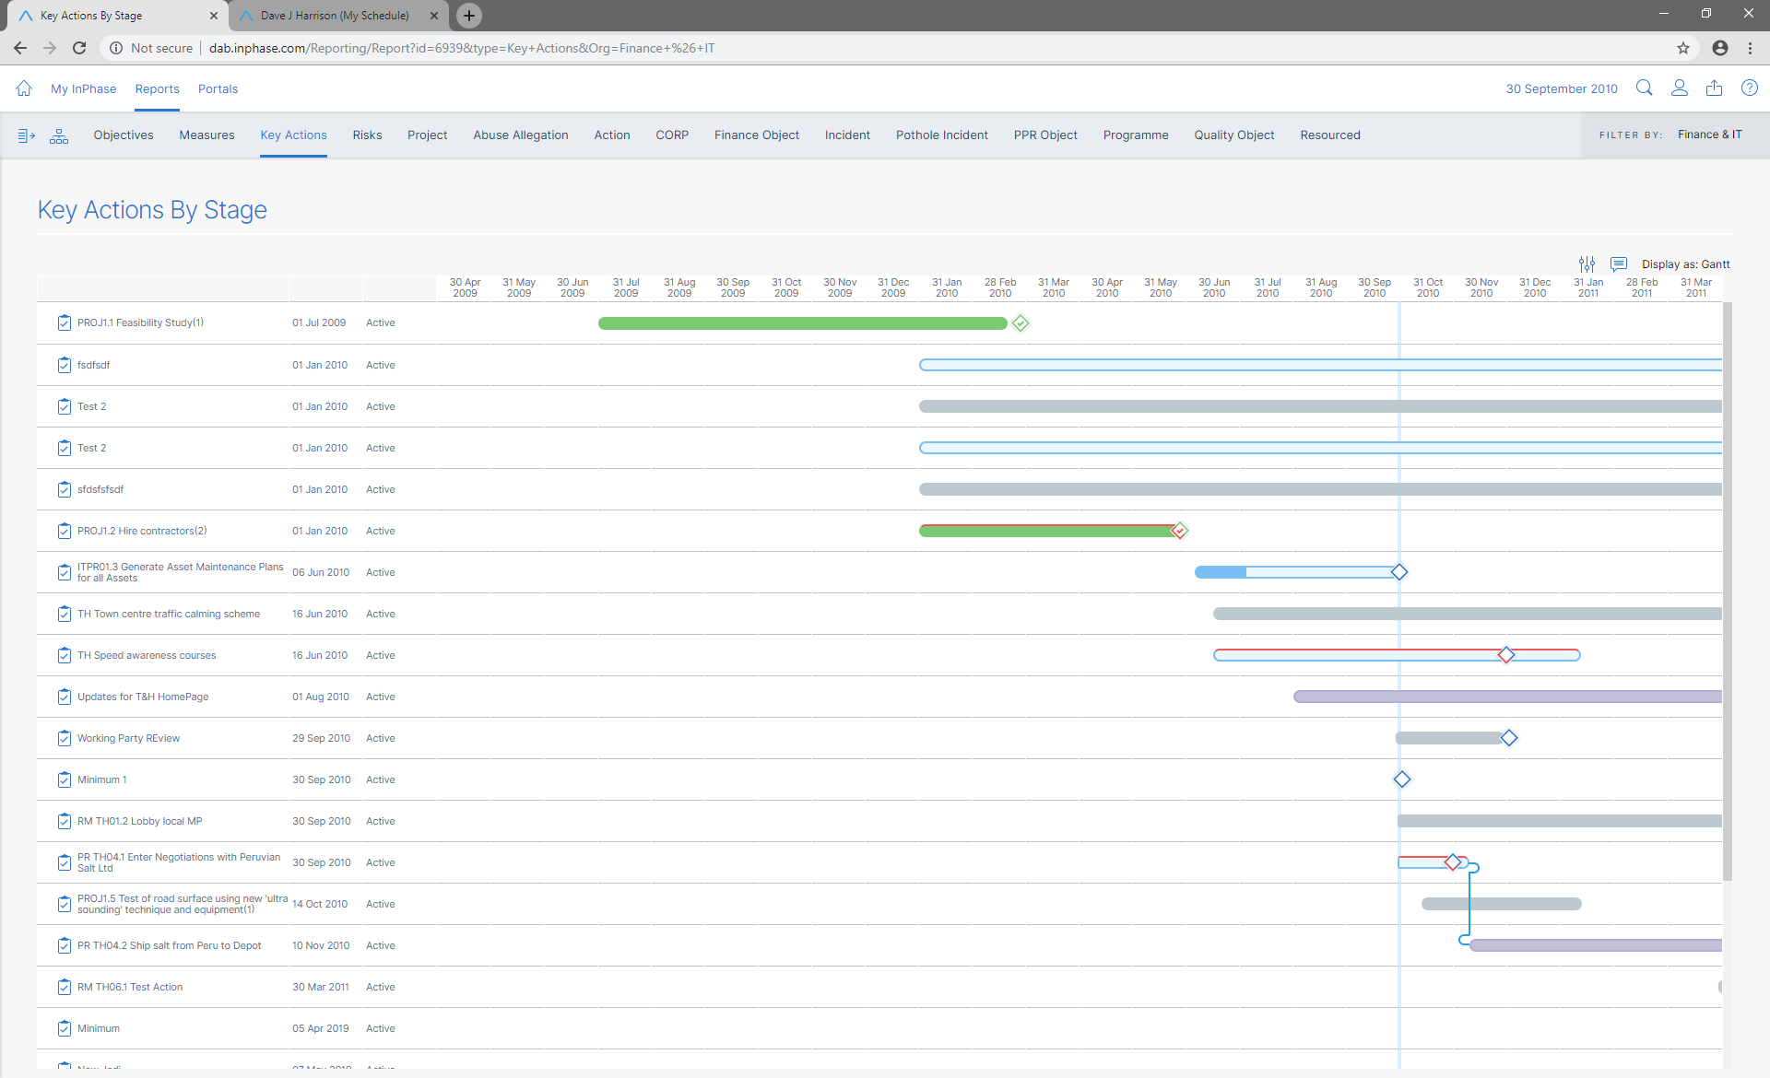
Quick Task Update property panel
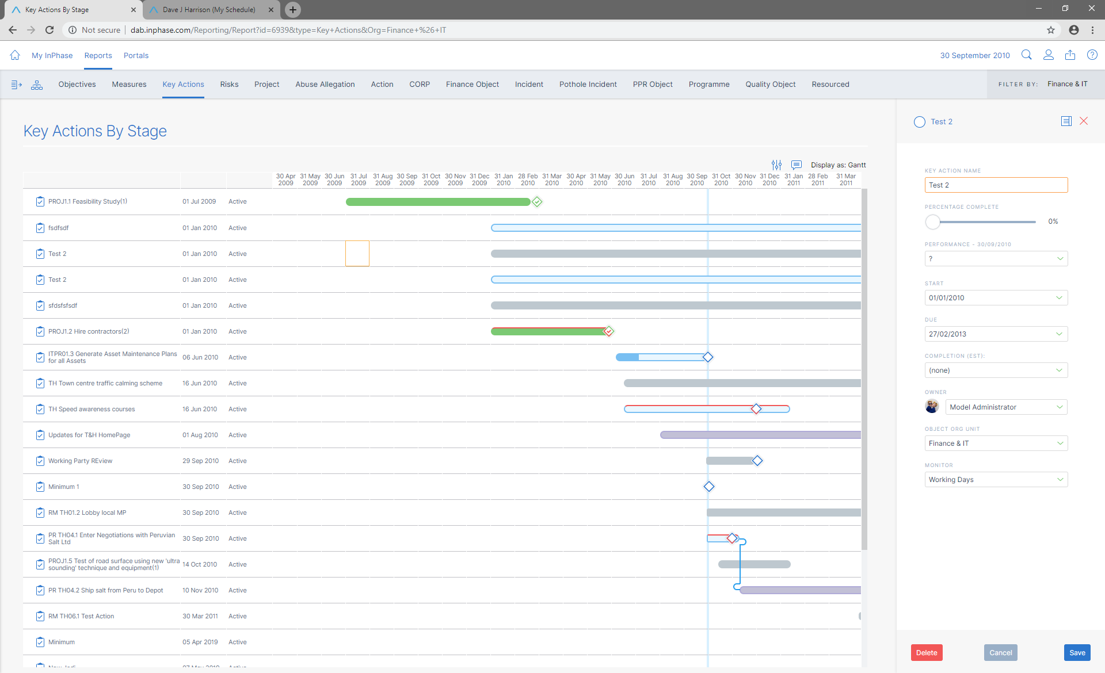
Critical Path Analysis built into Performance Details pop-up where Tasks have dependencies
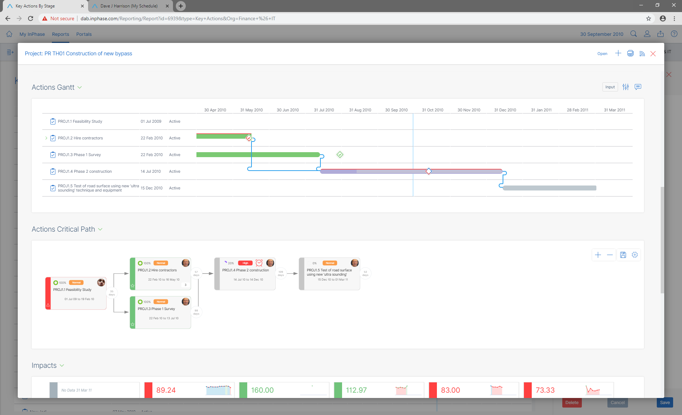

Portal Page Layout

Briefing Book Page
New linked frame option “Master View”. Use a single Trend widget to act as the dataset for the page. Pick either Object or measure with a slicer. This is passed to all widgets on the page. User can print the page for all Objects/Measures in the master view or the current one in focus. Will reduce reliance on “Page Per Measure” where pages are cloned. Use of nested Parent Of/Child Of is useful to get linked entities from different levels.

Page flow for simple page layouts. If the Page only has widgets that do not cross each other vertically, the page can be displayed so all content pushes down to eliminate vertical scroll bars. Where widgets are touch top/bottom they are treated as a single container which allows the second image below. Charts and other visualisations that have no inherent height use the height they were display in designer.
Supported: Not supported: 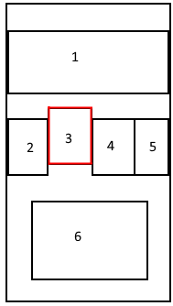
The Page Flow will try to keep the spacing between the widgets consistent with the layout in Designer and will attempt to extract images/text from the Background Freeform to keep in the same location, even though the widget height is now variable. This can be used with Text as headers and images as background for multiple widgets.

General Application Changes

Aggregation
Performance improved:
- Saving updated values streamlined
- Handling large models with many relationships
- For example, 112 mins to 37 mins, reduction of 66%

Employee Name
Now displayed as First Name, Surname

Model End date
Upgrader will automatically populate the Working Days pattern and Monthly pattern to 2030 or your current Model End Date, whichever is earliest.

Critical Path
Now handles Tasks with child tasks. Visualisation of Tasks with children is different from “leaf”. The example below shows that the parent Task is comprised of 9 child tasks and it shows the critical path for this Task.
New options on how to calculate Critical Path:
- To the Object/Tasks in focus (default setting)
- To the Parent Object – e.g. the project.

New Options on what to display:
- Only connected to in focus and child tasks (default setting)
- Show full critical path – all tasks on the critical path are shown. If using calculate to Parent Object, Tasks not directly related to the in-focus item will be shown.
- Show all Tasks for Parent Object – all tasks at all levels for the first Parent Object (non-task) are shown. This could be a large number, so a warning is given.

Example of calculate for Parent Object and show Only Connected:
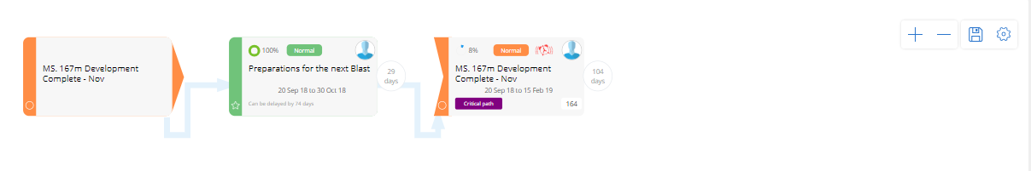

Example of calculate for Parent Object and show full critical:
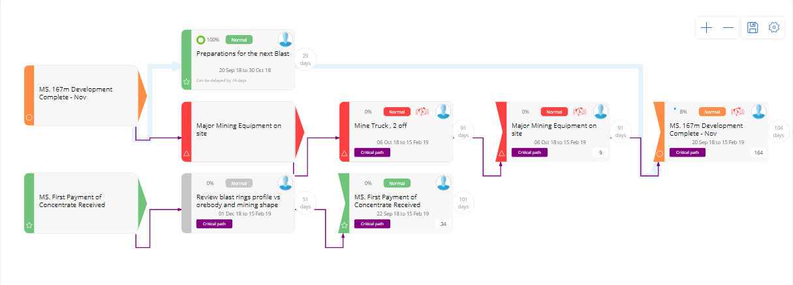

Technical Hardware and Software Requirements
INPHASE has two modes. The main user mode is Enterprise mode, which is optimised for end user response times and runs on all major browsers, desktop, tablet and smart phones.
The other mode is Designer mode, which is for the model building, reports, and portal design and configuration. Designer mode runs on PC platforms only and utilises ActiveX downloads.
Only power users that will use Designer mode require ActiveX downloads.
Unity Enterprise mode summary
- Easy on IT administration; no ActiveX downloads.
- Any browser – organisations trapped in legacy IE can use latest Chrome or Edge.
- More engaging, better looking, faster, more in-built features.
Liberated user – any device mobile data reporting, data capture, data analysis, discussion.

Hardware Requirements
Please note: if you are using a virtualised environment then these requirements must be set as minimum reserved resources.

COMPULSORY TECHNICAL NOTE
There is no virtual environment over-allocation of resource configuration that is approved for INPHASE.

Application Web Server
 | Minimum under 50 users | Standard max 200 users | Up to 500 users**
RAM | 8GB | 12GB | 16GB
Disk | At least 15% free space (min 250GB)  7200rpm or faster  32MB or greater cache | At least 15% free space (min 500GB)  7200rpm or faster  32MB or greater cache | At least 15% free space (min 1TB)  7200rpm or faster  32MB or greater cache
CPU | 4 Core  2.4 GHz or faster | 8 Core  2.4 GHz or faster | 12 Core  2.4 GHz or faster

Database Server
 | Minimum under 50 users | Standard max 200 users | Up to 500 users**
RAM | 8GB | 12GB | 16GB
Disk | At least 15% free space (min 250GB)  7200rpm or faster  32MB or greater cache | At least 15% free space (min 500GB)  7200rpm or faster  32MB or greater cache | At least 15% free space (min 1TB)  7200rpm or faster  32MB or greater cache
CPU | 4 Core  2.4 GHz or faster | 8 Core  2.4 GHz or faster | 12 Core  2.4 GHz or faster

Combined Application and Database Server
 | Minimum under 50 users | Standard max 200 users | Up to 500 users**
RAM | 16GB | 24GB | 32GB
Disk | At least 15% free space (min 500GB)  7200rpm or faster  32MB or greater cache | At least 15% free space (min 1TB)  7200rpm or faster  32MB or greater cache | At least 15% free space (min 2TB)  7200rpm or faster  32MB or greater cache
CPU | 8 Core  2.4 GHz or faster | 12 Core  2.4 GHz or faster | 16 Core  2.4 GHz or faster

Software Requirements
For an application (web) server that hosts the web application with the SQL Server databases hosted on a separate server, the requirements are:
- Latest version of Microsoft Windows, minimum Windows 2008 R2 Server or above including the most recent service packs,
- Microsoft. NET Framework™, Version 4.7.2
- Microsoft Internet Explorer 10 or above

For a database server (not acting as the Web application server) the requirements are:
- Latest version of Windows Server, minimum 2008 R2 Server or above including the most recent service pack
- Latest version of Microsoft SQL Server, minimum 2008R2, or above (Standard edition or higher), including the most recent service pack

For Designer mode use
Microsoft Windows PC Windows 10, 8.1 or 7, Internet Explorer 10 or above. ActiveX download permissions or ActiveX installed via msi.

For Enterprise mode use – main users
Microsoft Windows PC or tablet, Windows 10, 8.1 or 7 with Internet Explorer 10 or above, Edge, Chrome or Firefox,
Apple MacBook, macOS, iMac, with Chrome, Safari.
iPad or iPhone with Chrome, Safari.
Windows phones with Edge.

INPHASE v17 Cloud Hosting
Improve the currency of your version updating and reduce your total ICT costs by using INPHASE Cloud Hosting for v17. Options now available for v17 include:
INPHASE on Microsoft Azure managed servers with high speed servers and 100% redundant failover, includes your Windows Server Licences, SQL Server Licences, disc storage, daily back-up and 14 day retention, full latest version update service within 14 days of release.
INPHASE on N3. NHS N3 options available in partnership with Red Centric data centres.

UK and European, ISO 27001
All INPHASE hosting servers guaranteed to be UK and European based, ISO 27001 security standards, multi-location failover facilities, Tier 1 connection.
All our hosted servers can now support encrypted Live Connect to SQL servers, either in the cloud or on-premises.

INPHASE Microsoft Azure AD and MFA
v17 supports Microsoft Azure Active Directory Federated Services, with optional Multi-Factor Authentication. This can be supported either from our hosted options or from a self-hosted server.

17.5.301
Improvement
- Double Click on Charts to get to the Object/Measures details
- Causal Map line generation for elbows improved
- Aggregation performance improved
- Performance Chart now supports statistics, accessed on the right click.
- Page flow is more forgiving with alignment. Treats widgets touching bottom/top as single column.
- On Page flow pages, Kanban column will stack on mobiles.
- Criteria for Performance can now compare against the Report End Range with or latest. This is useful for filtering against the latest entered even if that period has not been completed while handling other measures that have not be updated.
- Pages using a Page Source widget now add the Object/Measure to the url. This allows refreshing of the page while keeping the same Object/Measure selected. Navigating to another page using Page Source that has the same Object/Measure available will automatically select and load it. This is useful when using multiple pages to show different information about the Object.
- Task Notification now includes links to users home page, My Page and the Task Details page (the pop up on double clicking a Task within InPhase)

Fixes
- Scorecards now have a right click Context menu to access the Notebook/Details
- Mouse wheel now continues to work over charts for scrolling the page
- Series editor handles scenario where selected Benchmark series have been deleted
- Page source in Designer now updates all widgets, not just up to widget 15.
- Kanban with specific colours and no theme no longer prevents saving in Designer (no issue in Enterprise).
- Trends slicers with “List Filtered First” shows all valid entries first, not just the currently selected item.
- Ordering in Trends of merged Alert icons and the ordering of alert series “as Dimension” now show in band order, worst to best.
- Fixed issue with missing data for Task reminders not running due to a time check.
- Comment Panel resizing improved in page flow.
- Cards no longer loose their bottom border in PDF at certain zoom levels
- Linked Trends now clear the chart if Trends has no data.
- In Page Flow layout, the toggling of the Comments panel when on the left now forces the widget contents to always resize to fit,

