
InPhase v17 ‘Unity’
17.6.302 Release Notes

October 2020
Commercially Confidential

Contents
INPHASE v17.6 Unity Overview 4
INPHASE v17.6 Major Enhancements 4
Crisis 4
My Actions 4
Team Actions 6
Check In 6
Capacity 7
Other Feature Enhancements 8
Action Management 8
Planning and Performance Booster App 9
Risk Boost 9
PerfectWard Live Connect 9
Object Creation Permissions 9
Default Permissions on Object Creation 9
Auto-name on Create 9
Action Quick Edit 9
Microsoft Teams Integration 10
Object Comments 10
Comments Photos and Attachments 11
Derived Functions 13
Has measure criteria 14
Gantt 14
Master View Print Selected 15
Important Changes 16
Action Quick Edit 16
INPHASE v17.5 Major Enhancements 17
Booster Capability 17
Projects Boost 17
Other Feature Enhancements 19
Comments Panel Subject Lock 19
Quick Edit Risks (My InPhase) 19
Drag and Drop Lists Columns (My InPhase) 19
Slicers can include Parents 19
Trends Derived Measure Protection 19
Employee Search 19
Sunburst in-Period Values 19
Performance Chart add any Plan Series 19
Benchmark Series in Performance Details Popup 19
Freeform Anchor Right for Responsive Design 19
Reports Object Types configurable 20
Custom Object Types Customisable Icon 20
Permissions 20
Import Permissions 20
Bulk Employee Import 20
Linked Frames 20
Page Flow 21
Technical Hardware and Software Requirements 22
Hardware Requirements 22
Application Web Server 22
Database Server 23
Combined Application and Database Server 23
Software Requirements 24
INPHASE v17 Cloud Hosting 24

INPHASE v17.6 Unity Overview

INPHASE version 17.6 ‘Unity’ includes advances with a Crisis area and Microsoft Teams integration. Two new Boosts have been created to aid planning and Risk management.

INPHASE v17.6 Major Enhancements

Crisis
A new area within InPhase to manage your Crisis action and Issues. Here you can quickly manage your most critical actions and issues. There is a page dedicated to your team so you can quickly see where actions are and if there are any blockers.
The Crisis area also gives your organisation the ability to record the status of your employees regarding their working location, work capacity and their interactions with others. Optionally employees can be forced to record these on first login of the day. These feeds into a Staff Capacity which can be viewed for different teams within the organisation.
This new area needs to be activated. If you want to use the Crisis area, please contact InPhase Support.

My Actions
Each Employee can view their own Crisis actions and their Issues with the ability to use the Quick Edit to update quickly. The page is broken down into sections:
Today & Tomorrow – Crisis actions that are outstanding.
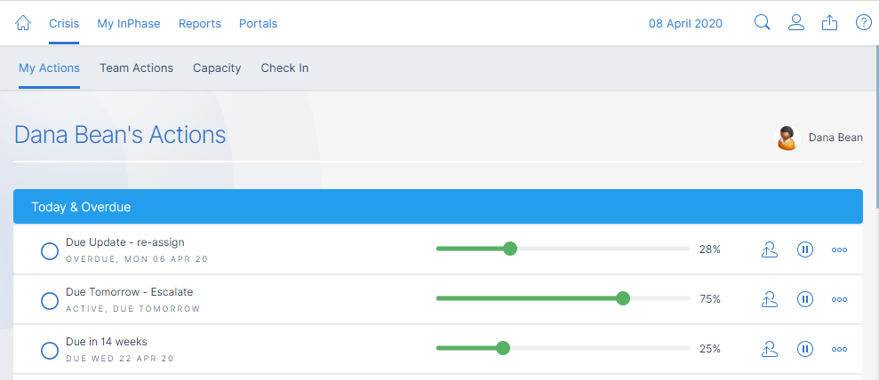
Issues – Issues that are outstanding:
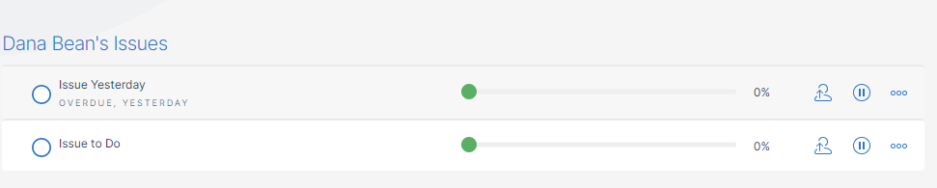

Escalated – Crisis actions and Issues that have been escalated from a direct report.
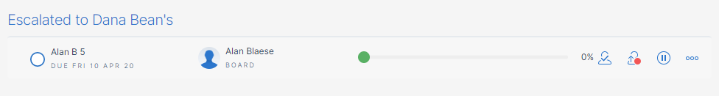

Direct Reports not checked in – Direct reports who have not updated their status.

Parked – Crisis actions and Issues that have been parked.
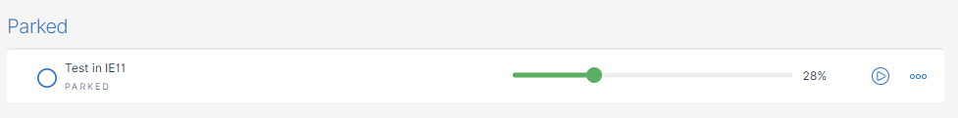
Completed in Last 24 Hours – All Crisis actions and Issues that have been completed in the last 24 hours.
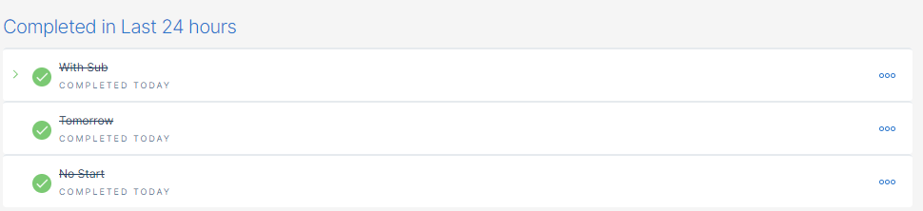

Other Completed – All Crisis actions and Issues that have been completed prior to the last 24 hours.

Team Actions
The entire team’s Crisis actions and Issues can be viewed on this page with the same sections as My Actions.

Check In
The Check In page allows your staff to record their working conditions, working capacity and how many people they will interact with.
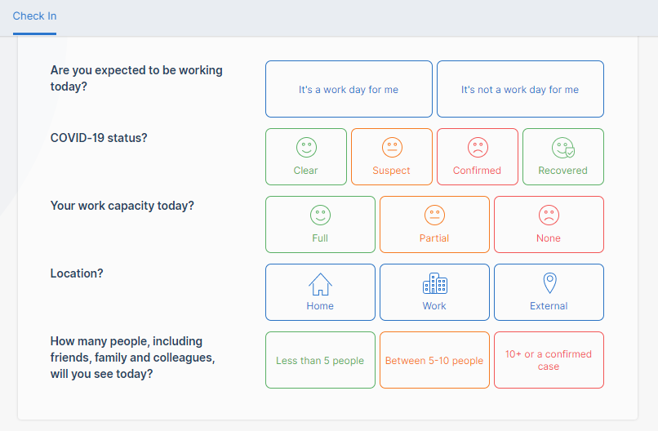

Capacity
The Capacity page reports the Check In data from the staff in the Team and subordinate Teams.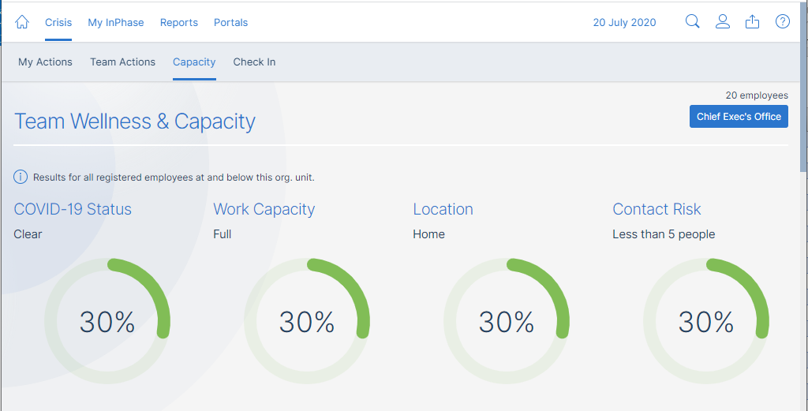
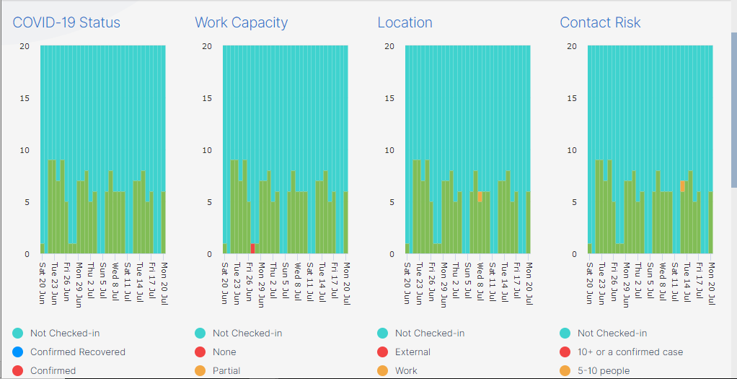
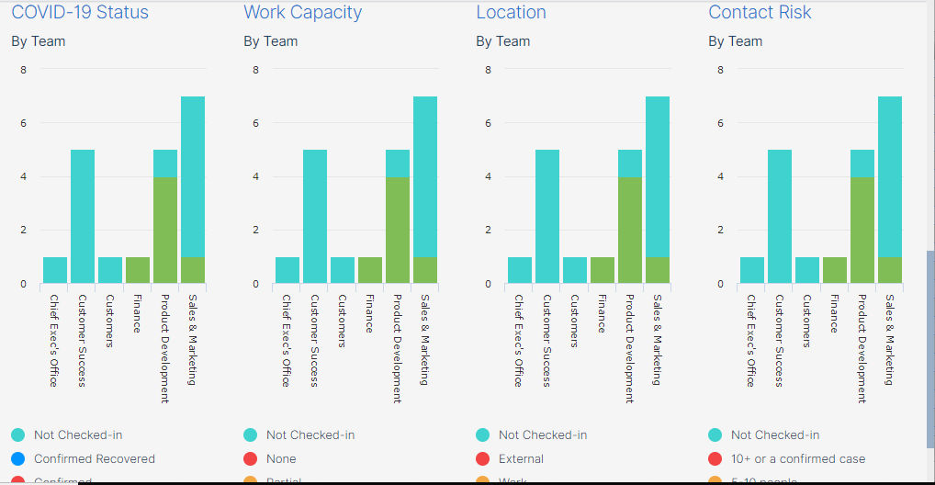

Other Feature Enhancements

Action Management
Actions can now be escalated to the owner’s manager with a single click. They have the option to take ownership, assign to a different user or return it back to the owner.
New actions are no longer driven by default by their child actions (start/end/due dates and % complete). This property aggregation can be enabled on any action manually through the action pop up.

Planning and Performance Booster App
A new Boost App available is the Planning and Performance App. This is designed to provide best practice support for business plan creation and management with full integration with Risks and Projects. This is a chargeable App.

Risk Boost
The Risk boost is a further pre-built boost application that is available from the INPHASE Booster Marketplace. The risk boost is designed to help our customers to quickly and easily manage, update and report on all organisational types of risks – from risk identification to management and mitigation, incorporating action management. The Risk app is integrated and works seamlessly the INPHASE Projects and Programmes and INPHASE Planning boost applications. This is a chargeable App.

PerfectWard Live Connect
A new optional connector is available to retrieve data from PerfectWard. Please contact your Account Manager to discuss enabling this connector. This is a chargeable connector.

Object Creation Permissions
This release provides the option to give lower licence users the ability to create Objects by specific type. To activate this, please contact your Account Manager as this requires changes to your licencing.

Default Permissions on Object Creation
This release provides the ability to set default permissions on newly created Objects, based on the Object Type. This configuration currently needs to be completed by an InPhase Consultant.

Auto-name on Create
A InPhase configurable option to enable a specified object type to auto-name on create with a unique name containing object type and unique reference number

Action Quick Edit
The action Quick Edit right hand panel on the My Page, Reports and Crisis has been enhanced to allow creation of child actions and saves as you go; no need to keep clicking on a save button. Each action can have different properties shown in the Quick Edit to help keep focus on the important information.

Microsoft Teams Integration
A Teams meeting can now be started from the comment panel of any Object or Action. The owner and all stakeholders will by default be included with the option to add/remove as required. Upon starting the meeting, a comment is made capturing who was in the meeting.

Object Comments
InPhase now support Object level Comments. These are comments against the object (Objective, Project, Risk, Task etc) which are independent of the planning pattern. They are not stored against a specific period date and are not affected by changing the start/end dates of the object. They are especially useful on items whose dates are changed often and are short lived such as tasks.
The comments panel now allows you to view one or all types of comment(Object Comments and Measure Period Comments) together to ensure you can see any comment made easily.
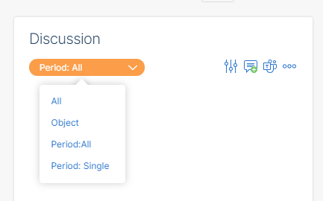

When creating an Object Comment, only the Object name will display:
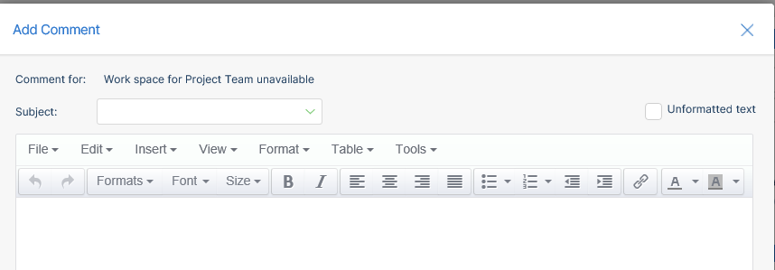

When creating a Measure Period Comment, the Object name, Measure name and period will be displayed:
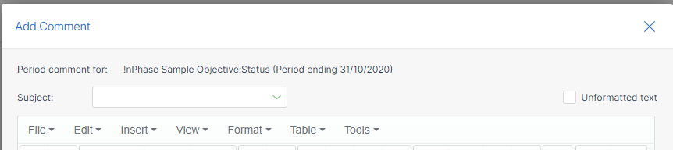

Object Comments can be show in Trends as part of the Comment series:
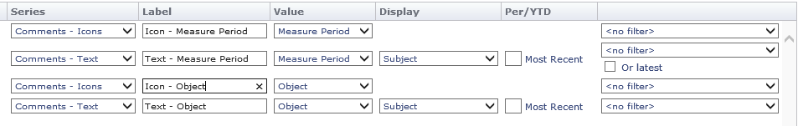

Comments Photos and Attachments
Adding photos and files to comments has been made easier with the ability to add the photo/file directly to the Comment rather than having to first upload them into the Inphase Library. If using a tablet or phone, the camera icon will open your camera so you can quickly add photographs directly.
The Comments panel shows the Camera icon for your Comments which allows direct attachment of a Photo to that comment:
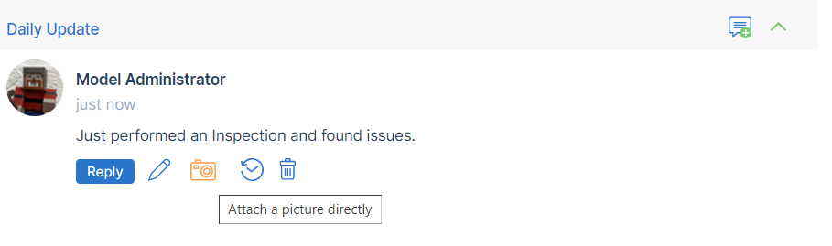
The Comment dialog attachment area now provides the options to link to a library file, attach a photo directly or attach a file directly:
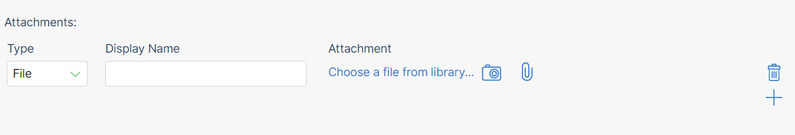

The Comment dialog also allows the pasting of images into the comment text. If the image is large, InPhase will give the option of embedding at a lower quality or attaching at the original quality.
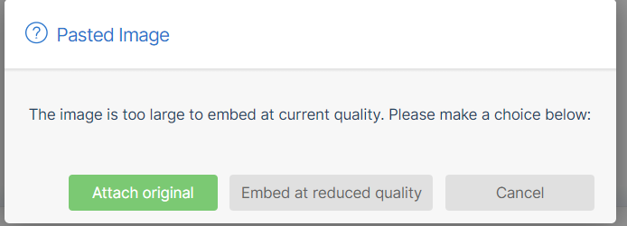

Derived Functions
New derived functions are available:
- Change in Value – Calculates the change in value between the previous period and the current period.
- Rolling 7/12/14/28 period average – Calculates the rolling average for the number of periods.
- Rolling 7/12/14/28 period sum – Calculates the rolling sum for the number of periods.
- Prior value 1/3/5/9/12 periods – Takes the value from a prior period, useful for calculations where there is a delay e.g. Marketing Spend vs Sales
- Stock Usage – This takes one or more stock level measures and a new stock measure to calculate the amount of stock used in a period. This can be combined with other measures to calculate days of stock left based on usage.
- Stock Remaining – This takes a stock level measure and a stock usage measure and will project the stock levels forwards until the stock levels reach 0 or for one calendar year, whichever is sooner.
- Count of Non-negative – Counts the number of donors that have a value of zero or more.
- Sum of Non-negatives – Sums the donor values where the values are zero or more.

Has measure criteria
New criteria that allows removal of all Objects which do not have at least one measure matching the criteria. The example below shows all Risks that the logged-on user owns, that have the Risk Rating measure with a red performance (performance is accessed by the details). This enables the report to show all the measures of the Risk, rather than just the Risk rating.
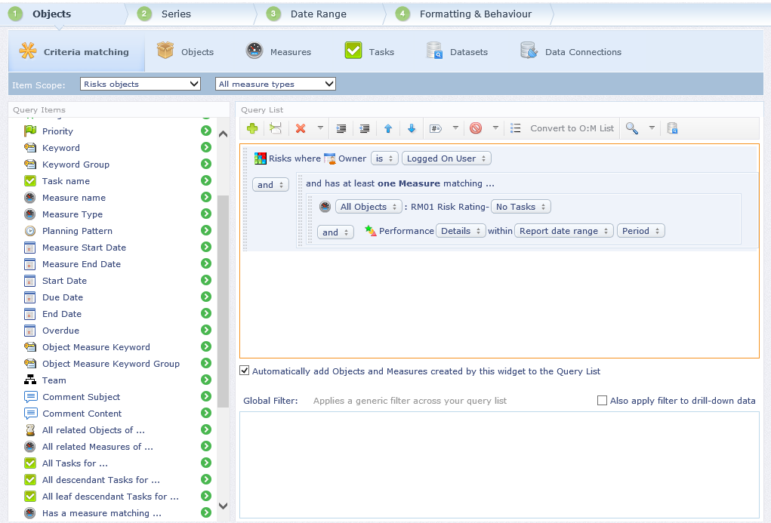

Gantt
Right clicking on a Gantt now allows the user to set the:
- Start - moves the task to start on the selected date.
- End – updates the task end date, changing the task duration as required. If the end date is put before the start date, the start date will be set to the same date.
- Due – updates the due date.

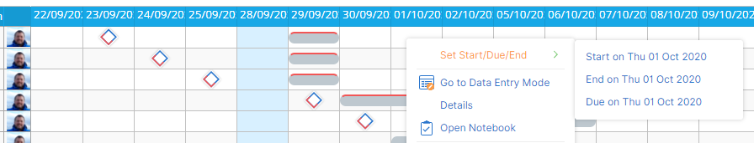

Master View Print Selected
Pages using Master View can now print a user selected list of the available Objects/Measures in the order selected.

Important Changes

Action Quick Edit
The action Quick Edit right hand panel on the My Page, Reports and Crisis has been enhanced to allow creation of child actions and saves as you go; no need to keep clicking on a save button. Each action can have different properties shown in the Quick Edit to help keep focus on the important information.

INPHASE v17.5 Major Enhancements

Booster Capability
Boost your InPhase implementation with new Booster capability. Boosts will be available from within https://support.inphase.com to download. Each Boost is a file that can be used in the new Booster wizard accessible from the Designer Utilities menu to add new capabilities to your InPhase site including portals, styles, analysis or other features. The Booster Wizard guides you through completing any configuration required for each Boost.

Projects Boost
The first Boost available is the Projects Boost. This contains a portal called Projects & PMO that assists with managing Programmes and their Projects.
This includes creation, approval, update, revision, re-forecasting, closure, costs and benefits, risk management and issue management for Projects, grouped in Programmes.
This Booster will:
- Create a Portal call “Projects & PMO”
- Update the Risk object type to include custom fields used by PMO
- Create/Update the Programme object type to include custom fields used by PMO
- Create/Update the Project object type to include custom fields used by PMO
- Create/Update the Issue object type to include custom fields used by PMO
- Add Comment Subjects:
  - Project Update
  - Issue Update
  - Project Quality
  - Action Update
- Add images used by the PMO
- Add Custom Fields

To use the Projects Boost you will need to have:
- the Risks add-in
- the Gantt add-in
- Planning Patterns for
  - Monthly
  - Quarterly
(names can be different and can be manually mapped):
- Series for:
  - Target
  - Forecast
  - Baseline
(names can be different and manually mapped)
The Planning Patterns and Series are configured through the Administrator application.
Full details of the Boost are available separately in User Guide and Admin Guide documents.

Other Feature Enhancements

Comments Panel Subject Lock
The Comment Panel can now be locked to single Subject. This will help when designing pages where you want end users to create a comment with a specific Subject that they cannot change by accident.

Quick Edit Risks (My InPhase)
Users can now Quick Edit Risks and update the Impact and Probability within My InPhase.

Drag and Drop Lists Columns (My InPhase)
The lists on My InPhase (Key Actions, Projects etc) now support reordering of columns using drag and drop.

Slicers can include Parents
You can now use Slicer for Parent/Ancestor properties.
Consolidate Hierarchy
Tasks that are children of other Tasks in the report are automatically removed from the root of the report and only shown in the hierarchy drill-down.

Trends Derived Measure Protection
You can now prevent data input into all series for Derived Measures to prevent users accidently overwriting the calculated value. This is an enhancement to InPhase preventing all users lower than Performance Manager from updating the Actual series. Users with a Role of Performance Manager and above are always allowed to update the Derived Measure’s series irrespective of this setting.

Employee Search
Employee fields now use the type/search control to assist when there are many Employees.
Multi-select Employee fields now use the multi-value dialog with additional search box.

Sunburst in-Period Values
Now has an in-period option so that you can display the data from the current period rather than the last completed period.

Performance Chart add any Plan Series
The Performance Chart can now show any series for a Measure in addition to the Actual and Target.

Benchmark Series in Performance Details Popup
The Measure Detail Popup includes any Benchmark series on the measure.

Freeform Anchor Right for Responsive Design
When creating a freeform for a page that fits the size of the Browser, you can anchor a picture/text to the right of the freeform. This will mean it will be visible on different size screens.

Reports Object Types configurable
The Reports area, accessible from the top menu, now shows the same list of Object Types as My InPhase. The Object Types displayed can be configured from the My Page by clicking on the cog icon on the 2nd level menu.

Custom Object Types Customisable Icon
Option to upload an SVG for your own Custom Object types icon. This is accessible from Designer Utilities menu.

Permissions
To prevent accidental data loss permission on change start and end dates have been tightened:
- Tasks
  - User requires AUTHOR rights
  - User needs to be a Briefing Book Viewer or above
- Objects (Objectives, Risks, Project, etc)
  - User requires AUTHOR rights
  - User needs to be a Performance Manager or above

Only users with a role of Reporter and above can access the Actions and Control properties in the Property Picker.
Objects and Task only appear in reports if the user has at least view rights. Previously only series
data and comments were hidden.

Import Permissions
Permissions for an Object/Task can now be imported.

Bulk Employee Import
Now creates Organisational Unit (Department) if not found. You will need to set the hierarchy through the organogram.

Linked Frames
Now include option to Cascade the selected Object/Measure. This clears/resets the slicers on destination widget(s). This is useful when using multiple Trends to cascade selects e.g. each trends deals with the level below the previous trends, allowing end users to select a directorate, then the area then the team.

Page Flow
Page flow handles more complex page designers and will automatically display widgets in a single column on mobile devices/small screens, reducing designer workload to support mobile and small screens.
The biggest change is where widgets are touching top & bottom they are now treated as a single container which enables the second image below to benefit from Page Flow responsiveness.
Charts and other visualisations that have no content inherent height use the height they were displayed in Designer mode.
Previously Supported: Now also supported
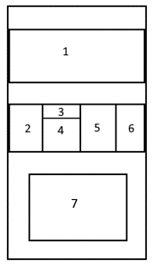

Technical Hardware and Software Requirements
INPHASE has two modes. The main user mode is Enterprise mode, which is optimised for end user response times and runs on all major browsers, desktop, tablet and smart phones.
The other mode is Designer mode, which is for the model building, reports, and portal design and configuration. Designer mode runs on PC platforms only and utilises ActiveX downloads.
Only power users that will use Designer mode require ActiveX downloads.
Unity Enterprise mode summary
- Easy on IT administration; no ActiveX downloads.
- Any browser – organisations trapped in legacy IE can use latest Chrome or Edge.
- More engaging, better looking, faster, more in-built features.
Liberated user – any device mobile data reporting, data capture, data analysis, discussion.

Hardware Requirements
Please note: if you are using a virtualised environment then these requirements must be set as minimum reserved resources.

COMPULSORY TECHNICAL NOTE
There is no virtual environment over-allocation of resource configuration that is approved for INPHASE.

Application Web Server
 | Minimum under 50 users | Standard max 200 users | Up to 500 users**
RAM | 8GB | 12GB | 16GB
Disk | At least 15% free space (min 250GB)  7200rpm or faster  32MB or greater cache | At least 15% free space (min 500GB)  7200rpm or faster  32MB or greater cache | At least 15% free space (min 1TB)  7200rpm or faster  32MB or greater cache
CPU | 4 Core  2.4 GHz or faster | 8 Core  2.4 GHz or faster | 12 Core  2.4 GHz or faster

Database Server
 | Minimum under 50 users | Standard max 200 users | Up to 500 users**
RAM | 8GB | 12GB | 16GB
Disk | At least 15% free space (min 250GB)  7200rpm or faster  32MB or greater cache | At least 15% free space (min 500GB)  7200rpm or faster  32MB or greater cache | At least 15% free space (min 1TB)  7200rpm or faster  32MB or greater cache
CPU | 4 Core  2.4 GHz or faster | 8 Core  2.4 GHz or faster | 12 Core  2.4 GHz or faster

Combined Application and Database Server
 | Minimum under 50 users | Standard max 200 users | Up to 500 users**
RAM | 16GB | 24GB | 32GB
Disk | At least 15% free space (min 500GB)  7200rpm or faster  32MB or greater cache | At least 15% free space (min 1TB)  7200rpm or faster  32MB or greater cache | At least 15% free space (min 2TB)  7200rpm or faster  32MB or greater cache
CPU | 8 Core  2.4 GHz or faster | 12 Core  2.4 GHz or faster | 16 Core  2.4 GHz or faster

Software Requirements
For an application (web) server that hosts the web application with the SQL Server databases hosted on a separate server, the requirements are:
- Latest version of Microsoft Windows, minimum Windows 2008 R2 Server or above including the most recent service packs,
- Microsoft. NET Framework™, Version 4.7.2
- Microsoft Internet Explorer 10 or above

For a database server (not acting as the Web application server) the requirements are:
- Latest version of Windows Server, minimum 2008 R2 Server or above including the most recent service pack
- Latest version of Microsoft SQL Server, minimum 2008R2, or above (Standard edition or higher), including the most recent service pack

For Designer mode use
Microsoft Windows PC Windows 10, 8.1 or 7, Internet Explorer 10 or above. ActiveX download permissions or ActiveX installed via msi.

For Enterprise mode use – main users
Microsoft Windows PC or tablet, Windows 10, 8.1 or 7 with Internet Explorer 10 or above, Edge, Chrome or Firefox,
Apple MacBook, macOS, iMac, with Chrome, Safari.
iPad or iPhone with Chrome, Safari.
Windows phones with Edge.

INPHASE v17 Cloud Hosting
Improve the currency of your version updating and reduce your total ICT costs by using INPHASE Cloud Hosting for v17. Options now available for v17 include:
INPHASE on Microsoft Azure managed servers with high speed servers and 100% redundant failover, includes your Windows Server Licences, SQL Server Licences, disc storage, daily back-up and 14 day retention, full latest version update service within 14 days of release.
INPHASE on N3. NHS N3 options available in partnership with Red Centric data centres.

UK and European, ISO 27001
All INPHASE hosting servers guaranteed to be UK and European based, ISO 27001 security standards, multi-location failover facilities, Tier 1 connection.
All our hosted servers can now support encrypted Live Connect to SQL servers, either in the cloud or on-premises.

INPHASE Microsoft Azure AD and MFA
v17 supports Microsoft Azure Active Directory Federated Services, with optional Multi-Factor Authentication. This can be supported either from our hosted options or from a self-hosted server.

