InPhase 22
Release Notes
22.0.304

October 2023
Commercially Confidential

Contents
INPHASE 22 Overview 4
Freedom from Internet Explorer and ActiveX 4
Questionnaire 5
Overview 5
Events 5
Surveys 5
Audits 5
LFPSE 6
Question Manager Activation 6
Questionnaire Structure 7
Questionnaire Versioning 8
Look Up Lists 8
Workflow 9
Object Sync 9
Compliance Questions 10
Instance Administration 10
Access to Questionnaire Administration 11
Creating a Questionnaire 11
Questionnaire Data 11
Administrator 13
Overview 13
Jobs 13
Benchmarks 13
Questionnaire 14
Questionnaire Export 15
Designer 17
Overview 17
Deleting a Visualisation 17
New Printing option 18
Responsive Grids 19
Repeating Visualisation Grids 20
Visualisations 21
Scorecard 21
Notebook Widget 23
Questionnaire Widget 24
Live Connect Picker 25
Custom Types 25
Custom Fields 25
Unsupported Legacy Features 26
Legacy Scorecards 26
Top Tips 26
Legacy Scorecards 26
Freeform Buttons 26
Software Requirements 26
INPHASE Cloud Hosting 27
Breaking Changes 28
Change Log 29

INPHASE 22 Overview

INPHASE 22 has three components: Enterprise, Designer and Admin. All of these operate fully in modern browsers only (Internet Explorer is no longer supported).

A new powerful Questionnaire module is optionally available to quickly capture data via custom Questionnaires / forms. Each Questionnaire has its own powerful workflow that allows different questions to be answered at different stages, automatic updating of questions and linked Objects and email notifications. Usages include:
- Incident reporting, including LFPSE
- Auditing
- Staff Surveys
- Holiday Request

Freedom from Internet Explorer and ActiveX

InPhase 22 is fully cross-browser-based with no client installation required.

Questionnaire

Overview
Questionnaires are a brand-new powerful part of InPhase for capturing data of different types. Questionnaire Administrators can create and update any number of questionnaires which can be reported on either via linked Objects or Live Connects for raw data analytics.

There are 4 types of Questionnaires:
- Events - Capture of a single event. This could include:
  - Health & Safety Incidents
  - Holiday Requests
  - Sickness reporting
  - Change request
- Surveys – Capture of multiple items over time. This could include
  - Customer Surveys
  - Friends and Family Surveys

- Audits – Capture of audits over time, usually with compliance. This could include:
  - Equipment Checklist
  - Clinical Audits
- LFPSE – Learn from Patient Safety Events

Events
Events can be used to capture any data that can occur in an ad hoc manner. Each instance links to its own InPhase Object so that it can be managed independently including permissions, custom fields synchronisation and reporting.

Surveys
Surveys are used to capture numerous instances of data over time. A single InPhase Object is used to group multiple instances of the Survey e.g., you would have an InPhase Object per service to hold that service’s surveys.

Audits
Audits are used to repeatedly capture the current state of an item/location/process within the organisation with the added ability to use questions to calculate the level of compliance achieved. This level of compliance can be synchronised with measures within an InPhase Object to track compliance easily over time.

A single InPhase Object is used to group multiple instances of an Audit to easily show the audit data over time. When compliance is used, the InPhase Object will automatically create the required Measures to track the compliance.

LFPSE
NHS England has announced that all healthcare providers are required to upgrade to Learn from Patient Safety Events, or LFPSE, to report incidents which collates data from all NHS organisations to a national database.

InPhase provides an LFPSE-compliant questionnaire that automatically updates NHS England with the details of all locally recorded patient incidents, risks, outcomes and good care events to be used immediately for learning and improvement work.

The LFPSE questionnaire can be extended to include all locally required questions and use a custom workflow to apply your own Incident workflow suited for your organisation. This includes assigning Investigators/Approvers and notifying groups of InPhase users when new incidents have been recorded for areas that concern them such as location of incident, level of harm or service line.

Each LFPSE instance creates an InPhase Object so that it can be managed independently including permissions, custom fields synchronisation and reporting.

The LFPSE Questionnaire is an optional extra within InPhase which will require some basic configuration using keys provided by NHS England specifically for your organisation.

Question Manager Activation

All toolkit customers with full Designer licenses will receive Question Manager for one-time forms free of charge in their InPhase22 upgrade.

If you'd like to make use of LFPSE Incidents, Surveys or repeating audits, please contact your account manager.

Questionnaire Structure

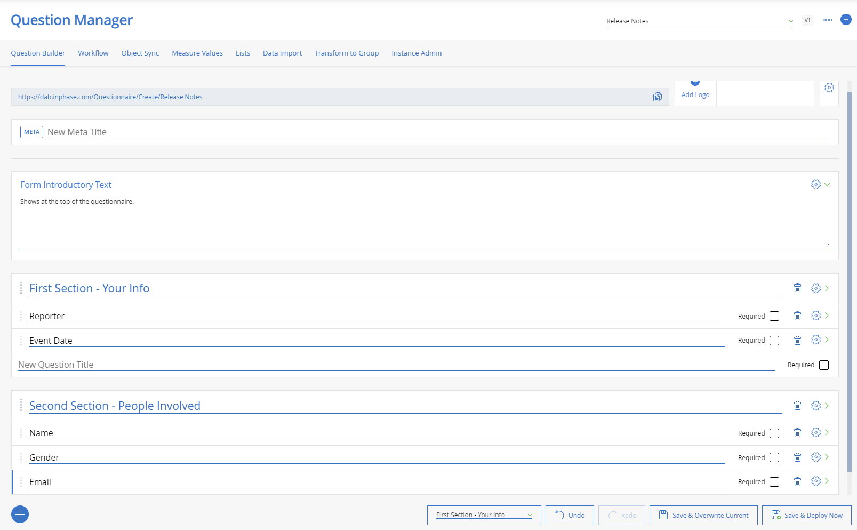

Each Questionnaire is made up of introductory text, metadata, logo image and Sections, each section has one or more Questions. Each Question can have one or more Sub-questions.

A section can be made to be repeating to allow the recording of multiple instances of the section e.g., people affected by the event. Each section can be configured to:
- Show based on the answer to previous questions/current stage
- Lock inputs based on the answer to previous questions/current stage
- Repeat, holding multiple instances of data e.g. People affected by an event
- Only be visible to users within a specified InPhase Group
- Only be editable to users within a specified InPhase Group

A question type of Grouper or Repeating Question Group Title allows you to capture multiple instances of the sub-questions e.g., list of injuries each person received due to the event.
The questions used to capture data can be configured to:
- Require the user to enter data
- Show based on the answer to previous questions/current stage
- Lock inputs based on the answer to previous questions/current stage
- Validated e.g., date cannot be in the future

The Questions can capture a range of information including:
- Text
- Choice including Yes/No
- Multi-choice
- Number
- Date
- Risk (Likelihood/Impact using the InPhase Risk settings)
- Email
- Telephone
- Employee (from InPhase’s Employee list)
- Comments
- Links to InPhase Objects
- Links to InPhase Tasks
- File Attachment

Questionnaire Versioning

When updating the Questionnaire, any changes can be applied to the current version of the Questionnaire or deployed as a new version. If deployed as a new version, existing instances are not changed and will continue running the workflow for that version. Any new instances will use the new version.

Look Up Lists

Choice Questions use Look Up lists. The Look Up lists support hierarchies so that a Questionnaire can be configured with multiple questions targeting the different levels in the hierarchy. InPhase will automatically cascade the choices from the level 1 question to the level 2 question. The number of levels is not limited and can be used to help users pick appropriate answers.

Workflow
All Questionnaires have multiple stages, by default they have New and Completed. Each Questionnaire can be separately configured to have its own workflow with as many stages as required with the ability to configure pathways between any of the workflows.
Each stage in the workflow can be configured to:
- On entering stage
  - Update the Questionnaire Instance e.g., recording who moved stages and the date
  - Update the linked Object
  - Send Emails
- On Saving the stage, any number of conditional actions
  - Update the Questionnaire Instance e.g., recording who moved stages and the date
  - Update the linked Object
  - Send Emails
- Allow moving to a different stage via a button at the end of the Questionnaire. Each button can be configured separately:
  - run required validation or to ignore e.g., rejecting an event
  - show a section e.g., rejecting requires a rejection reason
  - stage to move to
  - button label
  - button colour

Object Sync
Questions can be configured to copy their answers to their linked InPhase Object. Any time the Questionnaire Instance is updated, the answers are pushed to the linked Object.
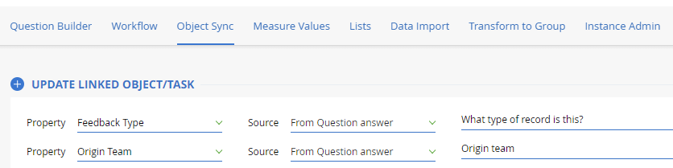

Compliance Questions

For Audits, questions can be marked as Compliance. This instructs InPhase to use the answer for generating a compliance score. The Pass value is configurable and when using a choice question, any value up to and including the pass value is considered a pass e.g. if the lists has options A, B, C, D, E and the pass value is set as C, the A, B, C count as a pass and D, E count as a fail.

There is a special case of Instant Fail, where if that question is marked as Not Compliant, it marks the whole audit as failed.

The linked InPhase Object will automatically gain the following Measures:
- Audit # - Count of the Audits in the period
- Required # - Count of the required questions in the latest Audit for the period
- Required completed # - Count of the required questions completed in the latest Audit for the period
- Required % - Percentage of the required questions completed in the latest Audit for the period
- Compliance questions # - Count of the compliance questions in the latest Audit for the period
- Compliance questions completed # - Count of the compliance questions completed in the latest Audit for the period
- Compliance questions completed % - Percentage of the compliance questions completed in the latest Audit for the period
- Compliance questions successful - Count of the compliance questions marked as Compliant in the latest Audit for the period
- Compliance questions failed - Count of the compliance questions marked as Not Compliant in the latest Audit for the period
- Compliance % - Percentage of answered compliance questions that are Compliant in the latest Audit for the period
- Compliance instant fail # - Count of instant fail questions marked as Not Compliant.

Instance Administration

Questionnaire Administrators can enter the ID of a Questionnaire Instance to:
- Change the stage back to an earlier stage
- Rerun the current stage workflow
- Update the version of the Questionnaire Instance to the latest
- Delete the Questionnaire instance

Access to Questionnaire Administration
InPhase contains a group for each of the 4 types of Questionnaires. Users must be added to the relevant Group to be able to create and maintain those types of Questionnaires:

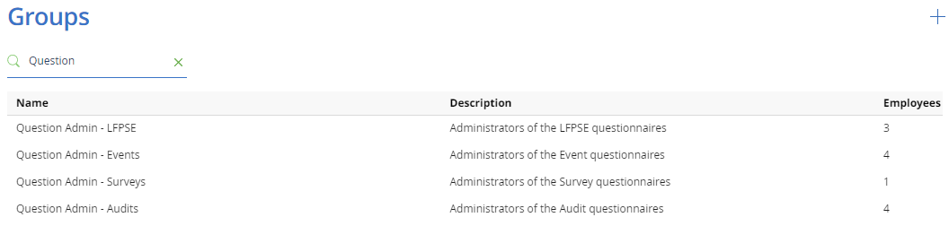

Creating a Questionnaire
Any number of Questionnaires can be created, first choose the questionnaire type in Administrator and then click on the create button:
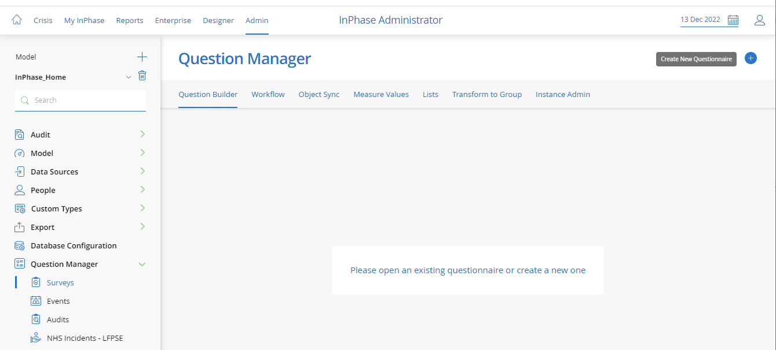

Questionnaire Data
The data within the Questionnaires can be accessed via the Live Data set up:
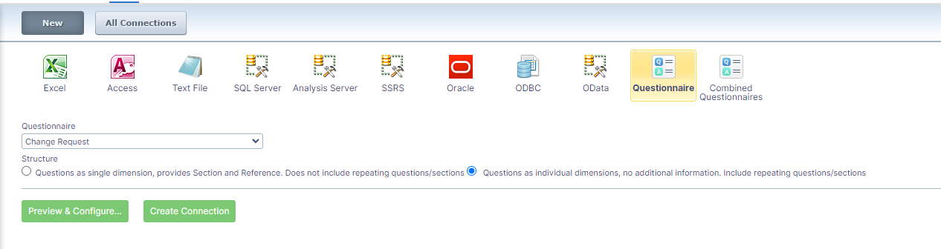

There are two modes:
- Questions as a single dimension – This forces the connection to have a single Question dimension and a single value dimension. It is useful for providing reports that require question metadata (section/reference/etc.) and the ability to filter by section and question name. Repeating sections are not supported.

- Questions as individual dimensions – This treats each question as a single dimension. It allows filtering by specific questions and will only bring in repeating data if requested.

Administrator

Overview

The administrator is fully browser-based and will allow a Model Administrator level user to administer their models.

The left-hand menu provides access to the Model selection and the administrative areas of the selected model.

Multiple improvements have been made to handle the management of a large number of items such as Employees.

Jobs
On-premise administrators can now generate a PowerShell file used to start a job. This uses a token valid only for that job and is no longer dependent on a user’s password. It also has no dependencies on the old Administrator Windows application.

Benchmarks
Benchmarks can now be maintained within the Administrator:

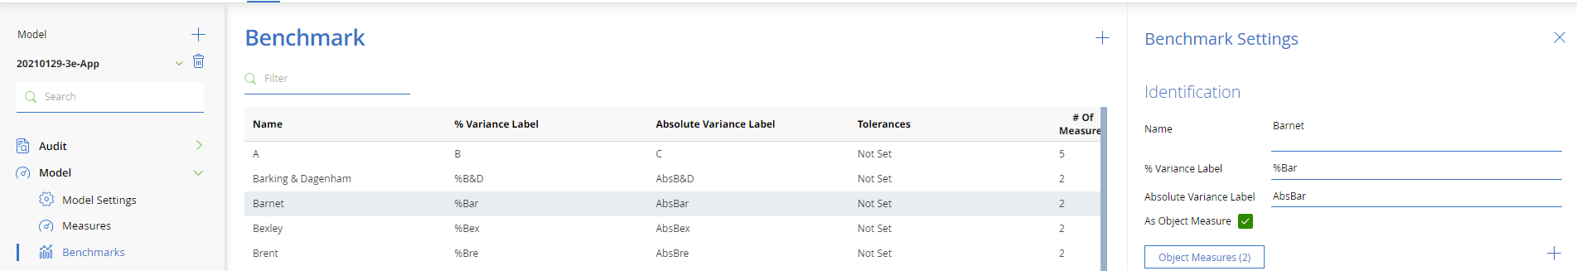

Questionnaire

The access point to creating and maintaining Questionnaires is via the Administrator’s Question Manager:
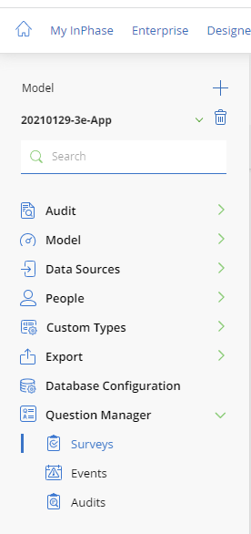

Questionnaire Export

Questionnaire Instance data can be exported from InPhase and 2 mechanisms are provided:
InPhase provides 2 mechanisms to export this data:

- Direct from Administrator:
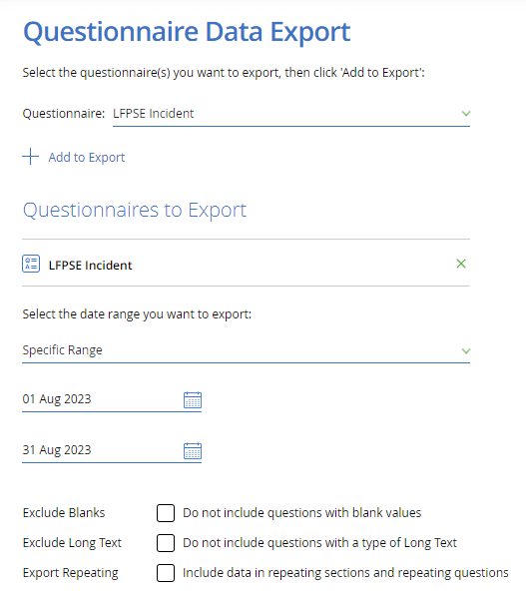
This allows the user to choose which questionnaires and the date range. Clicking export will generate the ZIP file containing one or more CSV files immediately.
- Job Step:
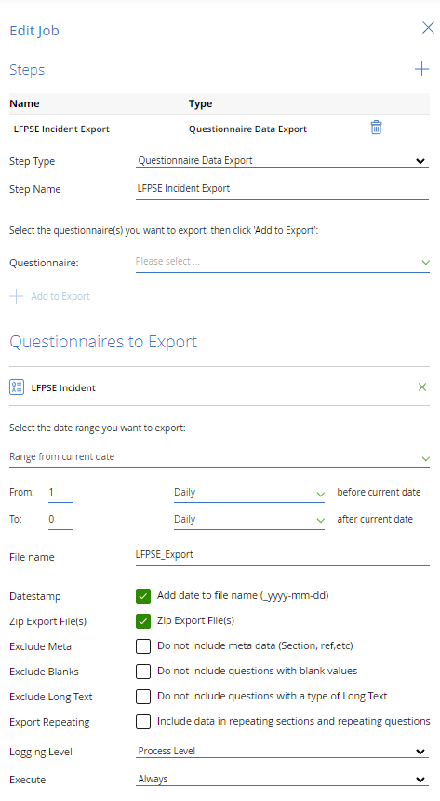
This allows an export from multiple questionnaires with a specific date range to be scheduled. The export is generated on the InPhase server with an optional date stamp (_yyyy_mm_dd) and can be retrieved using a PowerShell script with a Token provided by InPhase. Any exports older than 7 days will be automatically removed. Using the “Zip Exported Files” is highly recommended.
Exclude Metadata removes the Section/reference/data type/compliance columns from the data CSV files, they are contained within a [FileName]_Meta.csv file to ensure you pick up any new/changed questions.
Exclude Blanks removes questions that have blank answers. This can massively reduce the size of the data extract, but there may be cases where values were previously set and then cleared by users. This means on importing with this setting, the whole record within your Data Warehouse should be cleared down.
Exclude Long Text will prevent the export of any Long Text type questions including comments, Notification logs as these are generally not used by Data Warehouses.
Export Repeating will include all data contained within repeating sections and repeating questions. An example of repeating sections is Affected Patients as there can be more than one Patient affected by an Incident.

Designer

Overview
Designer is fully web-based and requires no additional installation. Page designs are all based on Grids which are native to all modern browsers.
A collection of Pages is combined into a single Portal.

Deleting a Visualisation
Visualisations can now be permanently removed from the Application by right-clicking on the visualisation name in the Saved Visualisation search:

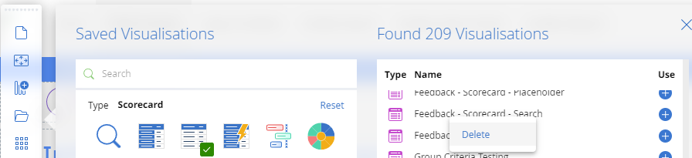

InPhase will check if a visualisation has been directly used in a Portal and return the relevant warning. If the visualisation has been used within a Scorecard (Open Visualisation In) or a freeform action button it will not automatically be found:

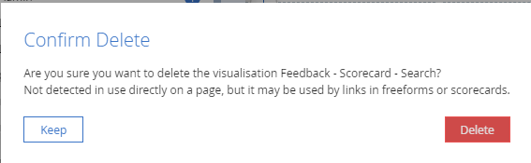
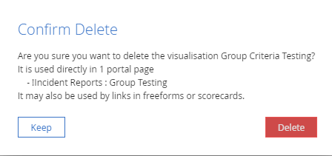

New Printing option
A section within a page can be forced to start on a new printed page:

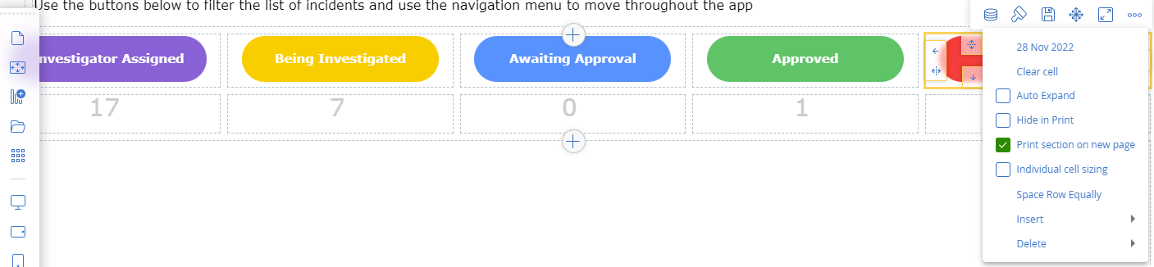

Scorecards now have extra options to aid with producing better prints:
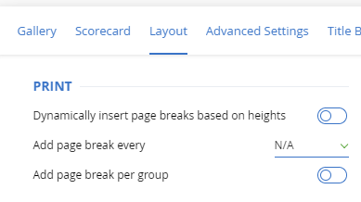

Responsive Grids

Columns within a grid are a percentage of the available width by default. All except one column can be forced to a specific column width in pixels to ensure the same width is always used by that column. If the screen size forces the mobile layout, this set width is ignored. If any columns use a fixed width, the grid columns cannot be manually resized and must be changed through the dialog.

InPhase 22 now allows you to choose whether the grid is responsive going left-to-right, then down (X-axis) OR top-to-bottom, then across (Y-axis):
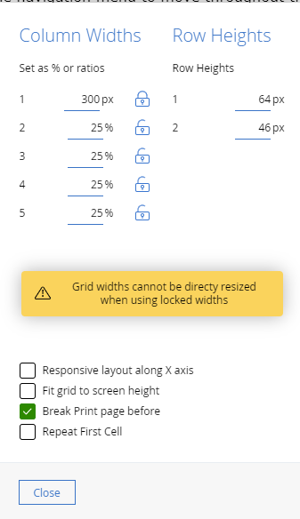

Repeating Visualisation Grids
A grid can be configured to repeat the first and only Visualisation for each item passed by linked frames. If passing Object or Measure data, you can choose whether to repeat on the Objects passed or on every Measure passed. If passing Live Data, you will need to enter the name of the Dimensions used to categorise the data into different visualisations:
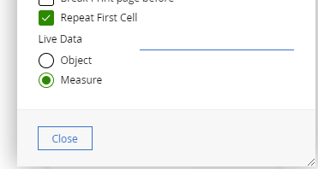

Visualisations

Scorecard

The Scorecard has new printing options available to help prevent rows from being split across page boundaries:

Dynamically inserting page breaks will attempt to detect where page breaks will occur and if a row would be split, it will insert a page break before. If a row is too big to fit on a single page, it will still be split.
For Scorecards with consistent-sized rows, you can ensure that there is a page break every X rows.
Where rows are grouped, each group can be started on a new printed page.

Scorecards allow basic editing as previously seen in My Page:
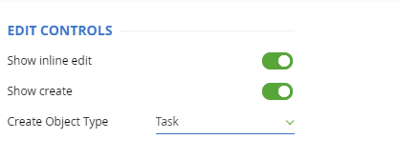
When configured to create new Tasks, if the Criteria of the Scorecard is “Key Actions Of …”, then the new Tasks will be automatically added to the Object within those criteria.
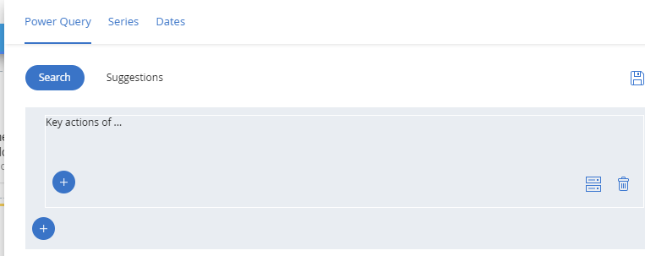

Object/Measure Date properties can be displayed with a modifier based on either current date or view date to highlight when something is overdue:
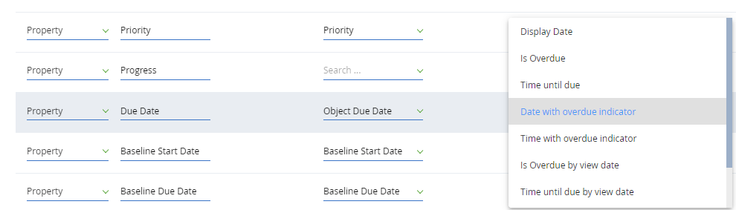

Scorecard Series can now generate a Date Series that will show the period end date the date came from. This may be due to using “Or Latest” or Measures with different planning patterns. A Series date source can be another series, allowing you to link the date across multiple series such as using the latest Actual data and showing the target /performance for that period end date automatically.

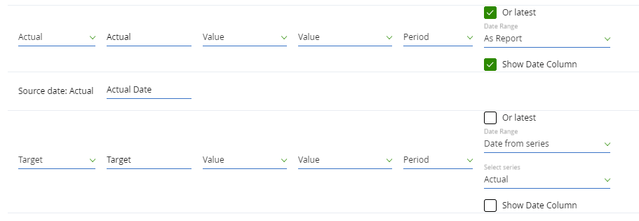

Different visualisations can be rendered by the Scorecard:
- Sparkline – used to show change in value of time
- Dials – used to show value, target and performance

Scorecard columns can be resized by dragging or by opening the configure column widths dialog. If at least one column is auto, the scorecard will fill the entire width of its cell.

Notebook Widget

The ability to create and maintain notifications is now available in Enterprise, using the same configuration as version 17.6:

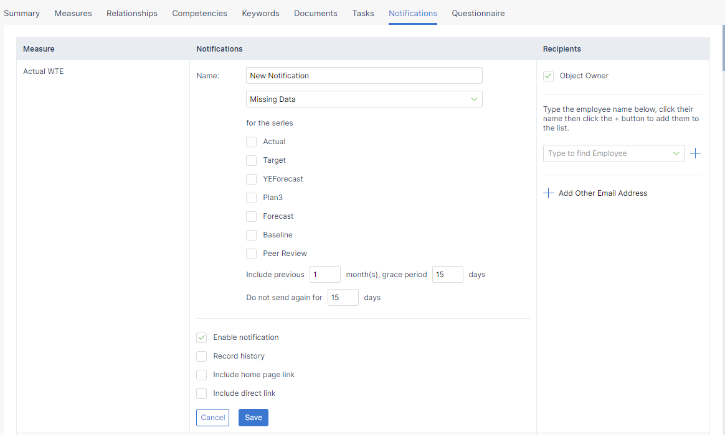

Questionnaire Widget

The Questionnaire Widget is used to show a Questionnaire Instance directly or show the Questionnaire Instance(s) linked to the Object in focus. It provides options on whether to show a list of other instances for the Object and icon to access the history of the Questionnaire Instance. The action to perform after the Questionnaire Instance has been submitted is also configurable.

Live Connect Picker

The Live Connect Picker Widget is used to choose a Live Connect that accesses Questionnaire data directly. This allows an end user to swap between different Questionnaires as the data source to pass to the page’s Visualisations.
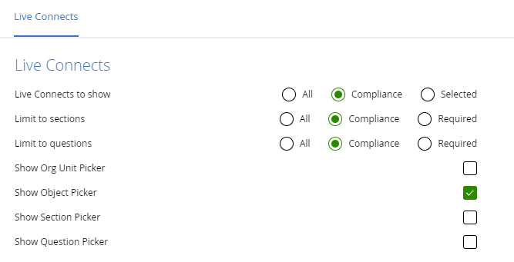

Custom Types

Custom Fields
A new custom Field type of “Group” is now available. This allows users to select a single InPhase Group as the value for the custom field. It works with a “Logged On User” criteria to bring back all Objects or Measures where the current user is a member of that group.

This is useful where many are teams working across different areas and by moving employees in/out of groups their logged-on user pages will automatically show the relevant Objects/Measures.

Unsupported Legacy Features

Legacy Scorecards
The ability to edit legacy Scorecard is not supported from InPhase21. Existing Scorecards can be used in Enterprise mode.

The new Scorecard replacement is available with a reduced feature set. The missing features are currently in development and should be available shortly.

New features and widget types are in development to bridge any gap in functionality.

Top Tips

Legacy Scorecards
17.6 Scorecards can be used in Enterprise mode but cannot be edited.

Freeform Buttons
All existing freeform buttons will continue to function; however, it is advised that all buttons be replaced with the new free-form button feature from InPhase21 onwards.

Software Requirements

For Designer mode use
Microsoft Windows PC Windows 10.
- Modern Browser; Chrome, Edge, Safari, Firefox

For Enterprise mode use – main users
Microsoft Windows PC or tablet, Windows 10,
- Modern Browser; Chrome, Edge, Safari, Firefox
Apple MacBook, macOS, iMac, with Chrome, Safari.
iPad or iPhone with Chrome, Safari.
Windows phones with Edge.

INPHASE Cloud Hosting
Improve the currency of your version updating and reduce your total ICT costs by using INPHASE Cloud Hosting. The available options include:

INPHASE on Microsoft Azure managed servers with high-speed servers and 100% redundant failover, includes your Windows Server Licences, SQL Server Licences, disc storage, daily back-up and 14-day retention, full latest version update service within 14 days of release.

UK and European, ISO 27001
All INPHASE hosting servers are guaranteed to be UK and European-based, with ISO 27001 security standards, multi-location failover facilities, and Tier 1 connection.

All our hosted servers can now support encrypted Live Connect to SQL servers, either in the cloud or on-premises.

INPHASE Microsoft Azure AD and MFA
INPHASE 22 supports Microsoft Azure Active Directory Federated Services, with optional Multi-Factor Authentication. This can be supported either from our hosted options or from a self-hosted server.

Breaking Changes
22.0.304
- Questionnaire Export - Format
The Questionnaire Export format has been changed to reduce file size and support data within repeating sections/questions:
  - The following built-in fields are no longer columns and are now included as rows within the export:
    - Stage
    - Update By
    - Updated
    - Created By
    - Version
    - Object Name
    - Object Id
    - Org Unit
    - Period End Date
  - The following fields have been added to the export to uniquely identify repeating Sections and repeating Questions:
    - Repeating Section Id
    - Repeating Question Id
- Questionnaire Export – File size
To prevent export files from becoming too big to process, export files are now split after 50,000 rows. To ensure all files are picked up, the ZIP option is recommended. This limit of 50,000 rows can be changed by InPhase by request.
- Email on Comment creation/reply
To prevent possible leak of PII data or commercially sensitive data via email, the content of a Comment or Reply can be configured to replace the content of the Comment/Reply with “Redacted”. This can be configured via the Model Settings in Administrator.

Change Log
22.0.304
- SSO
  - Integration with NHS Mail SSO. This is available by request.
  - Integration with Okta. This is available by request.
- Questionnaire – Instance
  - Fixed issue with validation of time “not later than” for Today.
  - Fixed issue with removal of employee(s) from multi-employee picker.
  - Fixed issue with cascading choice in a specific scenario not updating second drop-down.
- Questionnaire – Audits
  - Resolved an issue with Multi-choice Compliance questions using “N/A” preventing save
- Questionnaire – Template Editing
  - Improved auditing of changes to Sections, Questions and Stages.
  - “When to Show” validated on save to ensure rules are configured correctly.
- Questionnaire – Object Sync
  - If the end date is set to before the start date due to the Object Sync, the start date is moved instead of rejecting all Object updates.
- Questionnaire – Workflow
  - “Manager of Employee in Question” now available
  - Risk question values are now available to use in rule conditions
- Questionnaire – Stop the Clock
  - Stop the clock functionality now allows the start/stop date to be manually selected, rather than forced to the current date.
- Questionnaire – Accessibility
  - Employee picker labels.
  - Employee search format of job tile/org unit improved
  - Help text font size increased.
  - Choice/Multi-choice labels.
  - Type-ahead/Search now puts exact matches first.
- Question Manager
  - Validation on question conditions now detects if source question has been deleted
- Questionnaire – Import
  - Handles both CSV and Excel data.
- Questionnaire – Export
  - Built-in fields removed from columns and added as rows.
  - New columns for Repeating Section Id and Repeating Question Id to allow the export of repeating data.
  - Export file split into new file(s) after 50,000 rows of data written.
  - New options for export:
    - Specific date range
    - Zip export files
    - Exclude metadata
    - Exclude blanks
    - Exclude Long Text
    - Export Repeating
- Comments
  - Multi-file attach is now working for multiple local file upload.
  - Creation of Comment via a Questionnaire now sends emails notifications
  - Email notifications by default do not include the content to prevent data being sent via email. This setting can be changed in Administrator under Model Settings ->
- Scorecards
  - Enterprise comment bullet points now consistent with Designer
- Trends
  - Input to custom fields without a current value now supported. Issue introduced in 22.0.303
  - Export to Excel now forced to use dates as displayed as in some scenarios American date format was used
  - Live Data sources using “Numeric Id” as data type now support “Exact Value” slicers.
- Notebook
  - Tasks linked to a specific measure can now be unlinked from the Object Notebook.
- Live Connect
  - Report view data can be passed into an SQL Repository for custom queries using $ViewDate$
- Accessibility
  - New Portal page improved.
  - Open Sans font at 12px rendering improved.
  - UI inconsistencies in Safari and Firefox fixed for date pickers
  - Attachment dropping improved in Safari
- Admin
  - Improved auditing of changes to Model settings.
  - Importing users with surnames including spaces is now handled, provided the first part is longer than 3 characters. If the first part is 3 characters or less, it is treated as their Initial.
  - Job steps can now be removed
  - Password setting for max days is now set correctly.
  - Custom Fields form editor
    - drag and drop for sections improved
    - standard InPhase fields now appear in the fields list
    - fields list is now filterable
  - New Model Setting for “Self Service Profile”. This allows administrators to prevent users from updating their profile (name, email etc). The user can still update their preference via the profile pop up.
- Login
  - Password expiry is now checked on all pages loaded
- Performance improvements
  - Creating a new Object.
  - Caching of Employees, Department, Custom Object form templates.
  - Optimisation of report Object/Measure/Task criteria
  - Optimisation of “Needed” object relation criteria
- Email
  - Improved Subject sanitisation to prevent rejection based on subject
  - Notification on Task assigned to “you” by another user. Previously this was only on Task creation. Controlled by the same “On Task creation” setting in profile.
- Misc
  - Ability to set a model or entire site to “Training”. This will only alter the header to indicate a training model.


22.0.303
- Questionnaire Reporting
  - Performance improvements on Date Time field searching
  - Improved handling of Calculated Fields in Live Connect
- Causal Map
  - Drill down to Objectives with custom Obj Code now supported.
- Dimensions
  - The following Parent/Ancestor properties are now available to add to a report:
    - Owner
    - Owner’s Department
    - Description
    - Start
    - Due
    - End
    - Priority
    - Stage
    - Org Unit

22.0.302
- Questionnaire Reporting
  - Transposed reports use the Section reporting name, not the label.
- Questionnaire
  - QR Codes updated as some were generating incorrect codes.
  - Icons used to show file types in the Questionnaire.
  - Long Text input now automatically resizes (3 sizes) to assist with viewing the content.
- Questionnaire – Building
  - Links for Audits now carry a warning, the link from Administrator will not attach the Audit to an Object. Use the pages provided to correctly submit Audits against the correct Object.
  - Import/Export group transforms to Excel.
- Slicers
  - Employee slicer height inconsistency fixed.
- Criteria
  - Multi Select (any of, none of) selection now applies correctly in the UI.
- Admin
  - Ability to set the default Task Planning Pattern.
  - Visualisations area showing usage, ability to change owner and lock to Administrators.
- Word App
  - Now correctly handles sizing for pages using MM units.
- Perfect Ward Integration
  - Now handles when Area division is null.
- LFPSE
  - Good Care now includes location.
- Performance
  - Improvements to Custom Field loading times.
- Accessibility
  - Small adjustments to improve accessibility on buttons.

22.0.301
- Widgets
  - Search Widget now reloads on adding a new slicer.
  - Search Widget now has a user-defined limit on when to warn the user about the number of Object/Measures/Tasks that will be passed to other widgets.
  - Performance improvements when dealing with reports using Drill Down.
  - Trends now has “Link Parent Object”, “Link Child Object” action buttons.
- Questionnaire
  - New Access point for SSO customers to allow any user authenticated by their SSO to be able to submit Questionnaires even without an InPhase login.
  - Spurious warnings about losing data when leaving a page with a complex Questionnaire no longer show.
- Question manager
  - Link/QR code for each type of access (Incognito, Logged On, SSO).
  - Up to 10 fields can be set as Fast Search to improve the performance of reports E.g. NHS Number questions or Legacy Id.
  - Lists can now be deleted.
- Questionnaire Reporting
  - Speed improvements to Transposed data (Questions as single dimension)
- LFPSE
  - Reporting an incident that happened outside the organisation no longer causes a warning with the NHS England API.
- My Page
  - Default view now only shows Key Actions/Tasks where the user is the owner. Other object types can be added as before.
- Admin
  - Export Questionnaire sometimes would not show the saved settings correctly.
- General
  - Caching of Employee records to improve loading times across the entire application. Affects sites with 1000+ employees.
  - Caching of Custom Field forms to improve anywhere the custom fields are used.
  - Time delay caused by sending Emails removed.
  - Improved time taken by the InPhase Upgrader to upgrade a site. This upgrade may be slower due to some of the performance improvements in this version requiring data to be de-normalised.

Changes since 21.1.300

- Login
  - Azure Ad sites can use [site]/Auth/FormLogin to login using username as password. This prevents access to users that have SSO settings.
  - Reset Password sends an email with a one-time use link, that’s valid for 24 hours. Successful resets are now Audited.
  - Updating a password in InPhase requires the current password to remove XSS attack vector.
- Series
  - Series editor allows any standard series to be compared against any other standard series for the same period (Scorecard/Trends/Sunburst)
  - Series can use the date from another series.
  - Comments have the option to show comment Date rather than auto-showing when needed.
- Tasks
  - Tasks are no longer automatically subscribed to by the creator. This can be reactivated via the PPLUS.config.
- Measures
  - Status measures can now be set as Part Objective:Same Measure to aggregate from child objective’s status measures.
- Scorecard
  - Sparkline visualisation
  - Full formatting options
  - Cell span rows
  - Comment as row below
  - Report Date settings/per column date settings
  - Edit Controls
  - Drill Down options
  - $DATE$ as part of a series label will be replaced with the Date of that series (column)
  - Auto-print page break (prevent breaks in a row if possible)
  - Print a page break every X, Auto-break
  - Dial visualisations
  - Conditional Formatting of Cells
  - Sort can be toggled through Asc/Desc/Off via click
  - Sorting of Series data (e.g. View Rank) now sorts based on data type, not just Alphabetical
  - Ability to set the column widths as pixels in a dialog
- Sunburst
  - Can now select any of the standard Series (Actual, Plan1-9) to show data.
  - Can also compare any of those series against any other of those series.
- Trends
  - GIS now renders data on first load
  - Performance Arc now uses “Or Latest” correctly
  - Moving range average now uses the 1.28 modifier to match NHS calculations.
  - Ability to set the row header and column widths in a dialog.
- Live Data
  - New dimension type of Numeric Id, will not aggregate.
  - New dimension type of Url, if a valid Url a link will be generated that can be clicked on to open in a new tab.
- Live Data Trends
  - New Derived Measure “Count of Unique Values”
  - New Derived Measure “Count Running Total”
- Search Widget (NEW)
  - Populates on page load, used to pass a list of Objects/Measure to other widgets without having to reload for more performant page designs
- My Page
  - Stakeholders include custom employee fields on tasks and objects, not just on the measures.
- Administration
  - New PowerShell script to start jobs, no longer requires the legacy Administrator app
  - All add-ins are now activated by a code
- Publishing
  - New engine that works with new Page Layouts only
  - Uses Master Frame to generate a page per option
- Printing
  - Stopped Master Frame occasionally inserting and printing extra blank pages
  - Fixed issue where Trends borders disappeared in PDF
- Citizen Portal
  - Import of Derived Measure with no values handled
  - Export includes up to 5 years of future data
  - Fixed issue where export used 2 characters for new lines and import caused the description to be over the 1000-character limit

