InPhase is incoming!
Oversight, the new Learn from Patient Safety Events (LFPSE) compliant incident reporting and management system from InPhase, will be replacing our [previous supplier] systems and going live on [XX DATE]
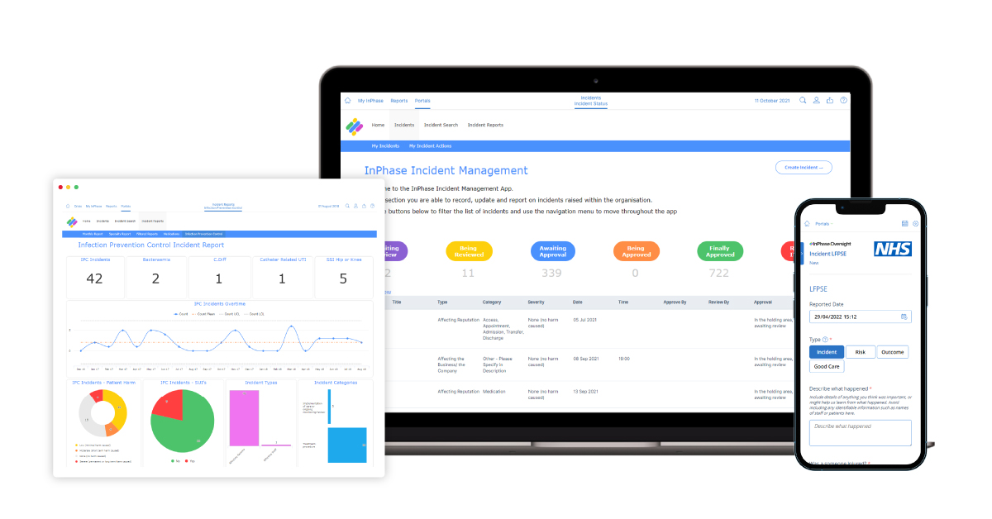
The new Oversight system has several benefits, including:
- Modern feel and easier to use when raising incidents, risks or complaints
- Quicker real-time reporting
- A cloud-based, mobile-friendly platform which can be accessed on iPads
- Features a lessons-learned functionality
- The same system will be used across sites, meaning reports can be accessed on both sites
- Sends alerts out to users
- Customisable, allowing us to develop on it following feedback
The implementation of Oversight forms part of our work to implement the National Patient Safety Strategy at the Trust. Oversight will help enhance the way we learn from patient safety incidents. Not only will this system make and keep us compliant with regulations, but it will also support our goals and keep up with the fast-paced nature of what we do.
We’re excited to see what this partnership will bring and look forward to continuously improving together.
Training on the new system will be available shortly and accessible anywhere.
For more information, please visit the intranet or contact XX NAME XX

InPhase is here!
Introducing Oversight, a new Learn from Patient Safety Events (LFPSE) compliant risk and safety incident management system from InPhase, which replaces our [PREVIOUS SUPPLIER] systems and going live by the end of [XX DATE XX]!
Oversight will be the system we use to report incidents, identify trends and common causes and develop an aligned improvement strategy.
Many benefits of the new system include:
- Modern feel and easier to use when raising incidents, risks or complaints
- Quicker real-time reporting
- A cloud-based, mobile-friendly platform which can be accessed on iPads
- Features a lessons-learned functionality
- The same system will be used across sites, meaning reports can be accessed on both sites
- Sends alerts out to users
- Customisable, allowing us to develop on it following feedback
This software is a vital part of our governance processes and supports our relationships with the CQC, ICB and NHS England. Oversight will help enhance the way we learn from patient safety incidents.
We’re excited to see what this partnership will bring and look forward to continuously improving together.
The information in the current [PREVIOUS] system will move over to Oversight meaning no reports or incidents will be lost.
As we work to implement Oversight with InPhase over the coming weeks, training will be available online which can be accessed on-site or at home.
Please keep an eye out for more communications on this shortly.
In the meantime, if you have any questions, please contact [NAME]

