InPhase is incoming!
The Safeguarding App, the new integrated safeguarding reporting system, from InPhase, will be replacing our [previous supplier] systems and going live on [XX DATE]
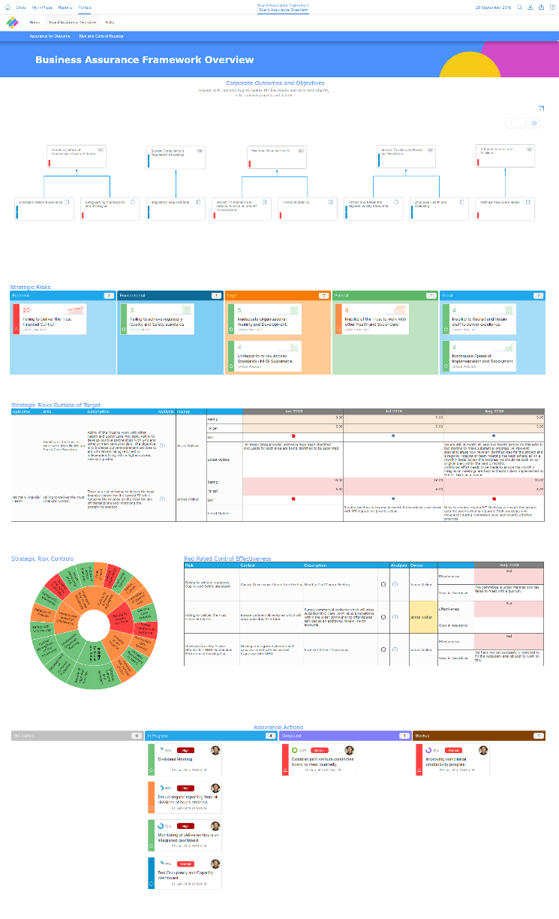
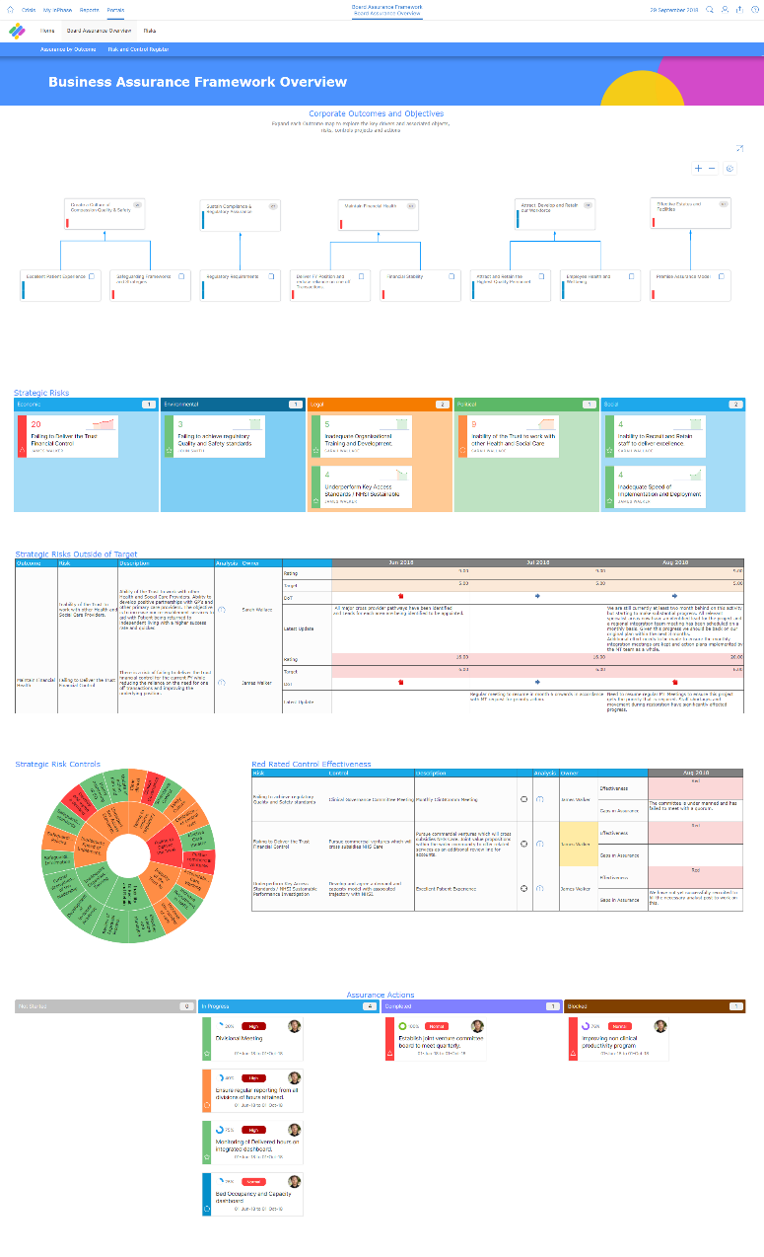
The new safeguarding app has several benefits including:
- Fast Forms decrease the amount of time it takes to report a safeguarding issue with the data immediately uploaded to your database for review, so you can learn and improve from the event
- Simple management of safeguarding reviews to quickly and easily see the review progress of the report, how many you have to review and be able to see approved reviews for future reference
- Intelligent workflows so you can create actions to improve based on the data reported and displayed.
- Triangulate data against CQC Quality, Audits, Incidents, and others to rapidly identify trends, issues and areas for improvement
Implementing the Safeguarding App from InPhase will support us in maintaining care quality, outcomes and patient safety. It will give robust and reliable assurance from team to ward to board and allow us to be more confident in our decisions and actions.
This partnership with InPhase will support our quality improvement and aid us in achieving our goals. The time it saves is invaluable and our ability to mitigate risks and continue to improve will significantly increase.
Training on the new system will be available shortly and will be accessible anywhere.
For more information, please visit the intranet or contact XX NAME XX

InPhase is here.
Introducing The Safeguarding App, the new integrated, digital safeguarding reporting and review management app from InPhase, which replaces our [PREVIOUS PROCESS] and going live by the end of [XX DATE XX].

Implementing the Safeguarding app will support us in maintaining care quality, outcomes, and patient safety. It will give robust and reliable assurance from team to ward to board and allow us to be more confident in our decisions and actions.
The new safeguarding app has several benefits including:
- Fast Forms decrease the amount of time it takes to report a safeguarding issue with the data immediately uploaded to your database for review, so you can learn and improve from the event
- Simple management of safeguarding reviews to quickly and easily see the review progress of the report, how many you must review and be able to see approved reviews for future reference
- Intelligent workflows so you can create actions to improve based on the data reported and displayed
- Triangulate data against CQC Quality, Audits, Incidents, and others to rapidly identify trends, issues, and areas for improvement
This partnership with InPhase will support our quality improvement and aid us in achieving our goals. The time it saves is invaluable and our ability to mitigate risks and continue to improve will significantly increase.
As we work to implement the Safeguarding App with InPhase over the coming weeks, training will be available online which can be accessed on-site or at home.
Please keep an eye out for more communications on this shortly.
In the meantime, if you have any questions, please contact [NAME]

