InPhase is incoming!
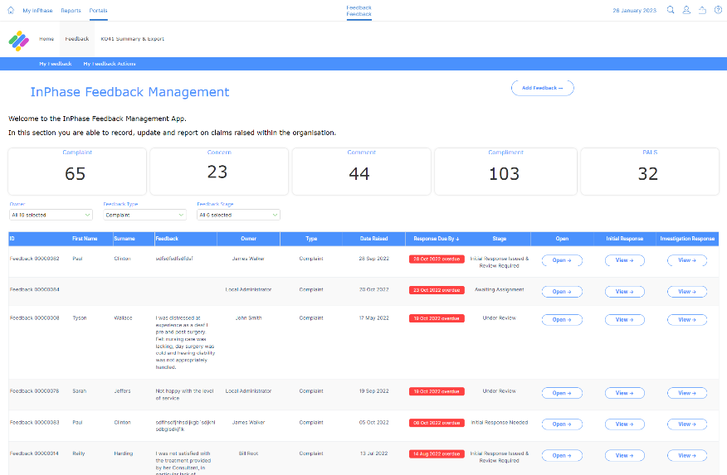
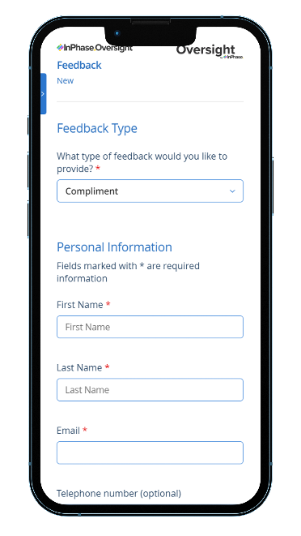
Discover how the brand-new Feedback App coming in from InPhase will transform how we receive, manage and learn from feedback. The new system will replace our [previous supplier or system] and go live on [XX DATE], and we can’t wait!

A few of the incredible benefits we’ll get from this new system are:
- Fast Forms that run at lightning-speed across any device that makes logging a compliment or complaint faster and easier for users than before.
- Intelligent workflows and notifications that make sure complaints and compliments get to the right person, always.
- A personalised dashboard for all managers to see the complaints and compliments relevant to them.
- One, single place to manage feedback from complaints, compliments and PALS for quick and simple review and the ability to celebrate success where we see it.
Once we’ve implemented this transformational feedback system, we’ll have a single place for all feedback, including PALS, complaints and compliments that will help us learn and identify opportunities for improvement. We all want to provide patients with the best care and experience possible as well as encourage each other by celebrating our successes.
Our goals for [our organisation] need the support of a next-level system that can keep up with the fast-paced nature of what we do. We’re excited to partner with InPhase on our continuous journey to improvement and look forward to seeing what we can all achieve together.
Training on the new system will be available shortly and will be accessible anywhere.
For more information, please visit the intranet or contact XX NAME XX
InPhase is here!
The new Feedback App from InPhase is now live! The new feedback, PALS, complaints and compliments management system from InPhase, which replaces [PREVIOUS SUPPLIER OR SYSTEM] and went live on [XX DATE XX]!
As we exit the implementation stage and move forward with using it, we want to shine a light on just how game-changing this new system is.

A reminder of the amazing benefits of our new system are:
- Fast Forms that run at lightning-speed across any device that makes logging a compliment or complaint faster and easier for users than before.
- Intelligent workflows and notifications that make sure complaints and compliments get to the right person, always.
- A personalised dashboard for all managers to see the complaints and compliments relevant to them.
- One, single place to manage feedback from complaints, compliments and PALS for quick and simple review and the ability to celebrate success where we see it.
We’ll have a single repository for all our feedback, including PALS, complaints and compliments that will help us learn and identify opportunities for improvement. We’re excited to partner with InPhase on our continuous journey to improvement and look forward to seeing what we can all achieve together.
As we work to implement the Feedback integrated system with InPhase over the coming weeks, training will be available online which can be accessed on-site or at home.
Please keep an eye out for more communications on this shortly.
In the meantime, if you have any questions, please contact [NAME]

