InPhase is incoming!

The Performance Management App, the new integrated Performance management system, from InPhase, will be replacing our [previous supplier] systems and going live on [XX DATE]
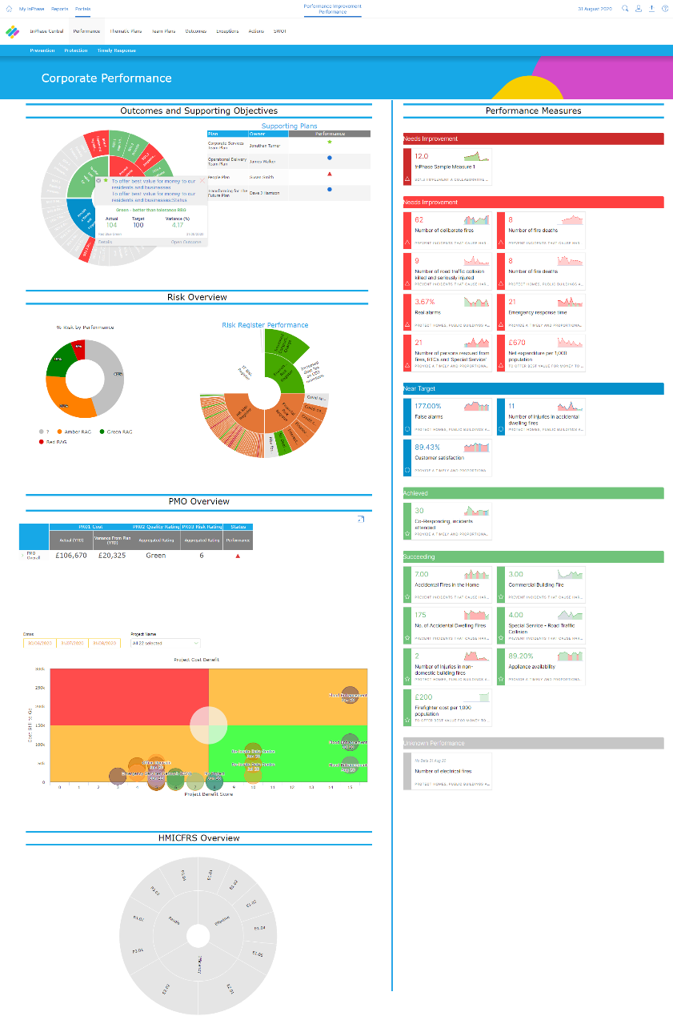

The new system has several benefits including:
- A single, integrated system that deploys project goals, targets and actions to everyone involved in their individual frame of reference
- Align actions with overall performance and improvement goals for maximum impact
- Improve decision making and problem solving with effective performance reporting in real time
- Create a culture of performance for continuous improvement and get everyone actively engaged in our overall performance
The implementation of the integrated Performance system will give us a single place for all performance management information, drive out wasteful actions and be fully customisable to our unique needs.
As we focus on what we can do together as a team, we’re excited to have InPhase on board, supporting us in achieving our goals and bringing us all closer to where we want to be.
Training on the new system will be available shortly and will be accessible anywhere.
For more information, please visit the intranet or contact XX NAME XX

InPhase is here!
Introducing the new Performance Management App, the new project and business planning management system from InPhase, which replaces our [PREVIOUS SUPPLIER] systems and going live by the end of [XX DATE XX]!
The implementation of the integrated Performance system will give us a single place for all performance management information, drive out wasteful actions and be fully customisable to our unique needs.

Many benefits of the new system include:
- A single, integrated system that deploys project goals, targets and actions to everyone involved in their individual frame of reference
- Align actions with overall performance and improvement goals for maximum impact
- Improve decision making and problem solving with effective performance reporting in real time
- Create a culture of performance for continuous improvement
As we focus on what we can do together as a team, we’re excited to have InPhase on board, supporting us in achieving our goals and bringing us all closer to where we want to be.
While we work to implement the Performance integrated system with InPhase over the coming weeks, training will be available online which can be accessed on-site or at home.
Please keep an eye out for more communications on this shortly.
In the meantime, if you have any questions, please contact [NAME]

