InPhase is incoming!
Audit Oversight, the new audit management system from InPhase, will be replacing our [previous supplier] systems and going live in [XX DATE]
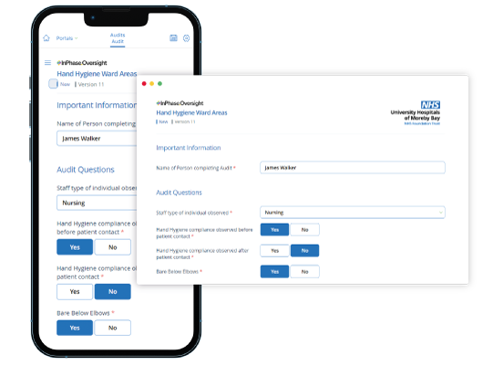
The new Audit Oversight system has a number of benefits including:
- Quicker, more responsive audit forms that show relevant fields only significantly reduce the time it takes to complete audits and increase audit completion rates.
- Quicker reporting that helps us see compliance and completion in real-time and can be filtered by service, division, ward or team for better oversight and insight.
- Cloud-based, mobile-friendly platform, which is accessible on iPads, iPhones and android devices as well as the intranet.
- A customisable question manager that deploys changes Trust-wide immediately with no limit on edits or the number of audits we can create.
The implementation of Audit Oversight will support us in our audit management, increase audit completion rates and create aligned actions for improvement all while having a significant financial and time-saving impact.
Not only this, but we can create specific actions for improvement based on audit results aligned with our broader Trust goals and triangulate audit data against other key care quality information for better oversight and insight into how we can continue to improve.
Our partnership with InPhase will allow us to elevate the way we us our data and we’re looking forward to seeing what we can achieve together.
Training on the new system will be available shortly and will be accessible anywhere.
For more information, please visit the intranet or contact XX NAME XX

InPhase is here!
Introducing Audit Oversight, a new audit management system from InPhase, which replaces our [PREVIOUS SUPPLIER] systems and going live by the end of [XX DATE XX]!
Audit Oversight will be the system we use to manage and complete audits, increase completion rates and create aligned actions for improvement.
The implementation of Audit Oversight will support us in our audit management, increase audit completion rates and create aligned actions for improvement all while having a significant financial and time-saving impact.
Not only this, but we can create specific actions for improvement based on audit results aligned with our broader Trust goals and triangulate audit data against other key care quality information for better oversight and insight into how we can continue to improve.
Many benefits of the new system include:
- Quicker, more responsive audit forms that show relevant fields only, significantly reduce the time it takes to complete audits, and increasing audit completion rates.
- Quicker reporting that help us see compliance and completion in real-time and can be filtered by service, division, ward or team for better oversight and insight.
- Cloud-based, mobile friendly platform, which is accessible on iPads, iPhone and android devices as well as the intranet.
- A customisable question manager that deploys changes Trust-wide immediately with no limit on edits or the amount of audits we can create.

Our partnership with InPhase will allow us to elevate the way we us our data and we’re looking forward to seeing what we can achieve together.
This software is a vital part of our governance processes, as well as supporting our relationships with the CQC, ICB and NHS England.
As we work to implement Oversight with InPhase over the coming weeks, training will be available online which can be accessed on-site or at home.
Please keep an eye out for more communications on this shortly.
In the meantime, if you have any questions, please contact [NAME]

