InPhase is incoming!
The Board Assurance Framework App, the new integrated Board Assurance Framework, from InPhase, will be replacing our [previous supplier] systems and going live on [XX DATE]
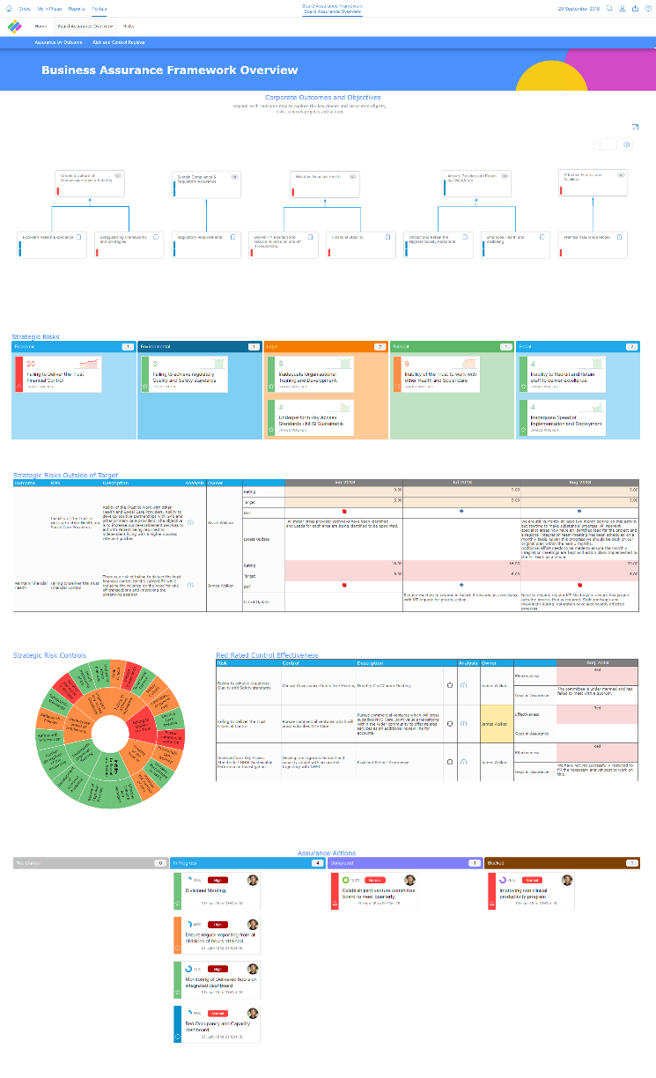
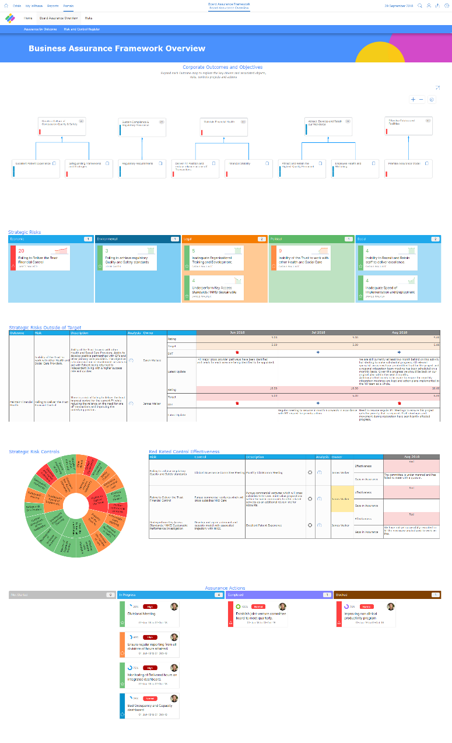
The new Board Assurance Framework has several benefits including:
- Save incredible amounts of time each month by digitising reports and data collection and disseminating data collection to wider teams for a more efficient, modernised Board Assurance Framework
- Shorter improvement cycles with the help of real-time reports and connectivity to mitigate risks before they happen
- Better insight, foresight and oversight into risks thanks to responsive dashboards that can digitise board meetings with the ability to drill down into, analyse and comment on risk data for the Trust
- Provide complete, accurate and up-to-date information to the board for full trust in the data and robust, reliable assurance.
Implementing the Board Assurance Framework will support us in maintaining care quality, outcomes and patient safety. It will give robust and reliable assurance from team to ward to board and allow us to be more confident in our decisions and actions.
This partnership with InPhase will support our quality improvement and aid us in achieving our goals. The time it saves is invaluable and our ability to mitigate risks and continue to improve will significantly increase.
Training on the new system will be available shortly and will be accessible anywhere.
For more information, please visit the intranet or contact XX NAME XX

InPhase is here!
Introducing The Board Assurance Framework App, the new integrated, digital Board Assurance Framework from InPhase, which replaces our [PREVIOUS POCESS] and going live by the end of [XX DATE XX]!
Implementing the Board Assurance Framework will support us in maintaining care quality, outcomes and patient safety. It will give robust and reliable assurance from team to ward to board and allow us to be more confident in our decisions and actions.

Many benefits of the new system include:
- Save incredible amounts of time each month by digitising reports and data collection and disseminating data collection to wider teams for a more efficient, modernised Board Assurance Framework
- Shorter improvement cycles with the help of real-time reports and connectivity to mitigate risks before they happen
- Better insight, foresight and oversight into risks thanks to responsive dashboards that can digitise board meetings with the ability to drill down into, analyse and comment on risk data for the Trust
- Provide complete, accurate and up-to-date information to the board for full trust in the data and robust, reliable assurance.
This partnership with InPhase will support our quality improvement and aid us in achieving our goals. The time it saves is invaluable and our ability to mitigate risks and continue to improve will significantly increase.
As we work to implement the Board Assurance Framework App with InPhase over the coming weeks, training will be available online which can be accessed on-site or at home.
Please keep an eye out for more communications on this shortly.
In the meantime, if you have any questions, please contact [NAME]

