InPhase is incoming!
The brand-new Risk App, the new integrated Risk management system from InPhase, will be replacing our [previous supplier] systems and going live on [XX DATE]
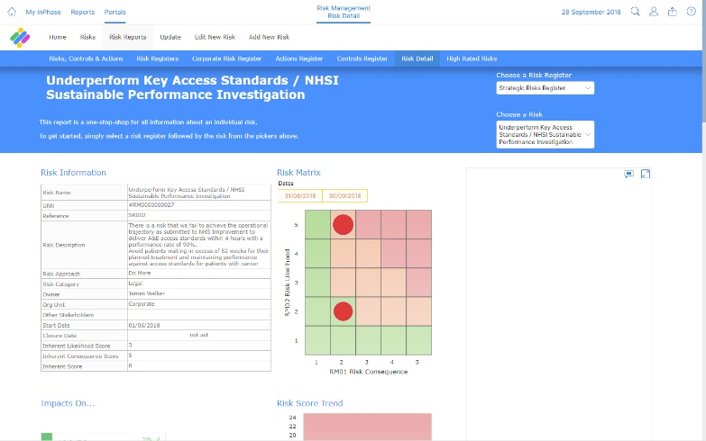
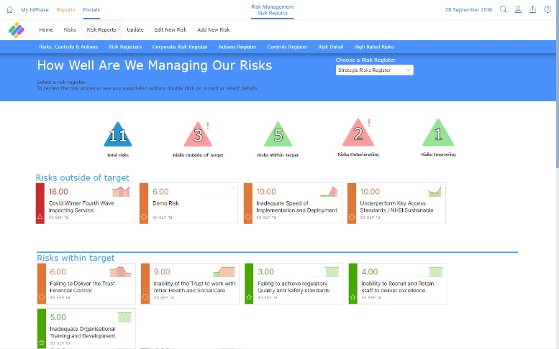

The new Risk app has several benefits, including:
- Clear and visual reports for real-time awareness to mitigate risks before they happen
- Modernise and speed up the risk management process for better risk management decision-making to handle risks correctly
- Complete oversight of aligned actions to mitigate risks for robust and reliable assurance
- Creates a culture of effortless risk management and mitigation through the dissemination of risk management to broader team members
Implementing the Risk Management App will support us in mitigating risks before they happen. With at-a-glance dashboards and aligned actions, we’ll be able to make risk management relevant and straightforward, ensure compliance and predict risks to lessen their effects. As well as this, we’ll be able to support our risk manager(s) and work together to create a culture of commitment to improvement and safety.
Training on the new system will be available shortly and will be accessible anywhere.
For more information, please visit the intranet or contact XX NAME XX

InPhase is here!

Introducing Risk from InPhase, the new risk management system, replacing our [PREVIOUS SUPPLIER or system]and goes live by the end of [XX DATE XX]!
Implementing the Risk Management App will support us in mitigating risks before they happen. With at-a-glance dashboards and aligned actions, we’ll be able to make risk management relevant and straightforward, ensure compliance and predict risks to lessen their effects. As well as this, we’ll be able to support our risk manager(s) and work together to create a culture of commitment to improvement and safety.

Many benefits of the new system include the following:
- Clear and visual reports for real-time awareness to mitigate risks before they happen
- Modernise and speed up the risk management process for better risk management decision-making to handle risks correctly
- Complete oversight of aligned actions to mitigate risks for robust and reliable assurance
- Creates a culture of effortless risk management and mitigation through the dissemination of risk management to broader team members

As we work to implement Risk Management App with InPhase over the coming weeks, training will be available online and can be accessed on-site or at home.
Please keep an eye out for more communications on this shortly.
In the meantime, if you have any questions, please contact [NAME]

