InPhase is incoming!
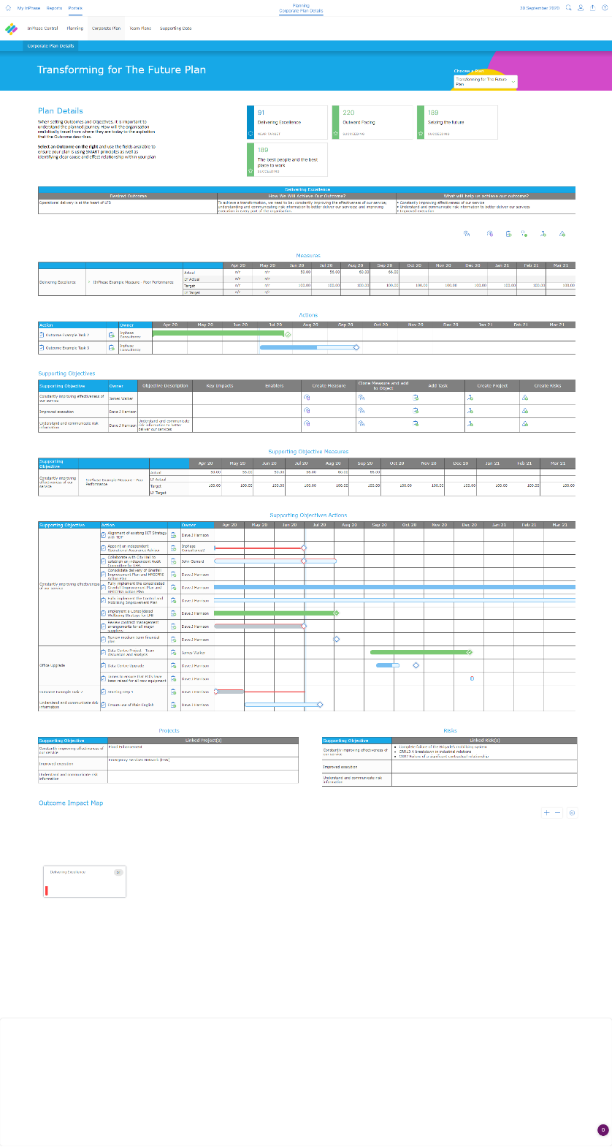
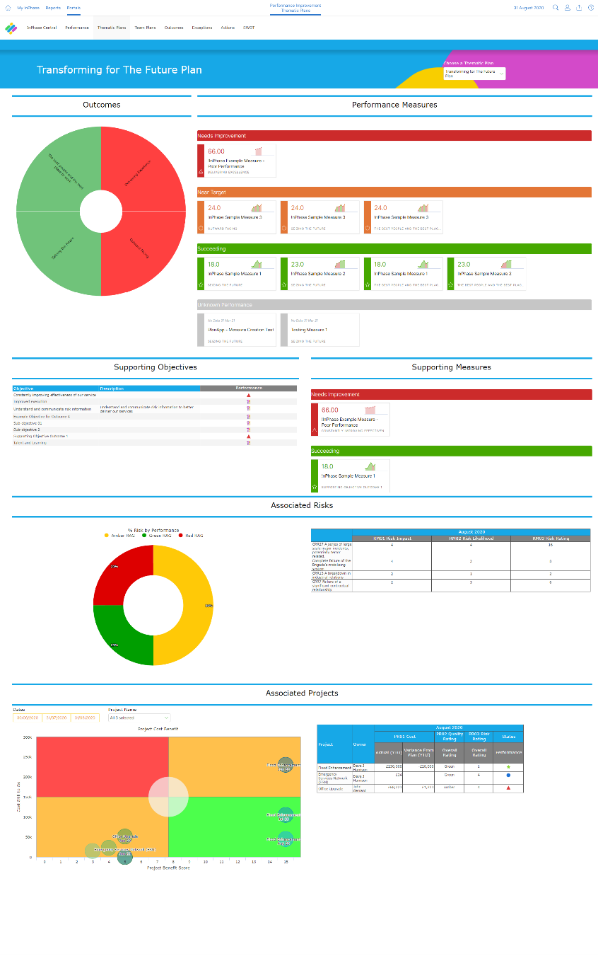
The Planning App, the new integrated Planning management system, from InPhase, will be replacing our [previous supplier] systems and going live on [XX DATE]

The new system has several benefits including:
- A single, integrated system creating one hub to manage all organisation plans deployed to each user in their frame of reference
- Easily see what needs our most urgent attention, creating a culture of focus and drive for maximum impact
- Improve decision making and problem solving thanks to being able to identify problem areas quickly and easily mitigate risks
- Real-time strategy deployment, with easily defined measures that allow us to see the impact of our actions aligned with goals
The implementation of the integrated Planning system will support us our project planning, give us real-time strategy deployment, help us manage actions and improve engagement and accountability.
Training on the new system will be available shortly and will be accessible anywhere.
For more information, please visit the intranet or contact XX NAME XX

InPhase is here!
Introducing the new Planning Management App, the new project and business planning management system from InPhase, which replaces our [PREVIOUS SUPPLIER] systems and going live by the end of [XX DATE XX]!
The implementation of the integrated Planning system will support us our project planning, give us real-time strategy deployment, help us manage actions and improve engagement and accountability.

Many benefits of the new system include:
- A single, integrated system creating one hub to manage all organisation plans deployed to each user in their frame of reference
- Easily see what needs our most urgent attention, creating a culture of focus and drive for maximum impact
- Improve decision making and problem solving thanks to being able to identify problem areas quickly and easily mitigate risks
- Real-time strategy deployment, with easily defined measures that allow us to see the impact of our actions aligned with goals
As we work to implement the Planning integrated system with InPhase over the coming weeks, training will be available online which can be accessed on-site or at home.
Please keep an eye out for more communications on this shortly.
In the meantime, if you have any questions, please contact [NAME]

