InPhase is incoming!
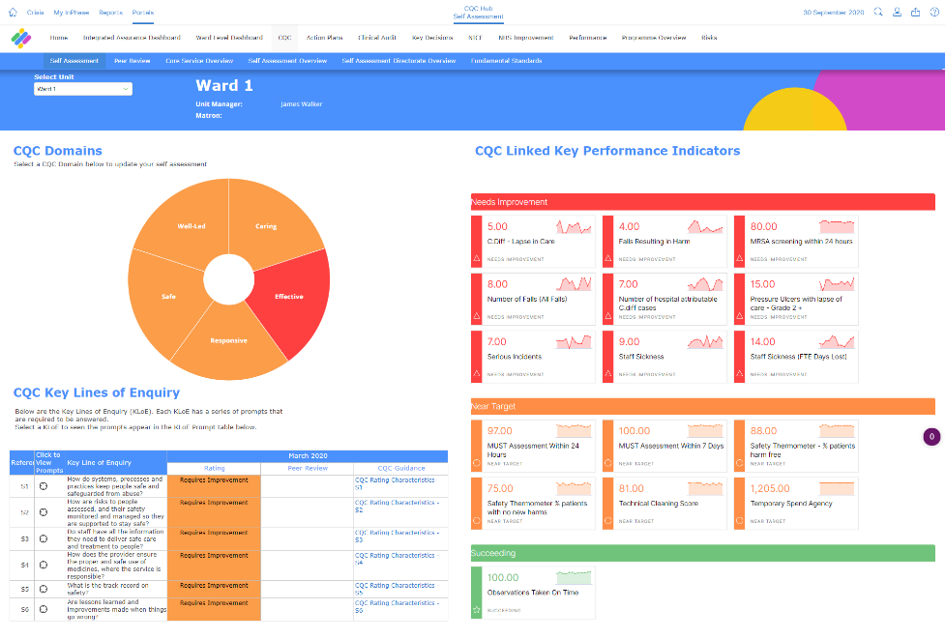
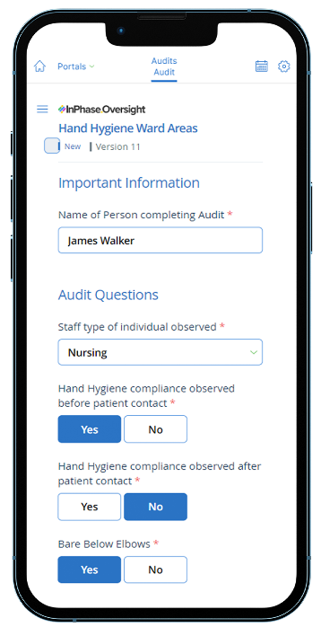
Quality Oversight, the new quality management system from InPhase, will be replacing our [previous supplier] systems and going live on [XX DATE]

The new Quality Oversight system has amazing benefits including:
- Modern feel and easier to use for us to run and manage CQC self-assessments.
- Quicker, real-time reporting against our KLoEs and other key care quality information for better insight, foresight and oversight of where we are before CQC visits.
- Cloud-based, mobile friendly platform, which is accessible on iPads, iPhone and android devices as well as the intranet.
- Aligned actions with broader improvement goals for the most impactful and strategic use of our time.
The implementation of Quality Oversight will support us in our Plan Do Study Act cycles of improvement by making our CQC self-assessments, NICE guidance compliance and quality improvement strategy easier and quicker to manage than before. We will have a clear understanding of where we stand with our CQC self-assessments before inspections and, more importantly, be able to create detailed and impactful plans to improve.
This partnership with InPhase will help us take our Trust to the next level and be a better base of support for the various lines of care quality we provide. We’re excited to have a system in place that can match the speed at which we do things.
Training on the new system will be available shortly and will be accessible anywhere.
For more information, please visit the intranet or contact XX NAME XX

InPhase is here!
Introducing Oversight, a new quality management system from InPhase, which replaces our [PREVIOUS SUPPLIER] systems and going live by the end of [XX DATE XX]!
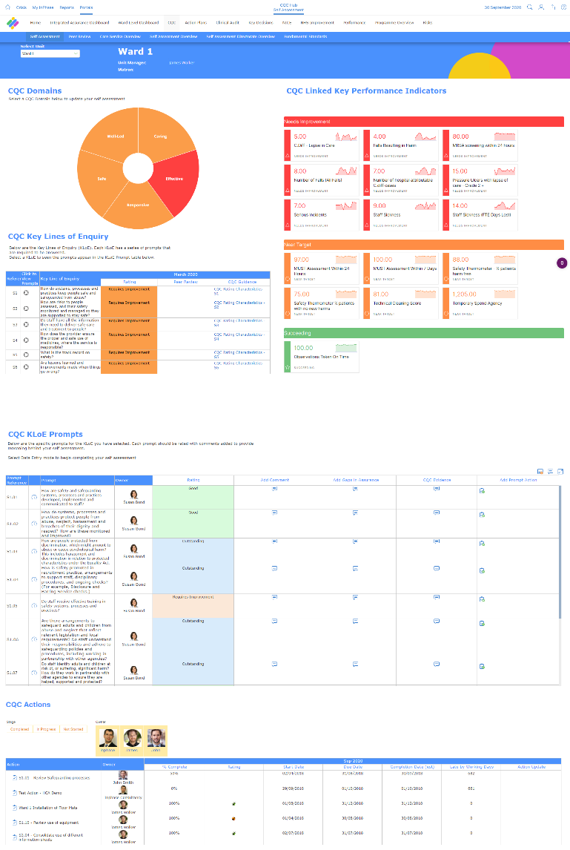
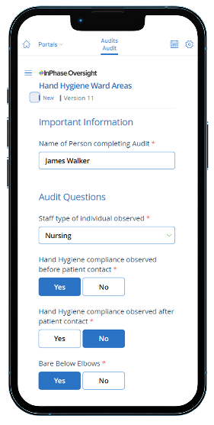
The implementation of Quality Oversight will support us in our Plan Do Study Act cycles of improvement by making our CQC self-assessments, NICE guidance compliance and quality improvement strategy easier and quicker to manage than before. We will have a clear understanding of where we stand with our CQC self-assessments before inspections and, more importantly, be able to create detailed and impactful plans to improve.

Many benefits of the new system include:
- Modern feel and easier to use for us to run and manage CQC self-assessments.
- Quicker, real-time reporting against our KLoEs and other key care quality information for better insight, foresight and oversight of where we are before CQC visits.
- Cloud-based, mobile friendly platform, which is accessible on iPads, iPhone and android devices as well as the intranet.
- Aligned actions with broader improvement goals for the most impactful and strategic use of our time.
This software is a vital part of our governance processes, as well as supporting our relationships with the CQC, ICB and NHS England.
This partnership with InPhase will help us take our Trust to the next level and be a better base of support for the various lines of care quality we provide. We’re excited to have a system in place that can match the speed at which we do things.
As we work to implement Oversight with InPhase over the coming weeks, training will be available online which can be accessed on-site or at home.
Please keep an eye out for more communications on this shortly.
In the meantime, if you have any questions, please contact [NAME]

