InPhase is incoming!
The Project Management App, the new integrated Project Management system, from InPhase, will be replacing our [previous supplier] systems and going live on [XX DATE]
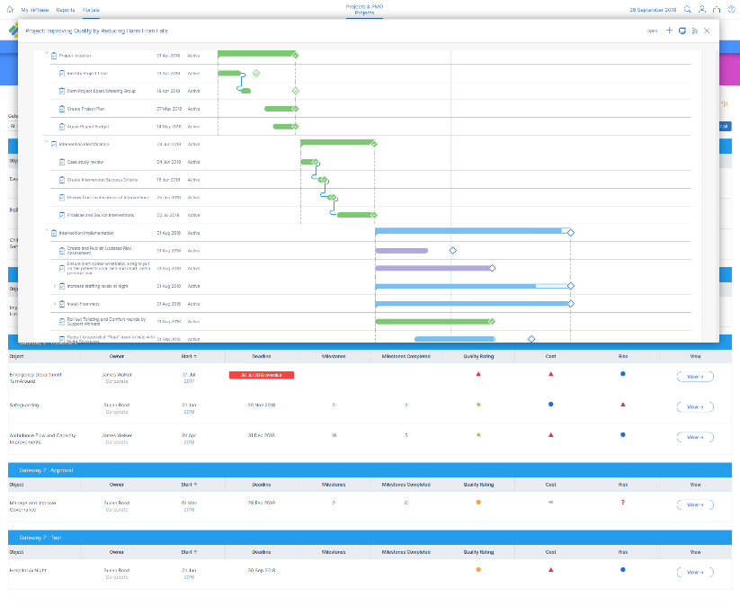
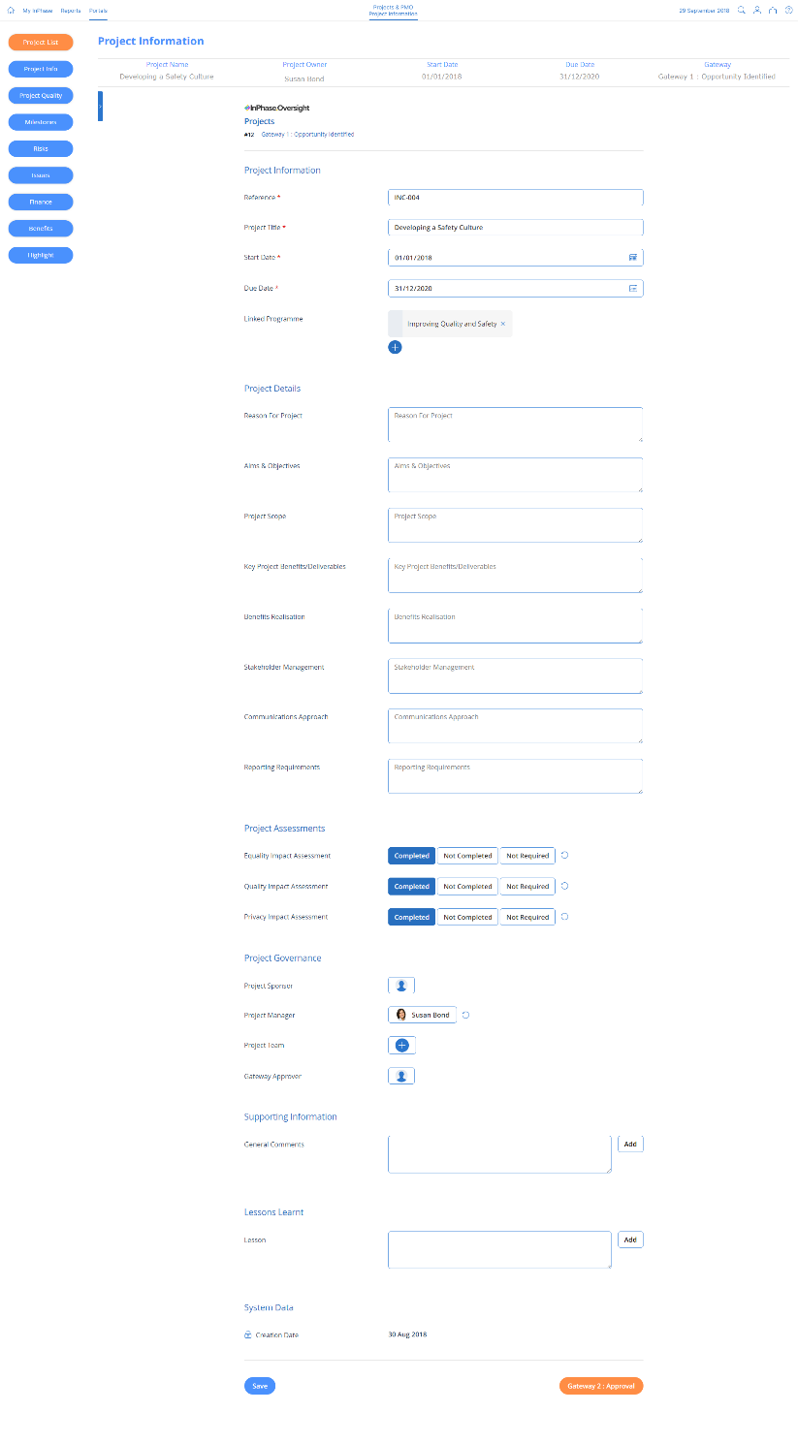

The new system has several benefits, including:
- A single, integrated system that deploys project goals, targets and actions to everyone involved in their frame of reference
- Align actions with overall project goals and improvement goals for maximum impact
- Improve decision-making and problem-solving with effective reporting in real time
- Create a culture of performance for continuous improvement
The implementation of the integrated Project Management system will give us a single place for all Project Management information, drive out wasteful actions and be fully customisable to our unique needs. This new system will give us a digitised framework of our projects and complete oversight of progress, what’s going well and where we need to focus our efforts.

As we focus on our goals and work towards continuous improvement, we look forward to what we will be able to achieve with InPhase.

Training on the new system will be available shortly and will be accessible anywhere.
For more information, please visit the intranet or contact XX NAME XX

InPhase is here!
Introducing the new Project Management App, the new project and business planning management system from InPhase, which replaces our [PREVIOUS SUPPLIER] systems and going live by the end of [XX DATE XX]!

The implementation of the integrated Project Management system will give us a single place for all our Project Management information, drive out wasteful actions and be fully customisable to our unique needs. This new system will give us a digitised framework of our projects and complete oversight of progress, what’s going well and where we need to focus our efforts.

Many benefits of the new system include:
- A single, integrated system that deploys project goals, targets and actions to everyone involved in their individual frame of reference
- Align actions with overall project goals and improvement goals for maximum impact
- Improve decision making and problem solving with effective reporting in real time
- Create a culture of performance for continuous improvement
While we work to implement the Project Management integrated system with InPhase over the coming weeks, training will be available online which can be accessed on-site or at home.

As we focus on our goals and work towards continuous improvement, we look forward to what we will be able to achieve with InPhase.

Please keep an eye out for more communications on this shortly.
In the meantime, if you have any questions, please contact [NAME]

