InPhase is incoming!
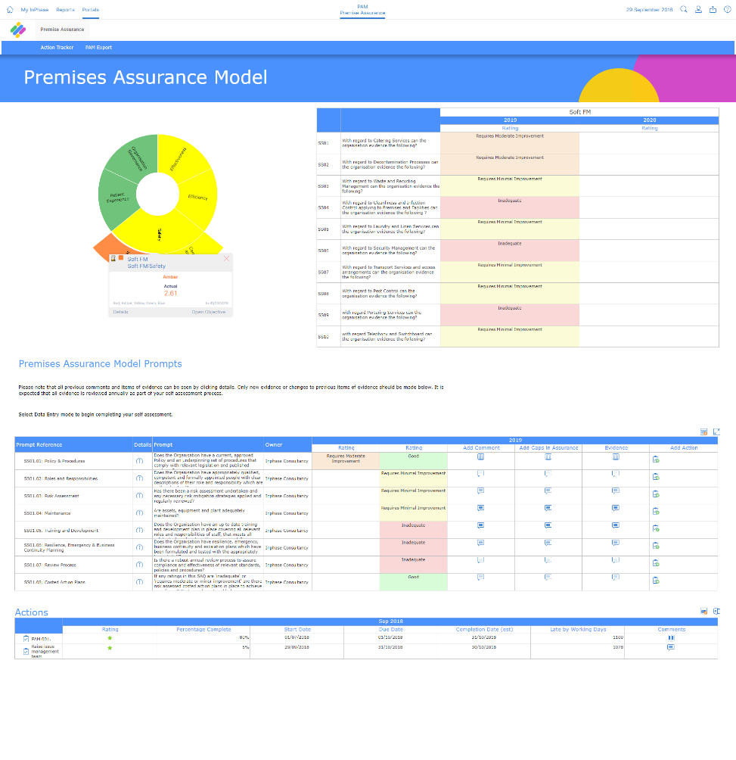
The Premise Assurance Model App, the new integrated Premise Assurance Model management app, from InPhase, will be replacing our [previous supplier] systems and going live on [XX DATE]

The new Premise Assurance Model has several benefits including:
- Always updated with the latest regulations.
- An entire view of our whole PAM process.
- Auditing, built-in action management and fully linked risks.
- Cloud-based, mobile friendly platform, which is accessible on iPads, iPhone and android devices as well as the intranet.
The implementation of the Premise Assurance Model (PAM) will support us in managing our entire PAM process. With at-a-glance dashboards, aligned actions and integrated self-assessment, quality assurance, auditing, inspections, risk assessments, and more, we’ll experience better decision making, save valuable clinical and non-clinical time and better collaboration between teams and departments.
Training on the new system will be available shortly and will be accessible anywhere.
For more information, please visit the intranet or contact XX NAME XX

InPhase is here!
Introducing the new Premise Assurance Model (PAM), the new PAM management system from InPhase, which replaces our [PREVIOUS SUPPLIER] systems and going live by the end of [XX DATE XX]!
The implementation of the Premise Assurance Model App will support us in managing our entire PAM process. With at-a-glance dashboards, aligned actions and integrated self-assessment, quality assurance, auditing, inspections, risk assessments, and more, we’ll experience better decision making, save valuable clinical and non-clinical time and better collaboration between teams and departments.

Many benefits of the new system include:
- Always updated with the latest regulations.
- An entire view of our whole PAM process.
- Auditing, built-in action management and fully linked risks.
- Cloud-based, mobile friendly platform, which is accessible on iPads, iPhone and android devices as well as the intranet.
As we work to implement the Premise Assurance Model App with InPhase over the coming weeks, training will be available online which can be accessed on-site or at home.
Please keep an eye out for more communications on this shortly.
In the meantime, if you have any questions, please contact [NAME]

