InPhase – CQC
User Guide

Contents
General Navigation and User Preferences 3
Accessing the Site 3
Username and Password 3
Navigation 4
Changing Password 4
View Date 6
General Functionality 7
Data Entry Mode 7
Performance Pop Up 7
Adding an Action 7
Adding a Comment 8
Page Selectors 9
CQC 10
Self Assessment 10
CQC Quality Statements 10
What this Quality Statement means 11
CQC Evidence 11
CQC Actions 11
Peer Review 12
Self Assessment Overview 13
Self Assessment Directorate Overview 13
CQC Self Assessment Progress 14
CQC Evidence Library 14
CQC Fundamental Standards 15

General Navigation and User Preferences

Accessing the Site
To access InPhase, enter the following website into any web browser:

https://oversight.inphase.com

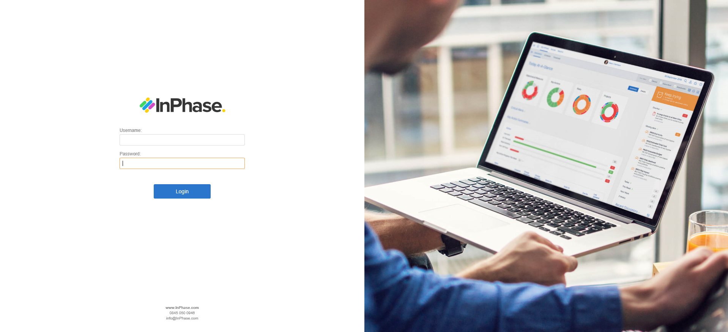

Username and Password

Usernames and passwords can be granted by an administrator.

The username format is: FirstName Surname

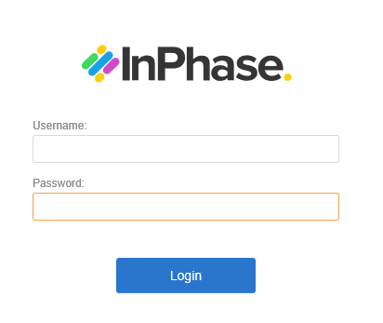

Navigation
To navigate to an App, click on the relevant option on the menu.
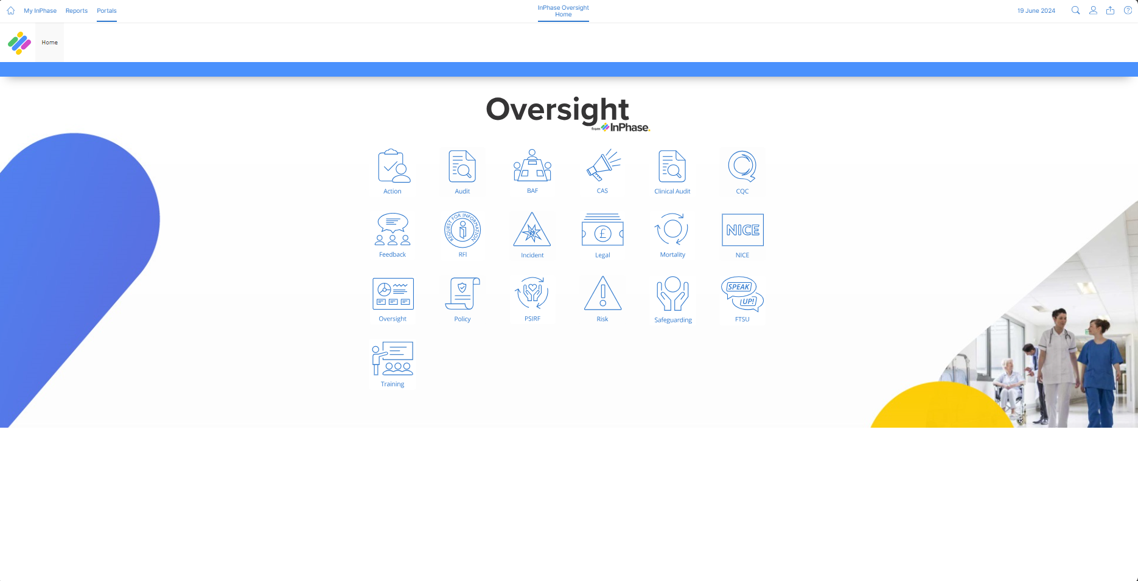

To return to the HOME page, to access your personal dashboard or to refresh the page you are on use the icons in the top left-hand corner of the screen

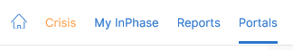

Changing Password
Click on the person icon at the top right-hand corner of the screen. Select Profile from the drop-down menu.

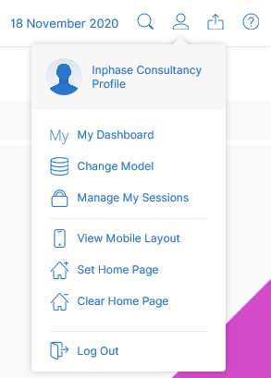

Enter your new password in the fields provided and click save.

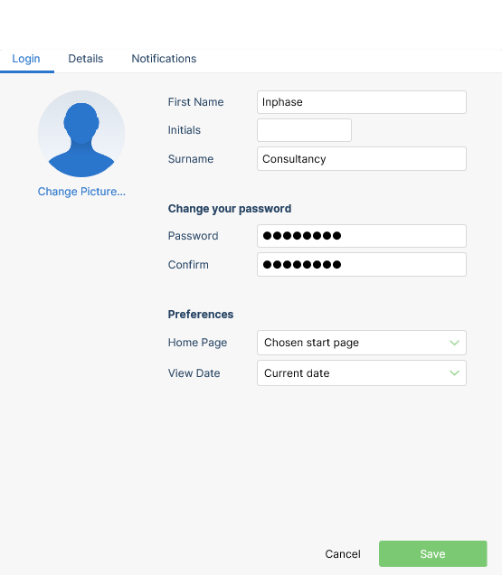

You will notice that you have other preferences that you can change on the profile pop up also.

View Date
Data entered and displayed in InPhase is tracked by date. This means that if you wish to see past date or future time periods you can by simply changing the view date.

The view date is in the top right-hand corner of the screen. Click the date to produce the calendar.

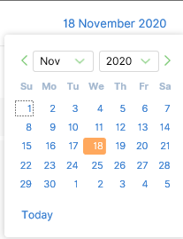

General Functionality
This section documents functions that are used throughout InPhase.

Data Entry Mode
InPhase has a number of tables where data can be entered or changed. The ability to add or change data is dictated by the Data Entry Mode icon. This icon will be positioned to the right-hand side of the table.

Clicking the icon will refresh the table and allow data to be entered or changed.

To exit data entry mode the select the following icon.



Performance Pop Up
If the option to see DETAILS is available either via an icon or by right clicking on an item, then a performance pop up is available

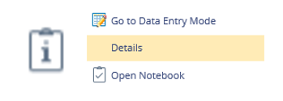

Performance pop ups allow you to either view and edit data (if an action) or view trend information.

Adding an Action
In each module there are areas to add actions. These will be displayed as either page buttons or table icons. Adding an action regardless of the module or page you are on requires the same process.



Clicking on either an Add Action button or Icon will produce the Action pop.

The following fields need to be completed:

- Name
  - Limited to 100 Characters. Should be clear and concise to what the action is.
- Start
  - Calendar Selector. Date of when action will start
- Completion (est)
  - Calendar Selector. Data of when action is estimated (or actually) completed. When first adding a task this should be set as the same as the Due Date
- Due
  - Calendar Selector. Date of when action is due to be completed by
- Owner
  - Defaults to the user adding the action. Can be changed if someone else will be responsible for completing the action

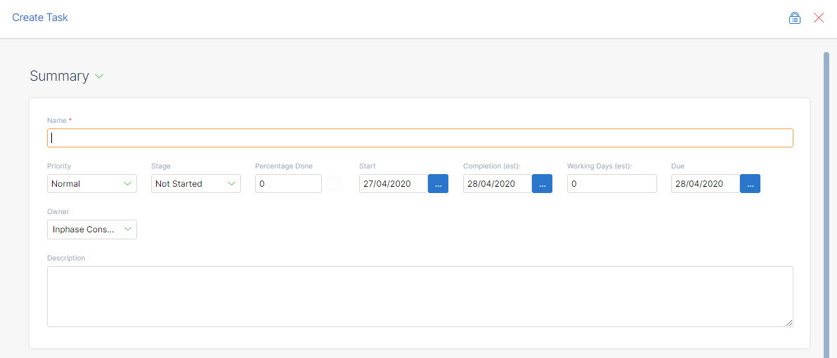

Once you have completed the required fields click Create.

Adding a Comment
Anywhere within InPhase the following icons are seen mean a comment or document can be added.


Clicking on either of the above icons will produce a comments pop up box. Type comment in the space provided and click save.

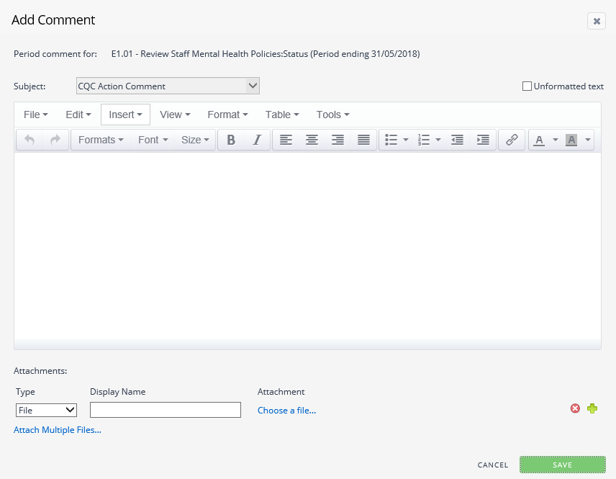

*TIP – You can attach documents or links to a comment using the attachments part at the bottom of the pop up

Page Selectors
On multiple pages you will have the ability to use a drop-down list to control the data displayed on the screen.

Click on the drop-down list to activate it. Either scroll through the available list or start to type into the box provided and the list will auto filter.

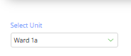

*TIP – Use an Asterix as a wildcard function. The system will then search for anything that contains that word

Once you have made your selection the page will begin to refresh and show data aligned with the selection.

CQC

The CQC Landing page shows the aggregated scores for the 5 Key Questions. The Overall Completion %, and a breakdown by ‘Division’.

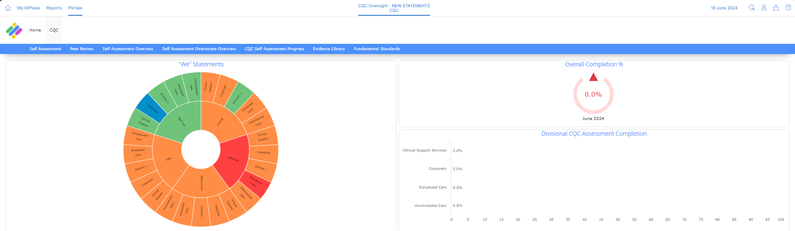

Self-Assessment

This page is controlled by the dropdown selection box. Once a selection has been made, the user can select a CQC Key Question from the Sunburst visualisation.

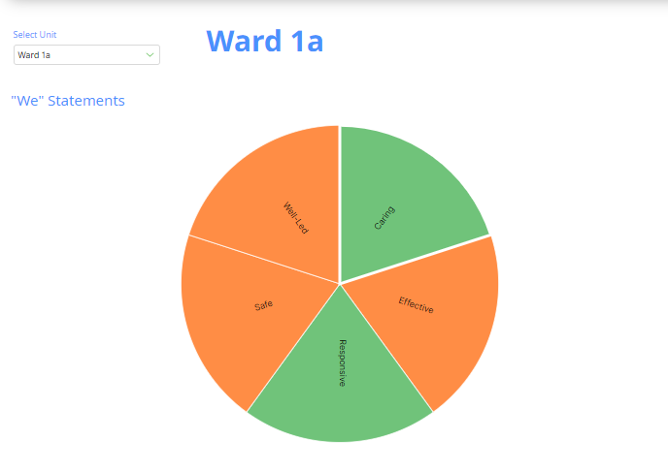

CQC Quality Statements

This table will update depending on the segment selected in the Sunburst. It shows the details of each Quality Statement associated to the selected Key Question, with the previous Performance Rating for the Quality Statement, as well as the current rating.

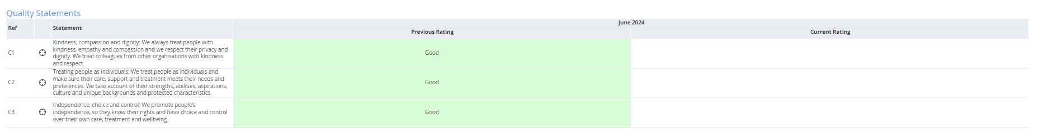

The user can select a Quality Statement by clicking on the ‘focus’ icon, to pass the information to the following table.

What this Quality Statement means

Once a specific Quality Statement has been put into focus, this table will update with the low level ‘prompt’ information, as well as the relevant ‘I Statements’. It is at this level that the assessment is made, and the user can make an assessment by entering Data Entry Mode using the icon in the top right corner of the tables.

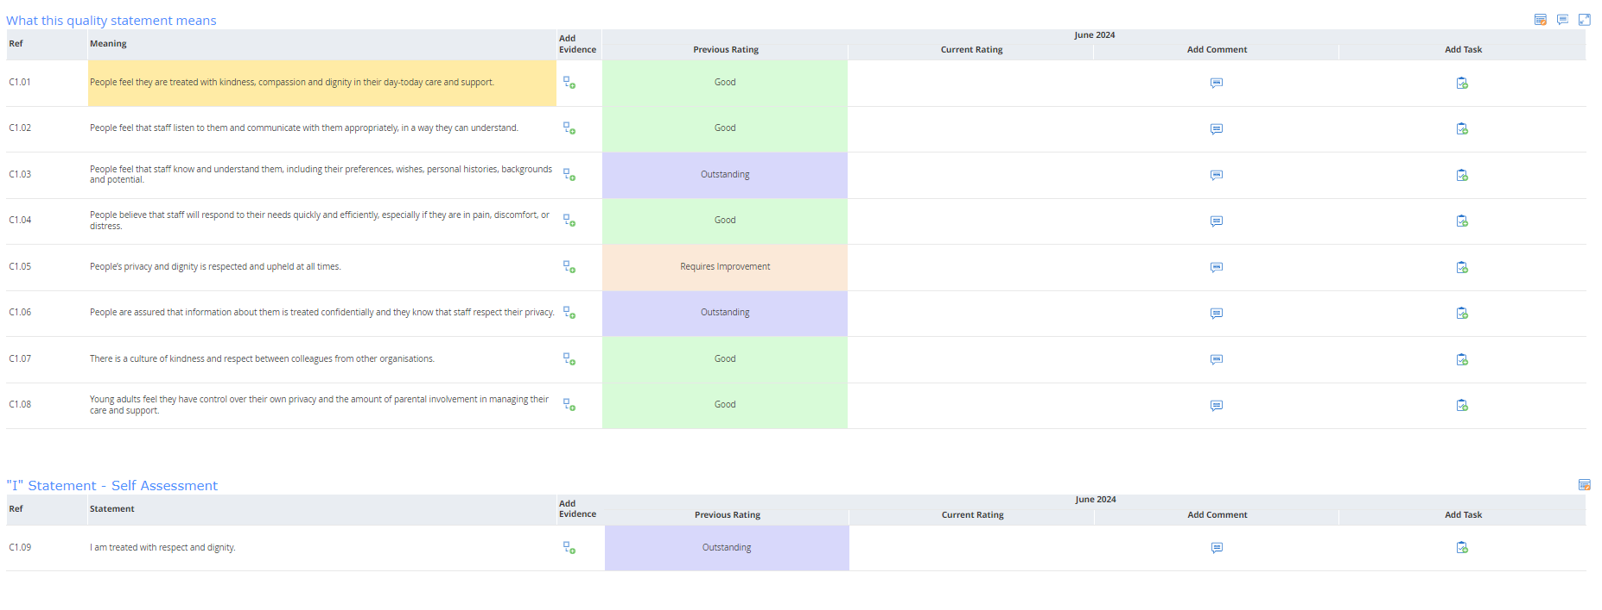

In addition to adding a rating, the user can also enter commentary against the comment subjects in the table and add Actions in relation to the Prompts.

CQC Evidence

Any evidence attributed to the Key Question will display in the table. Enter Data Entry mode to leave an evidence rating.

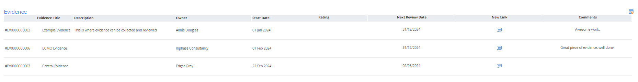

CQC Actions

This table displays all actions added against prompts which fall under the CQC Domain selected in the Sunburst. The user can enter Data Entry Mode to edit/update the details.

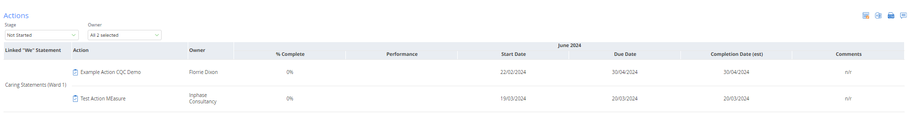

Peer Review

This page allows the Self-Assessment to be peer-reviewed, so the peer rating sits alongside the rating given by the Org Unit in question. The page is again driven by the dropdown selection box, which will populate the five Sunbursts, each containing the performance ratings of the CQC Key Questions and Quality Statements.

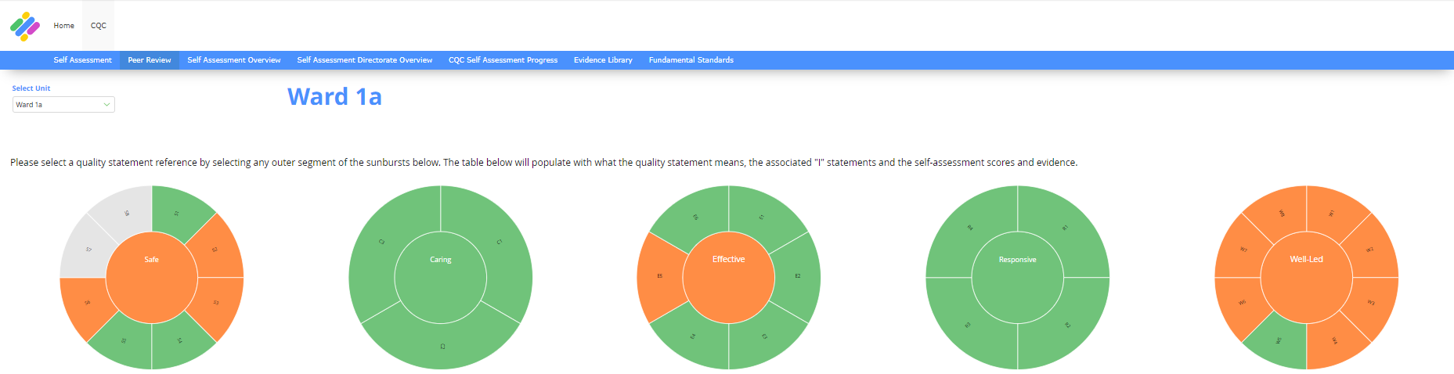

By selecting a segment on one of the Sunbursts, the user can display the Prompts and I Statements in the tables below.

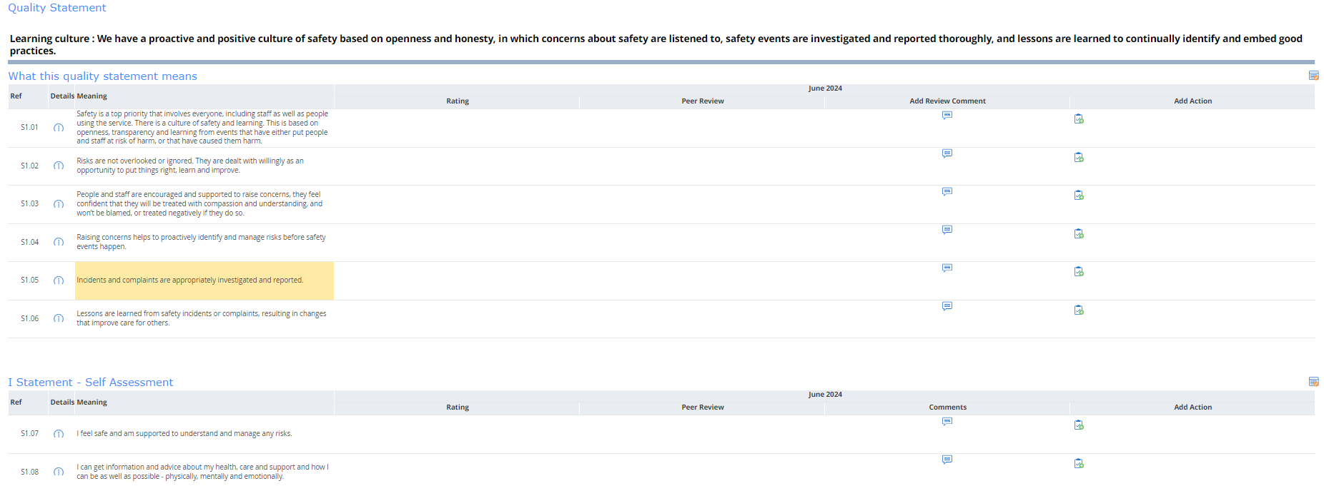

As with the Self-Assessment, the user can now enter Data Entry Mode and enter a rating in the Peer Review column.

Any Actions added will display in the Action table. The user can enter Data Entry Mode to edit/update the details.

At the foot of the page, there is a table containing Questions for the Peer Reviewer to complete.

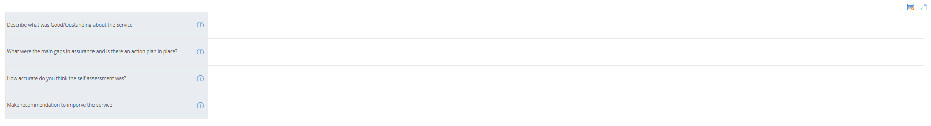

Self-Assessment Overview

This page contains a table showing the CQC Key Question performance at the Org Unit level.

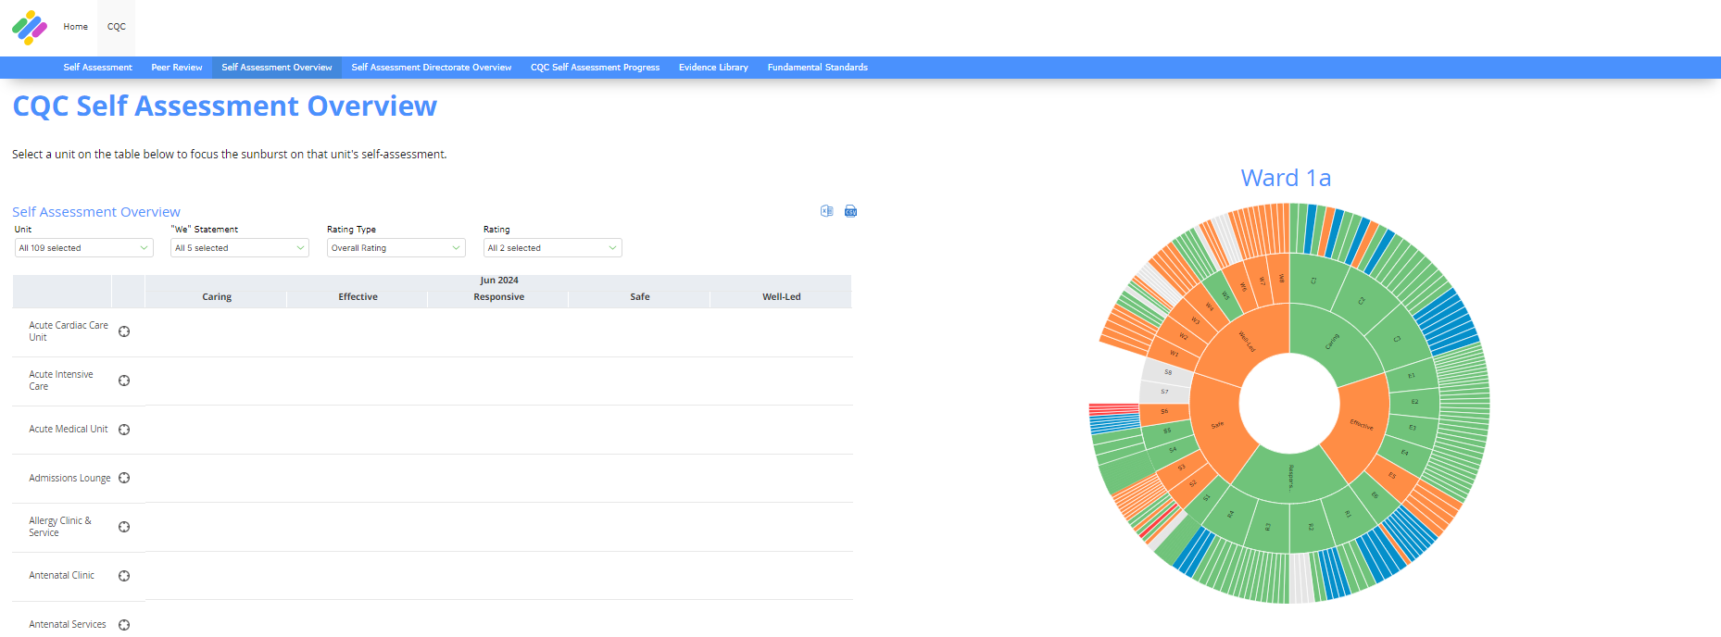

Selecting a Unit from the table will focus the Sunburst. The innermost level shows the CQC Key Question performance for the Unit, with the middle and outer level showing the scores for the Quality Statements and Prompts/I Statements respectively.

Self-Assessment Directorate Overview

This page contains a table showing the CQC Domain performance at a Directorate level.

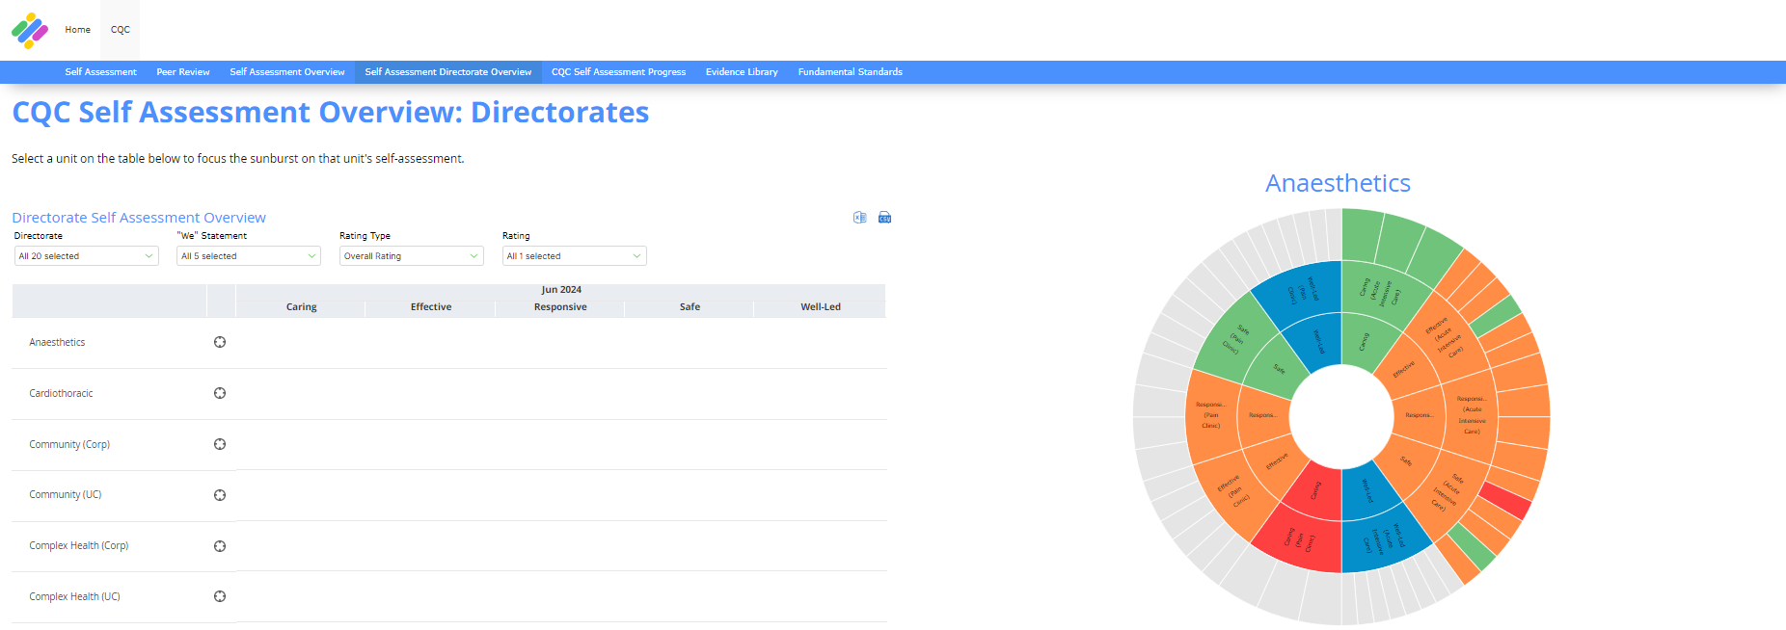

Selecting a Directorate from the table will focus the Sunburst. The innermost level shows the CQC Key Question performance for the Directorate, with the middle and outer level showing the scores for the Directorate’s Units, and the Unit Quality Statement scores respectively.

CQC Self-Assessment Progress

This page displays the Completion performance data for each Org Unit that completes the CQC Self-Assessment. Where data is present, the icon for each Key Question will display the overall rating, and historical completion performance can be seen in the ‘Sparkline’ in the column to the right-hand side of the page.

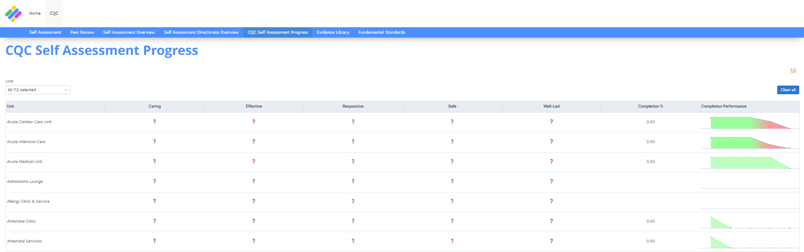

CQC Evidence Library

This page is a central store for all Evidence within the CQC App.

Evidence can be added via the Self-Assessment page, but also by clicking the ‘Add Evidence’ button.

Once in Data Entry Mode, the user can update the Evidence rating, link the Evidence to a Self-Assessment Key Question, as well as adding evidence links and comments.

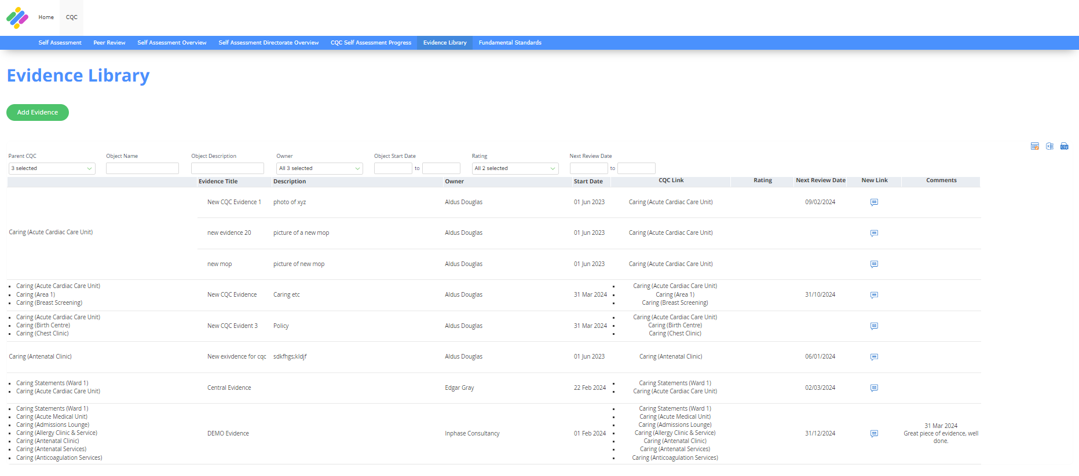

CQC Fundamental Standards

This page contains Performance Cards, with each card representing a CQC Fundamental Standard.

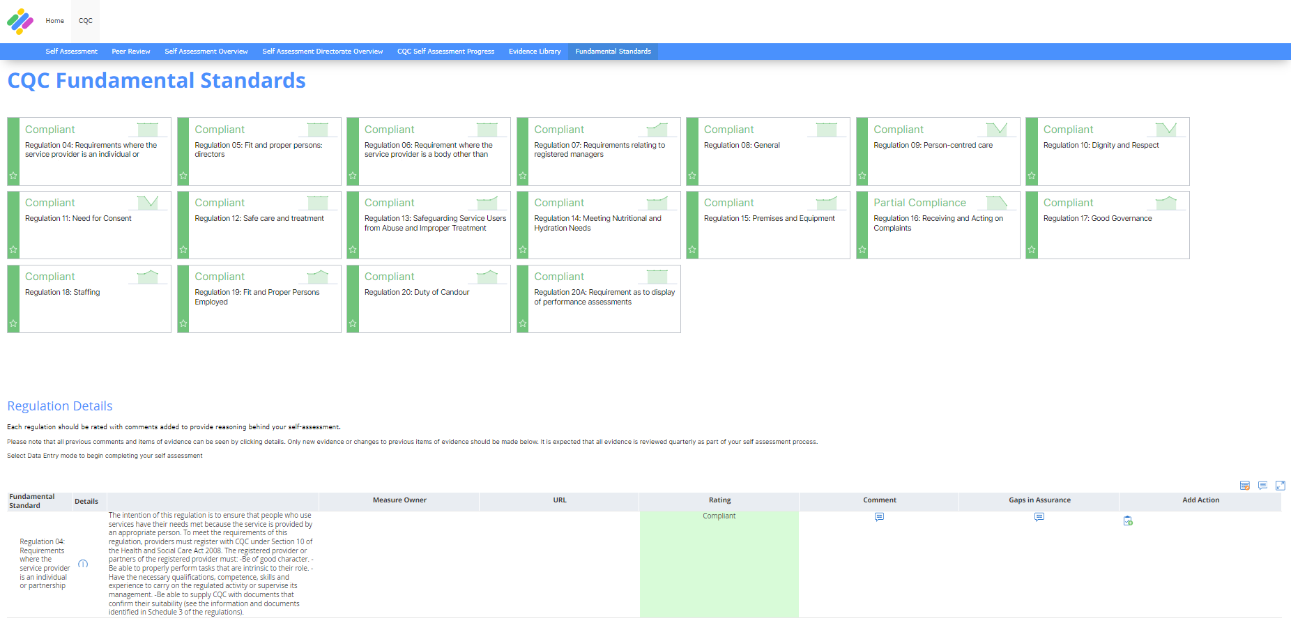

Once the user has selected a Card, the table beneath will update with details relating to the chosen Fundamental Standard. By entering Data Entry Mode, the user can add a rating, commentary and actions, in a similar way to the Self-Assessment pages.

Any Actions added will display in the table at the foot of the page.

